

THE
OBJECTIVES
OF FASTING

مقاصد الصوم

Abdul-Azeez ibn Abdus-Salam As-Sulami ‘Izzuddeen
(577-660 AH)

عبد العزيز بن عبد السلام السلمي عز الدين
577 – 660 هـ

ENGLISH – ARABIC
عربي - إنجليزي
REVISED BY THE SUNNAH COLLEGE COMMITTEE,
UNDER THE SUPERVISION OF:
SHEIKH DR. HAYTHAM SARHAAN
(TEACHER IN THE MASJID OF THE PROPHET ﷺ)

SARHAAN.COM – MAHADSUNNAH.COM

CONTENTS

INTRODUCTION. 2
CHAPTER ONE: OBLIGATIONS OF FASTING 3
CHAPTER TWO: VIRTUES OF FASTING 4
CHAPTER THREE: ETIQUETTES OF FASTING 11
CHAPTER FOUR: WHAT SHOULD BE AVOIDED IN IT 14
CHAPTER FIVE: SEEKING LAYLATUL QADR; NIGHT OF DECREE 17
CHAPTER SIX: SECLUSION, GENEROSITY AND RECITAL OF THE QURAN IN RAMADAN 20
CHAPTER SEVEN: FOLLOWING RAMADAN WITH THE SIX DAYS FAST IN SHAWWAL 22
CHAPTER EIGHT: FASTING IN GENERAL 23
CHAPTER NINE: VOLUNTARY FASTING 24
CHAPTER TEN: FORBIDDEN DAYS FOR FASTING 30



In the Name of Allah, the Entirely Merciful, the Especially Merciful.

May Allah’s Blessings and abundant Peace be upon our master Muhammad and his family [and followers].

The book of fasting
– and in it are ten chapters:

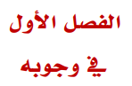

CHAPTER ONE: OBLIGATIONS OF FASTING
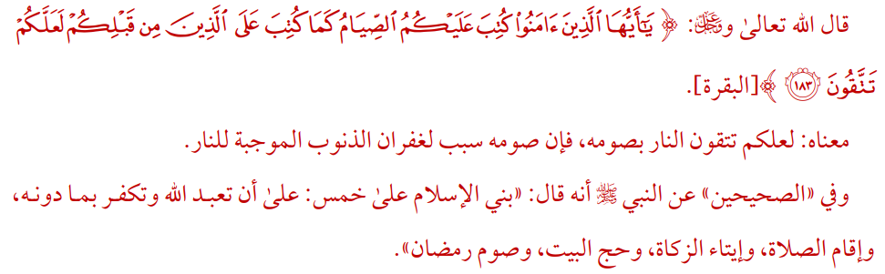
Allah, the Most High, said “O you who believe! Observing As-Saum (the fasting) is prescribed for you as it was prescribed for those before you, that you may become Al-Muttaqûn (the pious).”

The meaning of it is: so that you be mindful of the fire by fasting, for indeed its fasting is a means for forgiveness of sins that obligate the fire.

And it is reported in the sahiheen (Bukhari and Muslim) from the Prophet (ﷺ) that he said: “Islam is built upon five (pillars), upon that you worship Allah and disbelieve in what is besides Him, establishing the prayer, paying Zakah, performing Hajj to the house and fasting of Ramadan.”

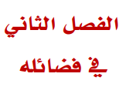

CHAPTER TWO: VIRTUES OF FASTING
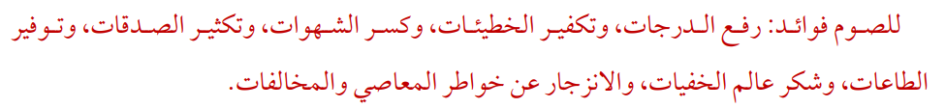
The fasting has benefits, (from it is) elevation of stations, expiation of sins, breaking of desires, increasing in charities, allowing different types of worships, being thankful to The Knower of the hidden matters (i.e., Allah), and repellence from the thoughts of disobedience and defiance.
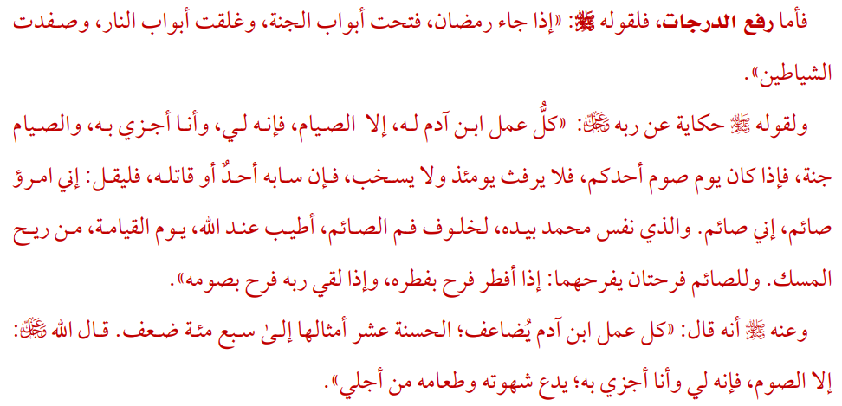
As for the elevation of the stations, then that is due to his statement (i.e. the Prophet (ﷺ)): “When Ramadan comes, the gates of Paradise are opened, and the gates of Hell are closed and the devils are chained.”

And due to his statement (i.e. the Prophet(ﷺ)), when he narrated from his lord (Allah) saying: “Every deed of the son of Adam is for him except fasting, for it is for Me, and I reward for it, and fasting is a shield, so if it is a day when one of you is fasting, then he should not be obscene on that day or quarrel, and if anyone insults him or fights him, let him say: I am a fasting person, I am fasting. By the One in whose hand is Muhammad’s soul, the smell of the mouth of a fasting person will be more pleasant to Allah on the Day of Resurrection than the scent of musk. The fasting person has two joys: when he breaks his fast, he rejoices in breaking his fast, and if he meets his Lord, he rejoices in his fasting.”

It is also narrated from him that he (ﷺ) said: “Every good deed of the son of Adam is multiplied ten times to seven hundred times. Allah said: Except for fasting, for it is for me and I reward it. He gives up his desires and food for my sake.”
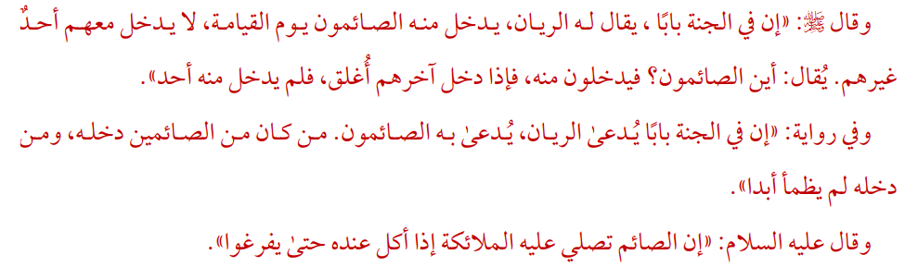
He (ﷺ) said: “There is a gate in Paradise, called Al-Rayyan, through which those who fast will enter on the Day of Resurrection, and no one will enter with them except them. It will be said: Where are the fasting people? So, they will enter through it, and when the last of them enters, it will be closed, and after no one will enter through it (the door).”

And in a narration: “There is a gate in Paradise called Al-Rayyan, through which those who fast are called. Whoever was from the fasting people will enter it, and whoever enters it will never be thirsty again”
And he (ﷺ) said: “Indeed the angels send Salat upon the fasting person when (others) eat in his presence, until they finish”
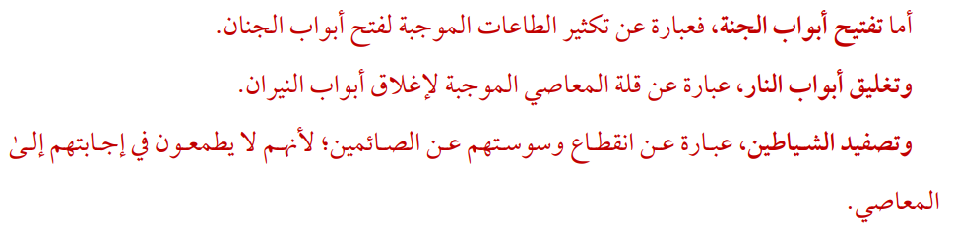
As for opening the gates of Paradise, it is an expression of multiplying acts of obedience that lead to opening the gates of Paradise.
Closing the gates of Hell is the absence of sins that require closing the gates of Hell.

Chaining the devils means stopping their whispering from those who are fasting. Because they are not eager to answer them in disobedience [of Allah].
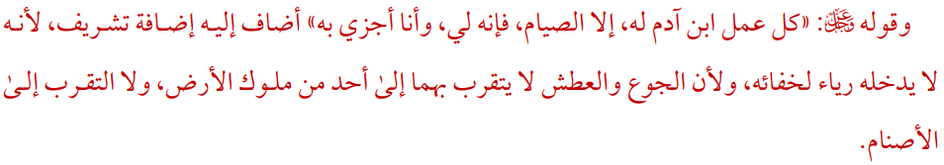
And His saying (Exalted be He): Every deed of the son of Adam is for him except fasting, for it is mine, and I will reward for it. He (i.e. Allah) attached it to Himself as an honorable attachment, because no showing-off enters into it due to its concealment, and because hunger and thirst are not used to get closer to one of the kings of the earth, nor are they used to get closer to the idols (i.e. they are not used as a form of worship for the idols by the idolators).
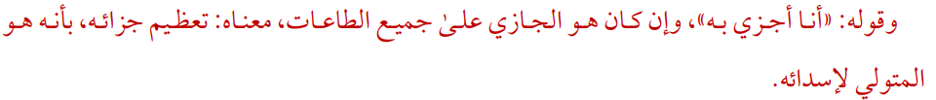
And his (i.e. Allah’s) saying: “I reward him”, even if he (Allah) is the one who rewards all acts of obedience, this means: magnifying his reward, because he is the person responsible for providing it.
His (ﷺ) saying: “Fasting is a shield” means: Fasting is a protection from the punishment of Allah.
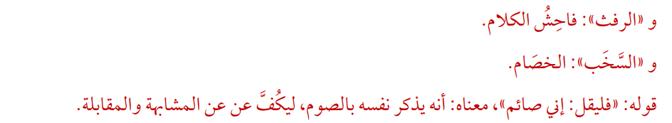
And obscenity (is) offensive/obscene speech.

And “quarrelling”: argumentation /quarrelling

His (ﷺ) saying: “Let him (i.e. the fasting person) say: I am fasting,” means that he reminds himself of fasting, in order to refrain from similarity and opposition.
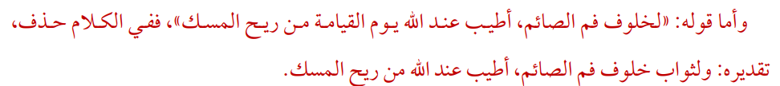
As for his (ﷺ) saying: “The breath from the mouth of a fasting person is more pleasant to Allah on the Day of Resurrection than the scent of musk,” there is an omission in the speech. And the estimation (of the meaning is): The reward from the mouth of a fasting person is better in the sight of Allah than the scent of musk.
As for the “two joys”, one is for his success in completing worship, and the other is for Allah’s reward when He rewards him.

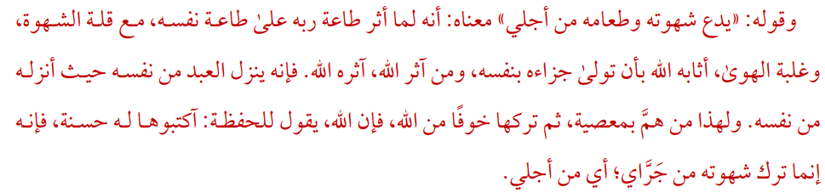
And his (ﷺ) saying: “He gives up his desire and his food for My sake” means: When he preferred obedience to his Lord over obedience to himself, despite the strength of desires and the dominance of whims, Allah rewarded him by taking care of his reward himself, and whoever preferred Allah, Allah will prefer him. For he (i.e. Allah) puts the servant from himself where he (i.e. the servant) put him from himself. For this reason, whoever intends to commit a sin, then abandons it out of fear of Allah, Allah says to the recorders: Write it down a s a good deed for him, for he left his lust for my sake; meaning, for me.

As for specifying their entry into Paradise by the Rayyaan Gate, they are distinguished by that door due to the distinction and honor of their worship.
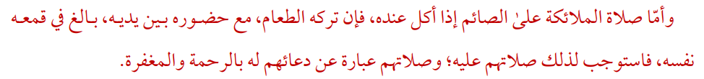
As for the angels’ prayers upon the fasting person when someone eats next to him, for his leaving of the food, while having it in front of him, is his utmost suppression of his nafs (his self/soul) , so because of that it necessitates their (i.e. Angels’) prayer on him. And their prayers are their invocation for mercy and forgiveness for him (i.e. for the fasting person).
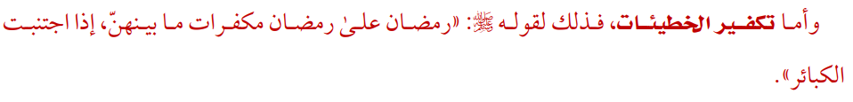
As for expiation of sins, that is due to His (ﷺ) saying: “Ramadan upon Ramadan expiates what is between them, if you avoided Major sins.”
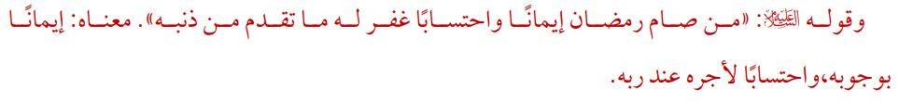
“Whoever fasts Ramadan out of faith and seeking (hoping in) reward, his previous sins will be forgiven.” It means faith in its obligation, and hoping of being rewarded by his Rubb (i.e., Lord, Cherisher, Sustainer, Protector, etc.).”

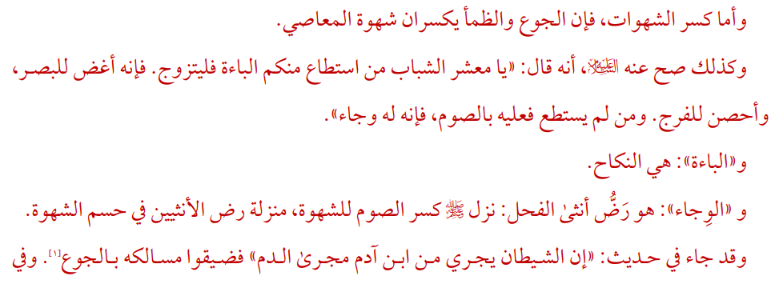
As for breaking desires, then hunger and thirst break the desire for sin. Likewise, it is authenticated from him that he (ﷺ) said: “O young people, whoever of you is capable of “ba’ah”, let him marry, for it is better for lowering the gaze, and better for guarding the private part. Whoever is not able to do so, then he must fast, for it is for him “wijaa’.”

And the “ba’ah”: is intercourse

“Al-Wijaa’”: is the rubbing of the testicles of the stallion, so he (ﷺ) placed the fast breaking the desires in the same position as rubbing the testicles in resolving the lust. It was stated in a hadith: “Satan flows through the son of Adam with blood, so narrow his paths with hunger”.
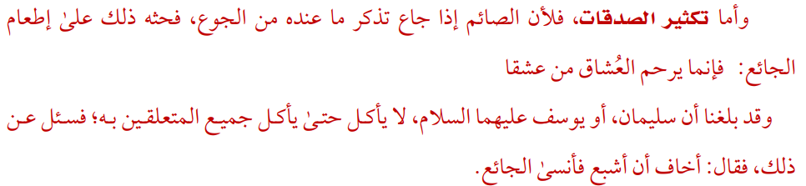
As for increasing in charity, this is because when the fasting person becomes hungry, he remembers what he has of hunger, and this encourages him to feed the hungry person, for verily the one that shows mercy to the lovers are the ones that love.

And it has reached us that Sulaymaan ﷺ or Yusuf ﷺ, would not eat until all those close to him had eaten; He was asked about that so he said: “I fear that I will become full and forget the hungry”.
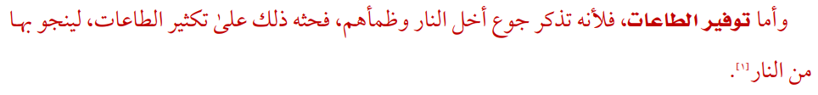
As for fulfilling the obedience, this is because he rem embered the hunger and thirst of the people of the Fire, and that prompted him to multiply the acts of obedience, in order to be saved by it from the fire".
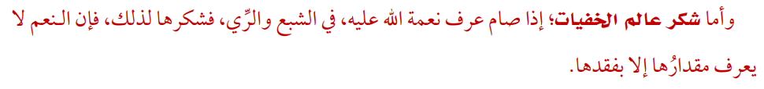
As for thanking The Knower of the hidden things: If he fasts, he recognizes Allah’s blessings upon him, when he is full or quenched, so he shows gratitude for it because of that, for verily the value of blessings are not known except by losing it.
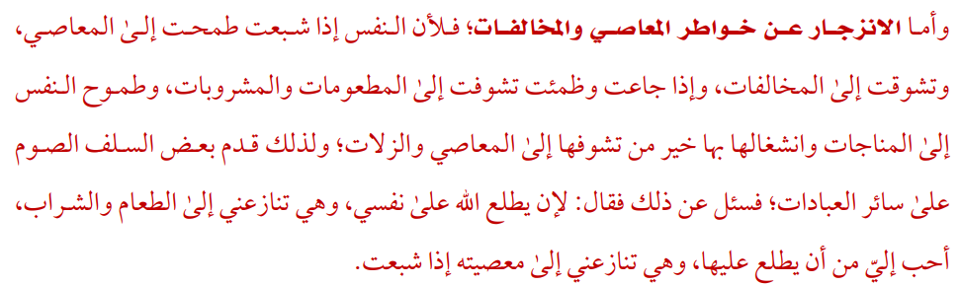
As for prevention from the thoughts of disobedience and transgressions; Because when the soul is satisfied, it aspires to sins and yearns for transgressions, and when it is hungry and thirsty, it longs for foods and drinks, and the soul’s determination with monologues and its preoccupation with them is better than its longing for sins and slips. That is why some of the predecessors (salaf) prioritized fasting over all other acts of worship. He was asked about that, so he said: Because Allah sees my soul, and it argues with me for food and drink, this is more beloved to me than him (i.e. Allah) seeing it and it (i.e. my soul) drives me to disobey him if when I am full.
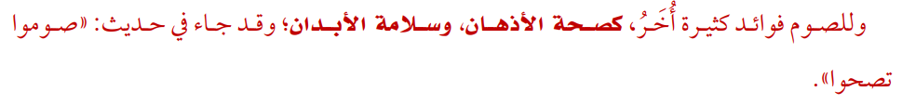
And fasting has many other benefits, such as the health of the mind and the safety of the body. It was stated in a hadith: “Fast and become healthy”.
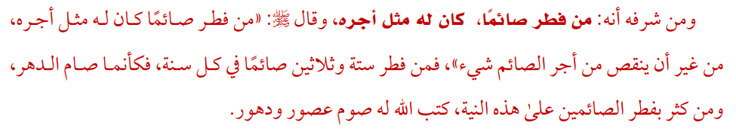
Part of its honor is that whoever breaks the fast (feeds) for a fasting person will have a reward similar to his reward, and he (ﷺ) said: “Whoever breaks the fast for a fasting person will have a reward similar to his reward, without detracting from the reward of the fasting person in any way.” So, whoever breaks the fast for thirty-six fasting people every year, it is as if he fasted for the whole time. Whoever breaks the fast of the fasting people a lot with this intention, Allah will record for him fasting for ages and ages.
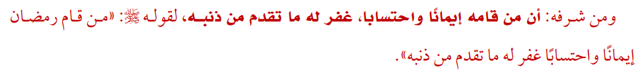
Part of its honor is that whoever performs it out of faith and seeking reward, his previous sins will be forgiven, as he (ﷺ) said: “Whoever performs Ramadan out of faith and hope (seeking reward), he will be forgiven for his previous sins.”

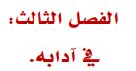

CHAPTER THREE: ETIQUETTES OF FASTING

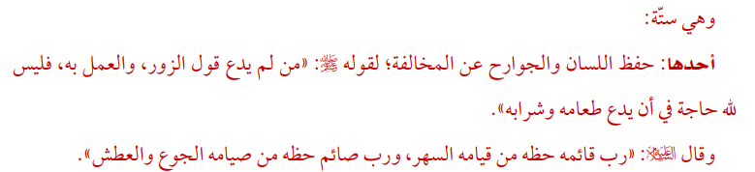They are six:
- Protect the Tongue
Tongue The Prophet ﷺsaid, “Whoever does not give up forged speech and evil actions, Allah is not in need of his leaving his food and drink” (i.e., Allah will not accept his fasting). The Prophet ﷺsaid: “There are people who fast and get nothing from their fast except hunger, and there are those who pray and get nothing from their prayer but a sleepless night”.

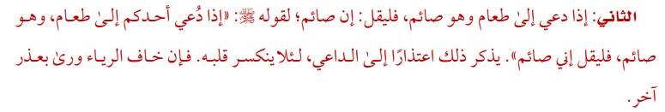

- When invited to have a meal and you are fasting
The Prophet ﷺsaid: “If any one of you is invited to a meal when he is fasting, he should say: I am fasting”. He should mention that as an excuse to the person who invited them, not to break his heart. If he fears showing off, then he should provide another excuse.

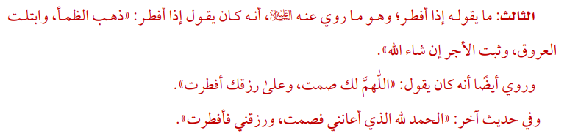

- What should be said when the fast is broken?
The Prophet ﷺsaid when he broke his fast: Dhahaba’d dhama’ wa’btallati’l `uruq wa thabata’l ajru in sha’ Allah “Thirst has gone, the vessels are moist, and the reward is sure, if Allah wills”. The Prophet ﷺsaid when he broke his fast: Allahumma laka sumtu, wa `ala rizqika aftart “O Allah, for you I have fasted, and with your provision I have broken my fast”. In another narration the Prophet ﷺsaid when he broke the fast: “Al-hamdu li’l Llah alladhi a`anani fa-sumt, wa razaqani fa-aftart” “All praise is due to Allah who assisted me, so I fasted; and who provided me, so I could break my fast”.

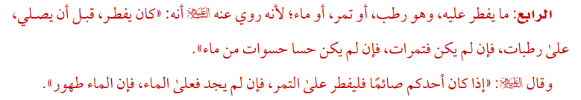

- With what to break the fast?
Fresh dates or Dry dates or Water There is a narration that the Prophet ﷺwould break the fast with fresh dates before performing Salat. If there were no fresh dates then (he would break the fast) with dried dates, and if there were no dried dates then he would take a few sips of water." The Prophet ﷺsaid: “When one of you is fasting, he should break his fast with dates; but if he cannot get any, then (he should break his fast) with water, for water is purifying”.

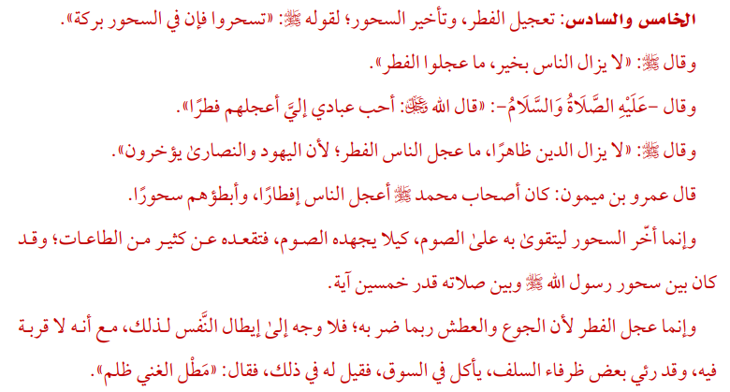

- and 6. Hasten to the break the fast and delay the suhur (Predawn meal)
The Prophet ﷺsaid: “Take Suhur as there is a blessing in it”. The Prophet ﷺsaid: “The people will remain on the right path as long as they hasten the breaking of the fast”. The Prophet said: “Allah, Mighty and Sublime is He, said: 'Those of My worshippers who are most beloved to me are the quickest to break their fast”. The Prophet ﷺsaid: “Religion will continue to prevail as long as people hasten to break the fast, because the Jews and the Christians delay doing so”. Amru bin Maymoon (Allah be pleased with him) said: “The Companions of the Prophet ﷺ were the hastiest at breaking their fasts and the slowest at finishing Suhur”. The interval between the Suhur and the Salaah of the Prophet ﷺwas sufficient to recite fifty verses of the Quran." We were asked to hasten breaking the fast because hunger and thirst may harm a person, there is no benefit or good deed in prolonging it. A humorous person from the Salaf was seen eating in the market and someone asked him about it, he said: “Delay in payment by a rich man is injustice”.

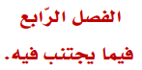

CHAPTER FOUR: WHAT SHOULD BE AVOIDED IN IT

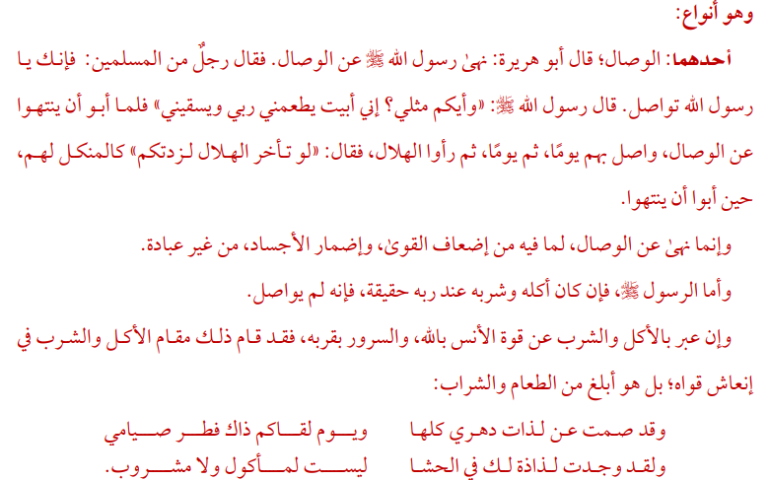
These are types:
- Wisaal; extended, continued fasting
Abu Huraira (Allah be pleased with him) narrated that the Prophet ﷺ forbade Al-Wisal in fasting. So, one of the Muslims said to him, “But you practice Al-Wisal. O Allah's Messenger ﷺ!” The Prophet ﷺ replied: “Who amongst you is similar to me? I am given food and drink during my sleep by my Lord”. So, when the people refused to stop Al-Wisal, the Prophet ﷺ fasted day and night continuously along with them for a day and then another day and then they saw the crescent moon (of the month of Shawwal). The Prophet ﷺ said to them, "If it (i.e., the crescent) had not appeared, I would have made you fast for a longer period”, as a punishment for them when they refused to stop.
Verily, he prohibited Wisaal because it will weaken our strength and harm our bodies and it is not considered an act of worship. As for if the Prophet ﷺ his breaking of fast is literal; at His Rubb (Lord) – he did not perform Wisaal. If he explained food and water as the strength of serene seclusion with Allah and His Nearness, for that has replaced the position of food and drink by nourishing his strength, rather, it is more powering than food and drink:
I have fasted from all the desires of my life, and breaking my fast is truly when meeting you,
I have found a pleasure in being full, not by food, nor by water!

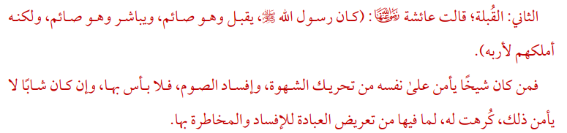
- Qublah; a kiss
Aisha (Allah be pleased with her) narrated that the Prophet ﷺ used to kiss and embrace (his wives) while he was fasting, and he had more power to control his desires than any of you. Whoever was an old person who is secure from inciting desires, then no problem. If he was a young one who cannot guarantee that, it is disliked for him as to what it can lead to from risking the worship.

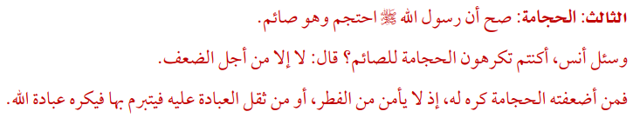
- Hijaamah; cupping
The Prophet ﷺ was cupped while he was fasting. Anas bin Malik was asked whether they disliked the cupping for a fasting person. He replied: “No, unless if it causes weakness.” Cupping is disliked for the one who might become weak. It may cause him to break his fast or he may feel the difficulty of worship or he may get bored of it and dislike it.

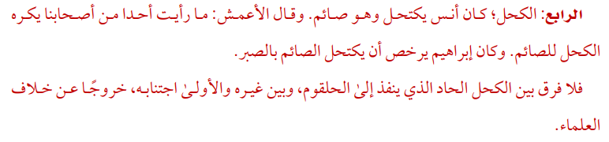

- Kohl (eyeliner)
Anas bin Malik (Allah be pleased with him) that he used to apply kohl when he was fasting. Al-A'mash (Allah be pleased with him) said: “I did not see any of our companions who abominated the use of kohl by a man who was fasting. Ibrahim would permit the man who was fasting to apply kohl with aloes”. There is no difference between intense kohl which can be felt /tasted in the throat or normal kohl. It is better to avoid both to be protected from the disagreement of the scholars.

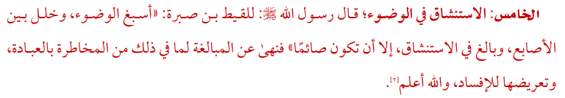

- Istinshaaq; sniffing water into the nasal cavity
The Prophet ﷺ said: “Perform ablution in full and make the fingers go through the beard and sniff with water well except when you are fasting”. The Prophet ﷺ forbade the exaggeration in rinsing the nose because it may invalidate the fast. Allah knows best.

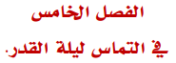

CHAPTER FIVE: SEEKING LAYLATUL QADR; NIGHT OF DECREE
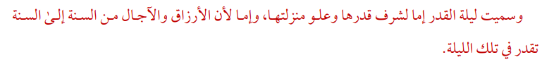
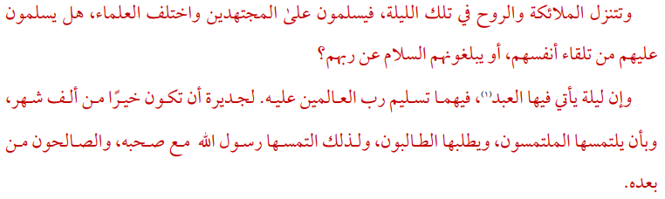
The Night of Decree is a blessed night. The blessings Allah has placed in it is more than [the virtues that are placed in] 1000 months. It is known as the Night of Decree either by the honor of its value and high status or because of the blessings, sustenance, and appointed times from year to year that are assessed in that night. The angels and the Ruh descend in that night and they give salam to those who work hard “in worship”. The scholars differed, do they give salam from themselves or do they convey it from their Lord? A night in which the worshipper comes, in which the Lord of the world gives salam to him is better than a thousand months and to be sought by the seekers and to be appealed by the appealers. That is why the Messenger of Allah ﷺ searched for it with his companions and it is also the practice of the righteous people after him.

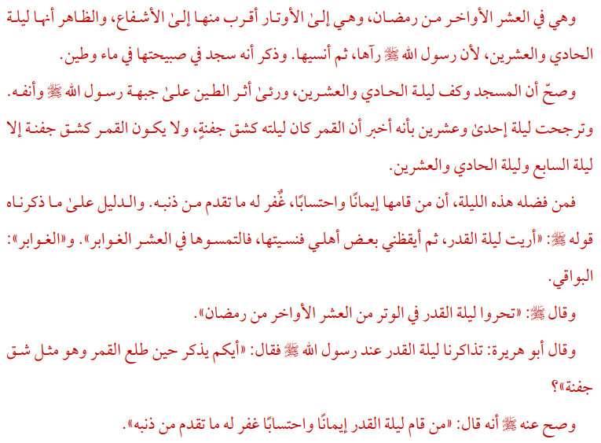

It is in the last 10 nights of Ramadan; it is closer to the odd nights than the even nights. Apparently, it is the 21st night because the Messenger of Allah ﷺ saw it and then was caused to forget it. And it was mentioned that he prostrated in the morning in water and mud. It was reported that rainwater was dropping from the mosque’s roof on the night of the 21st, and mark of the mud was seen on the forehead and the nose of the Messenger of Allah ﷺ. The night of the 21st was probably the night of power because the Prophet ﷺ said that moon was like half bowl that night. The moon does not look like half bowl except on the 7th night and the 21st night. One of the virtues of this night is that He who observes prayer throughout this night, out of sincerity of Faith and in hope of earning reward will have his past sins pardoned. The proof of what we mentioned is his ﷺ saying, “I have been shown Lailatul-Qadr, then I was caused to forget it, so seek it in the last ten nights”. The Prophet ﷺ said: “Search for the Night of Qadr in the odd nights of the last ten days of Ramadan”. Abu Huraira (Allah be pleased with him) reported: We were talking about Lailat-ul-Qadr in the presence of the Messenger of Allah ﷺ and he said: “He who amongst you remembers (the night) when the moon arose, and it was like a piece of plate”. The Prophet ﷺ said: “Whoever established prayers on the night of Qadr out of sincere faith and hoping for a reward from Allah, then all his previous sins will be forgiven”.

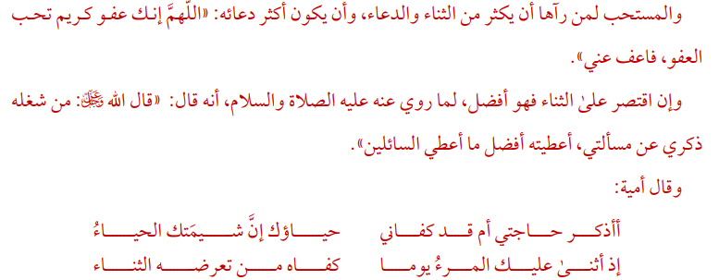

It is permissible to increase Thana (praising Allah) and Dua (Supplicating to Allah). One should repeat this dua often: 'Allahumma innaka 'afuwwun tuhibbul-'afwa, fa'fu 'anni. O Allah, You are pardoning and love pardoning, so pardon me. If one was to confine himself to praise Allah this is better because it is narrated that the Messenger ﷺ said: “The Lord, Blessed and Most High is He, has said: 'Whoever is busy with remembering Me from asking Me, then I shall give him more than what I give to those who ask”. Umayyah had said:

Do I mention my need, or has your shyness become sufficient for me for your trait is, indeed, shyness.
If one day, a person has singled you out in praise, it is sufficient for him such praise.

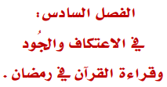

CHAPTER SIX: SECLUSION, GENEROSITY AND RECITAL OF THE QURAN IN RAMADAN

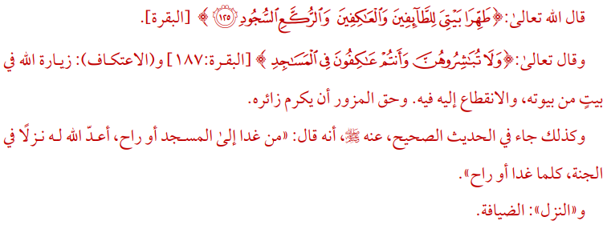
Allah said (meaning): “Purify My House for those who circumambulate it as a rite of worship, and those who abide in devotion, and those who bow and prostrate (in the Prayer).”
And He said (meaning): “And do not associate in intimacy with them (your wives) during the period when you are in I’tikaf (i.e., Seclusion in the masjid)”. I’tikaf is to visit Allah at one of his houses and worship him there and the visitor must honor the Host.”

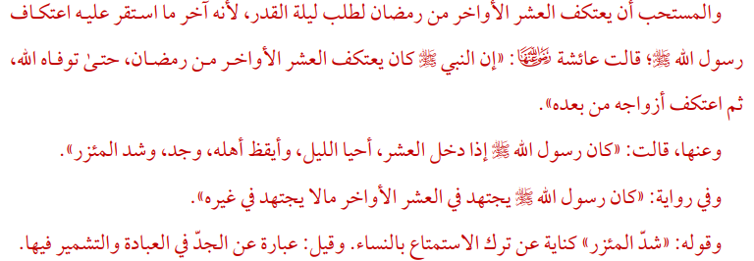

The Prophet ﷺ said: “Allah will prepare for him who goes to the mosque (every) morning and in the afternoon (for the congregational prayer) an honorable place in Paradise with good hospitality for (what he has done) every morning and afternoon”. Aisha (Allah be pleased with her) said: “The Prophet ﷺ used to practice I`tikaf in the last ten days of Ramadan till he died and then his wives used to practice I`tikaf after him”. Aisha (Allah be pleased with her) said: “With the start of the last ten days of Ramadan, the Prophet ﷺ used to tighten his waist belt and used to pray all night and used to keep his family awake for the prayers”. Aisha (Allah be pleased with her) reported that Allah's Messenger ﷺ used to exert himself in devotion during the last ten nights to a greater extent than at any other time. Tighten his waist belt refers to not being intimate with his wives or can also mean diligence and perseverance in worship.

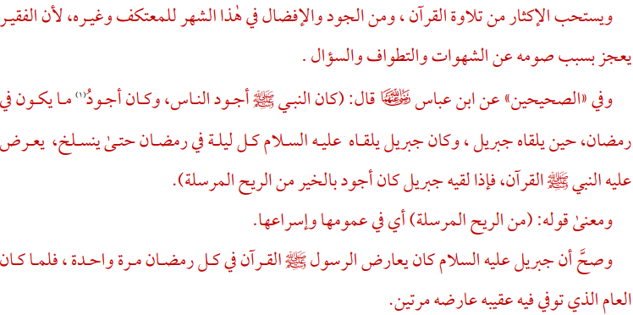

It is recommended to recite the Quran abundantly and it is better to be generous in this month. Ibn `Abbas (Allah be pleased with him) said: “The Prophet ﷺ was the most generous amongst the people, and he used to be more so in the month of Ramadan when Jibreel visited him, and Jibreel used to meet him on every night of Ramadan till the end of the month. The Prophet ﷺ used to recite the Holy Quran to Jibreel, and when Jibreel met him, he used to be more generous than a fast wind (which causes rain and welfare)”. And it has been authentically transmitted that Jibreel used to revise the Quran with the Prophet ﷺ every Ramadan once, but when it was the year that he passed away in it, he revised it on him twice.

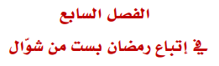

CHAPTER SEVEN: FOLLOWING RAMADAN WITH THE SIX DAYS FAST IN SHAWWAL

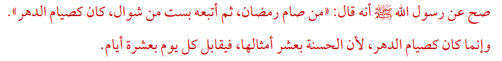
The Prophet ﷺ said: “He who observed the fast of Ramadan and then followed it with six (fasts) of Shawwal, it would be as if he fasted entirely”. It is like fasting a year because the reward of the good deed is ten the like thereof, so each day will be the same reward as 10 days.

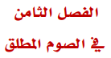

CHAPTER EIGHT: FASTING IN GENERAL

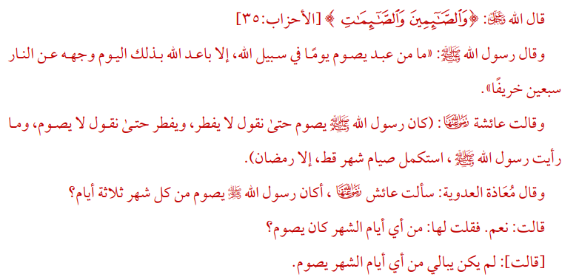
Allah said (meaning): “The fasting men and the fasting women.” The Prophet ﷺ said: “Indeed, anyone who fasts for one day for Allah's Pleasure, Allah will keep his face away from the (Hell) fire for (a distance covered by a journey) seventy Autumns (i.e., years)”. Aisha (Allah be pleased with her) said: “The Messenger of Allah ﷺ used to fast till one would say that he would never stop fasting, and he would abandon fasting till one would say that he would never fast. I never saw Allah's Messenger ﷺ fasting for a whole month except the month of Ramadan”. Mu'adha al-'Adawiyya reported that she asked 'A'ish (may Allah be pleased with them), whether the Messenger of Allah ﷺ observed fasts for three days during every month. She said: “Yes, I said to her: Which were (the particular) days of the month on which he observed fast? She said: He was not particular about the days of the month on which to observe fast”.

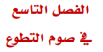

CHAPTER NINE: VOLUNTARY FASTING

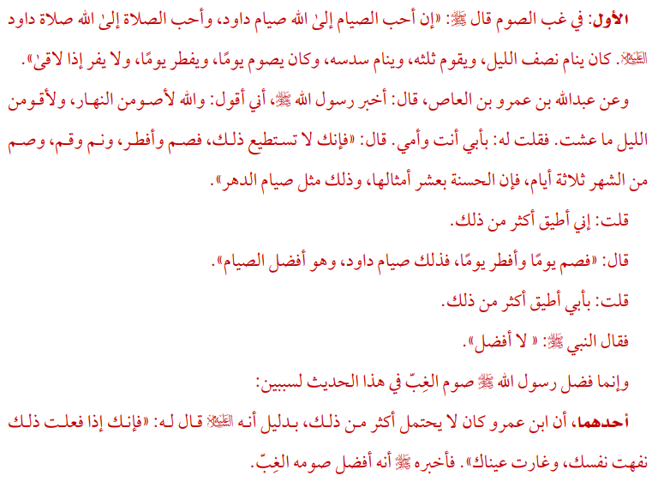
- Fasting one day and not the next
Abdullah bin 'Amr (Allah be pleased with him) reported Allah's Messenger ﷺ as saying: “With Allah the best fasting is that of Dawuud ﷺ and the best prayer is that of Dawuud ﷺ for he slept half of the night and stood for prayer for the third of it and (then) slept the sixth part of it and he observed fast one day and broke on the other”. Abdullah bin `Amr (Allah be pleased with him) reported that Allah's Messenger ﷺ was informed that I had taken an oath to fast daily and to pray (every night) all the night throughout my life (so Allah's Messenger ﷺ came to me and asked whether it was correct): I replied, “Let my parents be sacrificed for you! I said so”. The Prophet ﷺ said: “You cannot do that. So, fast for few days and give it up for few days, offer Salat (prayer) and sleep. Fast three days a month as the reward of good deeds is multiplied ten times and that will be equal to one year of fasting”. The Prophet ﷺ said to me, “Fast one day and give up fasting for two days”. I replied: “I can do better than that”. The Prophet ﷺ said to me, “Fast one day and give up fasting for a day and that is the fasting of Prophet David and that is the best fasting”. I said: “I have the power to fast better (more) than that”. The Prophet ﷺ said: “There is no better fasting than that.” The Messenger of Allah ﷺ preferred alternate fasting i.e., fasting one day and not the next day, as described in the above hadith, for two reasons.

The first reason: Ibn Amr could not endure more than that. The proof is that the Prophet ﷺ said: “If you did that your body would get tired and your eyes will become weak. So, he ﷺ told him the best fasting is to fast one day and not the next.
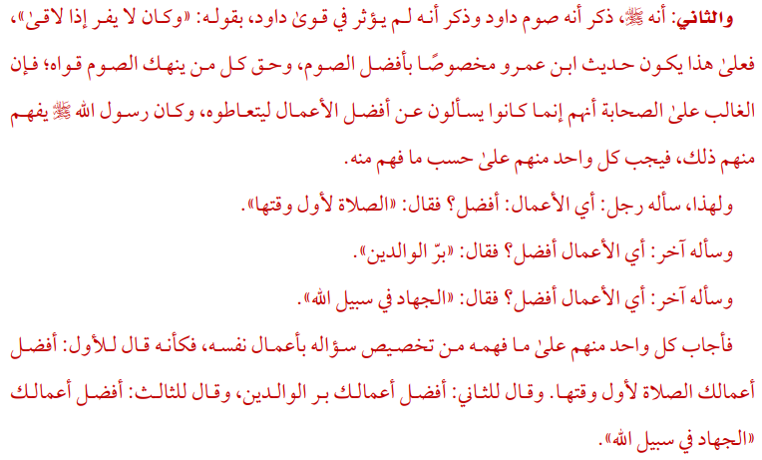
The second reason: The Messenger of Allah ﷺ mentioned that the fast of Dawud ﷺ did not affect his strength as it is shown in the words of the Messenger of Allah ﷺ: “He did not flee when meeting the enemy” and based upon this hadith by Ibn ‘Amr Al Aas specifies the best fast, and the reality is that fasting weakens the strength of any man. Most of the companions used to ask the Messenger of Allah ﷺ about the best deeds and actions that they could perform, and he answered each of them according their ability. For instance, a man asked him: “Which action is best?”, The Messenger of Allah ﷺ answered: “The performance of prayer at its earliest time.” Another man asked him: “Which deed is the best?”, The Messenger of Allah ﷺ answered: “Be good and kind to your parents.” Another man asked him: “Which action is best?”, The Messenger of Allah ﷺ answered: “To fight in the way of Allah.” It is quite clear that the Messenger of Allah ﷺ answered every single person based on the individual’s understanding with regards to the specific question and that person’s ability to perform that action. So, it is to say that he had said to the first person, “The best of your deeds is that you pray on time.” And to the second person, “The best of your deeds is that you obey your parents.” And to the third person, “The best of your deeds is fight in the cause of Allah.”

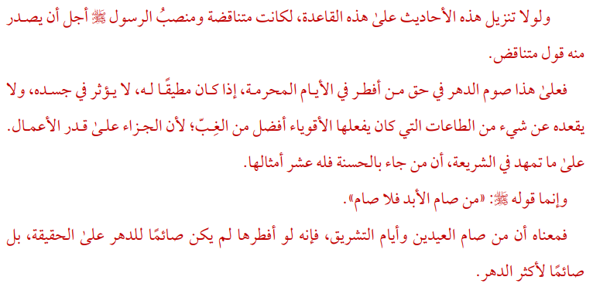

And if it weren’t for fitting these narrations on this foundational rule, it would’ve been contradictory, and the status of the Messenger ﷺ is so lofty that anything contradictory would come from him.

So, upon this, fasting the entire lifetime except the prohibited days – if one were able to do so and doesn’t affect his body nor hold him back from performing worship which the strong ones would do – is better than the outcome; since reward is based on actions. And as for what has been explained in the Shari’ah; whoever comes with one good deed, it is multiplied for him tenfold.

As for his saying ﷺ, “Whoever fasts forever (i.e., his entire life), then he has not fasted.” It means that whoever fasts both Eids and the days of Tashreeq, then if he has broken his fast in them, he wouldn’t be actually fasting entire life, rather, most of his life.

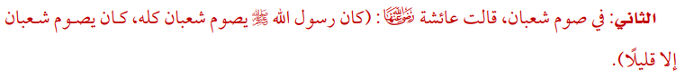

- Fasting in Shaban
Aisha (Allah be pleased with her) said: “The Messenger of Allah ﷺ used to fast all of Sha’ban, fasting it except a few [days].”

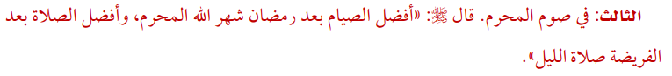

- Fasting in Muharram
The Prophet ﷺ said: “The best fast after Ramadan is Allah’s month al-Muharram, and the best prayer after what is prescribed is prayer during the night”.

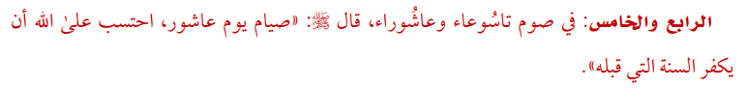

- and 5. The Ninth and Tenth of Muharram
The Prophet ﷺ said: “Fasting on the Day of Ashura, I seek from Allah that He expiates the sins of the preceding year”.

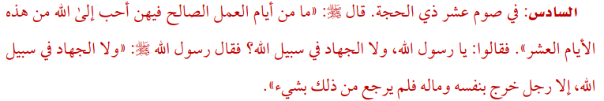

- Fasting on the first ten days of Dhul Hijjah
The Prophet ﷺ said: “No good deeds done on other days are superior to those done on these (first ten days of Dhul Hijjah)." The companions said, "Not even Jihad?" He replied, "Not even Jihad, except that of a man who does it by giving himself and his property in for Allah's sake, and does not return with any of those things”.

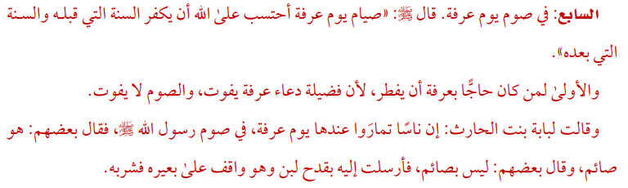

- Fasting on the day of Arafat
The Prophet ﷺ said: “I seek from Allah that fasting on the day of 'Arafah expiates the sins of the preceding and the coming year”. The priority is that whoever was doing Hajj is to break their fast, since the virtue of supplication would be missed, but fasting would not be missed.

Lubabah bint Harith (Allah be pleased with her) said: “While the people were with me on the day of `Arafat they differed as to whether the Prophet ﷺ was fasting or not; some said that he was fasting while others said that he was not fasting. So, I sent to him a bowl full of milk while he was riding over his camel, and he drank it”.

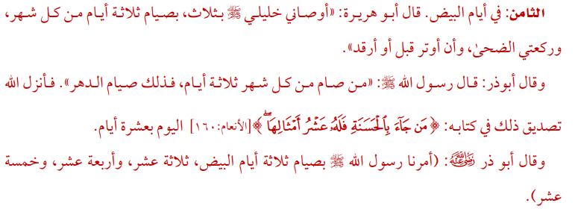

- Fasting on the White Days
Abu Huraira (Allah be pleased with him) said: “My best friend (i.e., the Prophet ﷺ) advised me to observe three things: (1) to fast three days of every month; (2) to pray two rak`at of Duha prayer (forenoon prayer); and (3) to pray Witr before sleeping.”
Abu Dharr (Allah be pleased with him) narrated: “The Messenger of Allah ﷺ said: “Whoever fasts three days in every month, then that is (like) fasting the lifetime.” Then Allah attested to that in His Book by revealing: “Whoever brings a good deed, shall have ten times the like thereof.” So, a day is like ten”.

Abu Dharr (Allah be pleased with him) narrated that: The Messenger of Allah ﷺ said: “Oh Abu Dharr! When you fast three days out of a month, then fast the thirteenth, fourteenth, and fifteenth”.

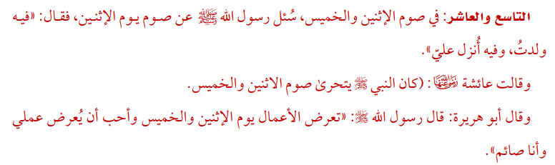

- and 10. Fasting on Mondays and Thursdays
The Messenger of Allah ﷺ was asked about fasting on Monday, whereupon he said: “It is (the day) I was born, and revelation was sent down to me”.

Aishah (Allah be pleased with her) said: “The Prophet ﷺ used to specifically fast on Mondays and Thursdays”.

Abu Hurairah (Allah be pleased with him) said that: The Messenger of Allah ﷺ said: “Deeds are presented on Mondays and Thursdays, and I love that my deeds be presented while I am fasting”.

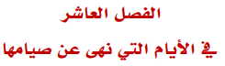

CHAPTER TEN: FORBIDDEN DAYS FOR FASTING

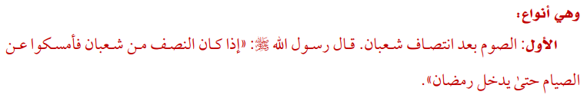
They are types:
- Fasting after the half of Sha’ban
The Messenger of Allah ﷺ said: “When a half of Sha’ban remains then do not fast. Stay away from fasting until Ramadan enters.”

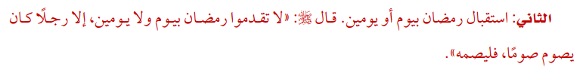

- Fasting a day or two days before Ramadan
The Prophet ﷺ said: “None of you should fast a day or two before the month of Ramadan unless he has the continuous habit of fasting (Nawafil), then he can fast that day”.

- Fasting on a Doubtful Day
Ammar bin Yasir (Allah be pleased with him) said: “Whoever fasts on a day in which there is doubt, then he has disobeyed Abul-Qasim ﷺ”.

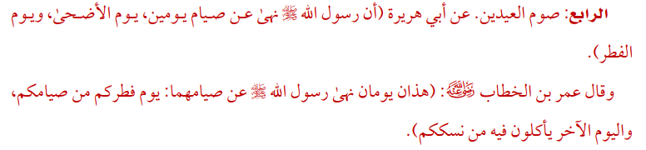

- Fasting on the Days of Eid
Abu Huraira (Allah be pleased with him) reported that the Messenger of Allah ﷺ forbade fasting on these two days. Eid-ul-Adha and Eid-ul-Fitr.

Umar bin Al-Khattab (Allah be pleased with him) said, “These are two days which Allah's Messenger ﷺ has forbidden people to fast; the day on which you break fasting (the fasts of Ramadan), and the day on which you eat the meat of your sacrifices.”

- Days of Tashreeq
The Prophet ﷺ said: “The days of Tashreeq are the days of eating and drinking and remembering Allah”.

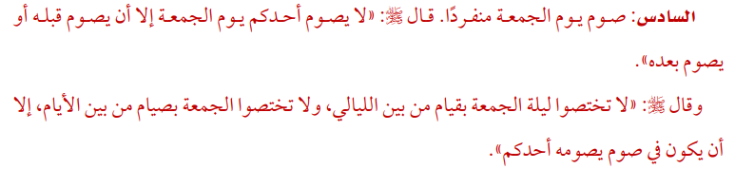

- Singling out Friday for Fasting.
The Prophet ﷺ said: “None of you should fast on Friday unless he fasts a day before or after it”.

The Prophet ﷺ said: “Do not single out the night (preceding) Friday among the nights for prayer and do not single out Friday among days for fasting but only when anyone among you is accustomed to fast (on dates) which coincide with this day (Friday)”.

This is the end of the benefits of fasting.

