
ﻗﺼﺔ ﻗﺎرون

STORY OF QARUN

ENGLISH LANGUAGE
ﺑﺎﻟﻠﻐﺔاﻻﻧﺠﻠﻴﺰﻳﺔ

REVISED BY THE SUNNAH COLLEGE COMMITTEE, UNDER THE SCHOLARLY SUPERVISION OF:

SHAYKH DR. HAYTHAM SARHAAN

(TEACHER IN THE MASJID OF THE PROPHET ﷺ)

SARHAAN.COM - MAHADSUNNAH.COM

ﺟﻤﻴﻊ ﺣﻘﻮق اﻟﻄﺒﻊ ﻣﺤﻔﻮﻇﺔ© RESERVED RIGHTS ALL

THIS PUBLICATION IS A WAQF FOR ALLĀH AND FOR THE BENEFIT OF ALL MUSLIMS; IT IS NOT TO BE SOLD AND WHOEVER WISHES TO PRINT, COPY OR DISTRIBUTE COPIES FOR FREE MUST DO SO WITHOUT ANY ALTERATIONS TO THE ORIGINAL TEXT.

WWW.SARHAAN.COM WWW.MAHADSUNNAH.COM



Allah said (Quran 28:76):

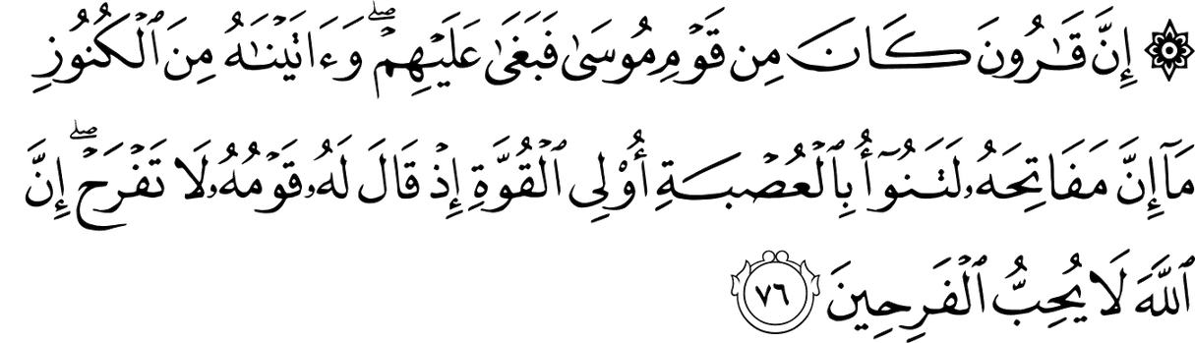

Verily, Qârûn (Korah) Was of Mûsâ’s (Moses) people, but he behaved arrogantly toWards them. And We gave him of the treasures, that of Which the keys Would have been a burden to a body of strong men. Remember When his people said to him: "Do not exult (With riches, being ungrateful to Allâh). Verily Allâh likes not those Who exult (With riches, being ungrateful to Allâh).

Verily Allaah (Ta'la) gave him huge money and lot of money and bulky treasures which reached it's bulkiness to an extent that it's keys were heavy for strong men to carry but the enemy of Allaah was unjust and proud. He rebelled from obedience to Allaah.

So some relatives said by way of sincere advise him and warning him: Don't rejoice Allaah doesn't Love those who rejoice. But seek, with that which Allah has bestowed on you, the home of the Hereafter, Meaning do not not rejoice with the delights of the dunya and turning away from the dunya and working for the Aakhirah.

Qarun replied to their advice (Quran 28:78):


He said: "This has been given to me only because of the knoWledge I possess."

Qarun went forth one day before his people with his magnificent regalia; wearing his fine clothes, accompanied by his fine horses, his servants and retinue. When those whose desired the world saw his adornments and splendor, they wished that they could have the same as he had been given, and said (Quran 28:79):

"Ah, Would that We had the like of What Qârûn (Korah) has been given!
Verily he is the oWner of a great fortune."

When the people of beneficial knowledge heard this, they said to them (Quran 28:80):



But those Who had been given (religious) knoWledge said: "Woe to you! The ReWard of Allâh (in the Hereafter) is better for those Who believe and do righteous good deeds, and this none shall attain except those Who are As-Sâbirûn (the patient in folloWing the truth)

And Qarun was destroyed in a state of transgression and Pride and the dunya was adorned to him which increased him in self-conceit leading to his sudden punishment.

So Allaah caused him and his house to be swallowed by the earth. The recompense is of the nature of the action.

As he elevated himself Allaah lowered him by causing him to be the lowest of the low. All that was from what he was deceived of his house and from the pomp and passing enjoyment he had (Quran 28:82);

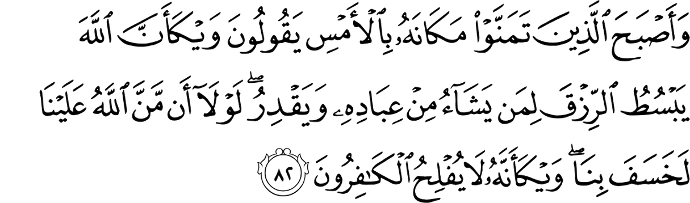

And those Who had desired (for a position like) his position the day before, began to say: "KnoW you not that it is Allâh Who enlarges the provision or restricts it to Whomsoever He pleases of His slaves. Had it not been that Allâh Was Gracious to us, He could have caused the earth to sWalloW us up (also)! KnoW you not that the disbelievers Will never be successful.

Thereby, he wasn't helped nor supported.

