

MAHADSUNNAH.COM SARHAAN.COM

MAJMOO’ AL-MUTOON

مجموع المتون

ENGLISH – الإنجليزية

WITHOUT COMMENTARY

REVISED BY THE SUNNAH COLLEGE COMMITTEE,
UNDER THE SUPERVISION OF SHEIKH DR.:
HAYTHAM SARHAAN
(TEACHER OF THE MASJID OF THE PROPHET ﷺ)
CONTENTS:
1. NULLIFIERS OF ISLAM 2
BY IBN ABDUL WAHHAAB RAHIMAHULLAH
2. FOUR FUNDAMENTAL PRINCIPLES 4
BY IBN ABDUL WAHHAAB RAHIMAHULLAH
3. THREE FUNDAMENTAL PRINCIPLES 8
BY IBN ABDUL WAHHAAB RAHIMAHULLAH
4. THE SIX FUNDAMENTAL PRINCIPLES 23
BY IBN ABDUL WAHHAAB RAHIMAHULLAH
5. FORTY NAWAWI HADEETH 27
BY AN-NAWAWI RAHIMAHULLAH
6. THE IMPORTANT LESSONS 50
BY IBN BAAZ RAHIMAHULLAH
7. SUMMARY OF RIGHTS CALLED FOR BY FITRAH 65
BY IBN UTHAYMEEN RAHIMAHULLAH
8. AL-‘AQĪDAH AL-WĀSIṬĪYAH 69
BY IBN TAYMIYYAH RAHIMAHULLAH

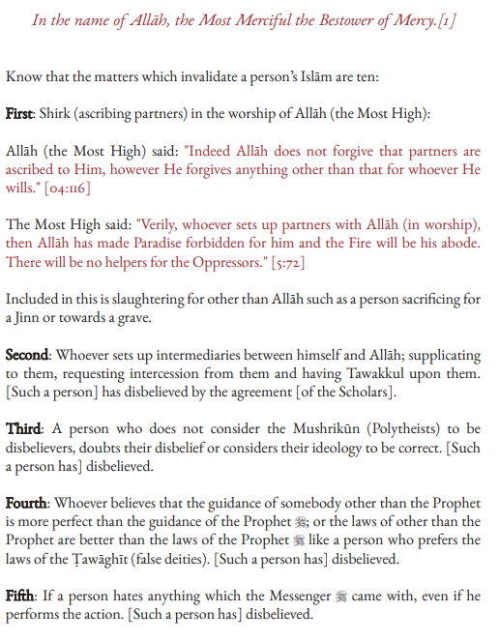

NULLIFIERS OF ISLAM

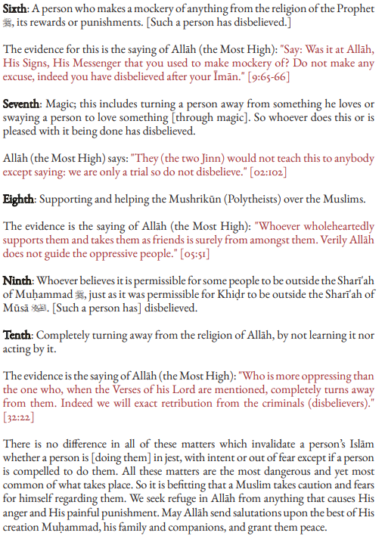

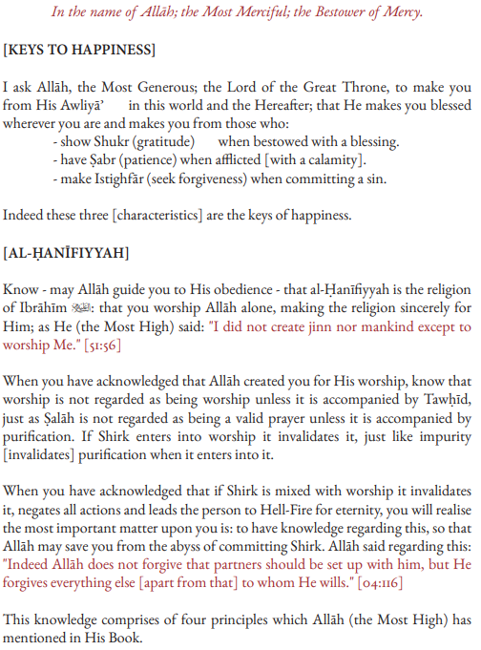
FOUR FUNDAMENTAL PRINCIPLES

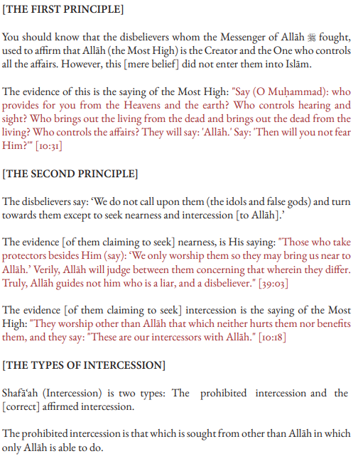
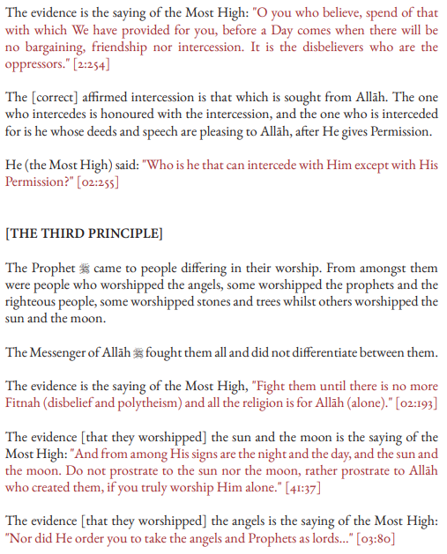
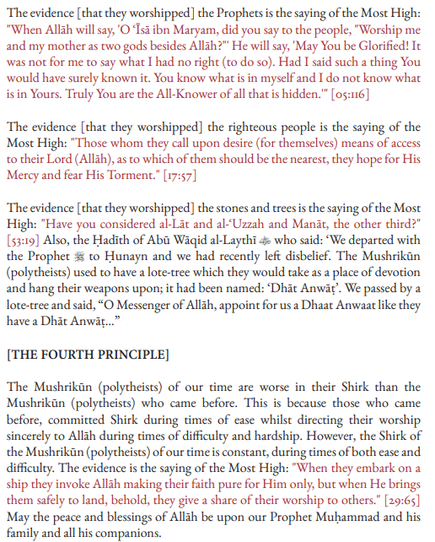

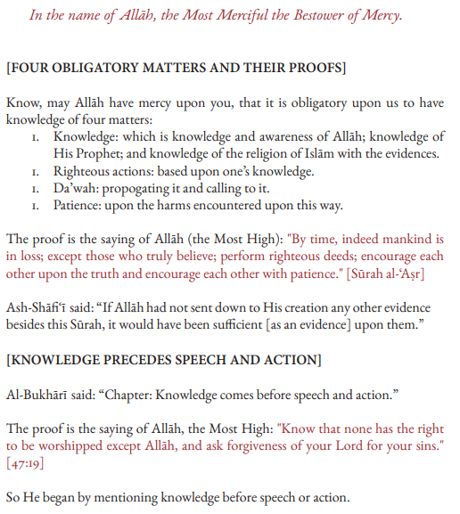
THREE FUNDAMENTAL PRINCIPLES

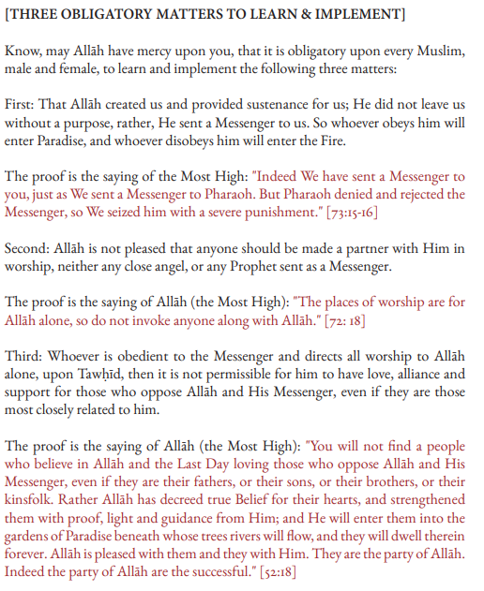
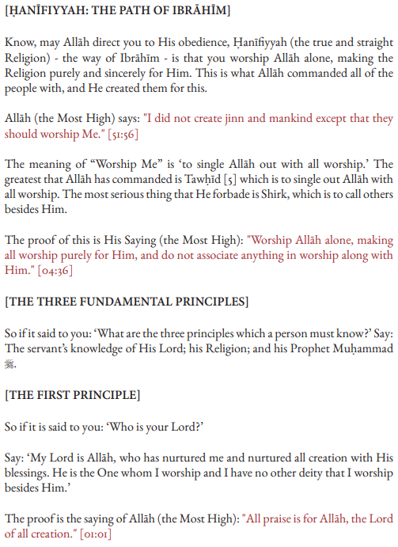
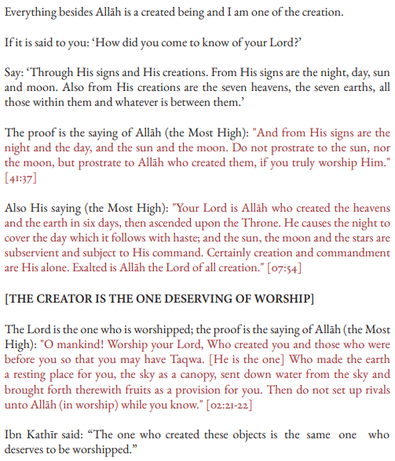
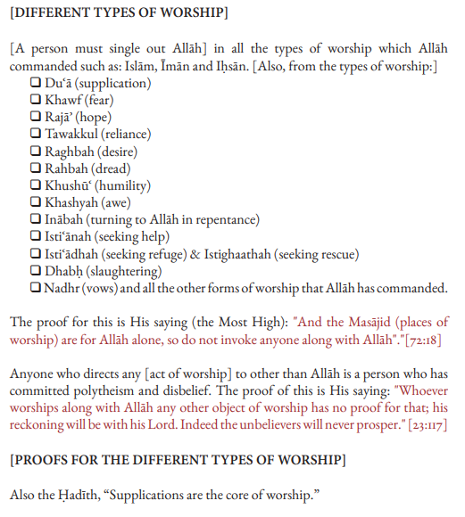
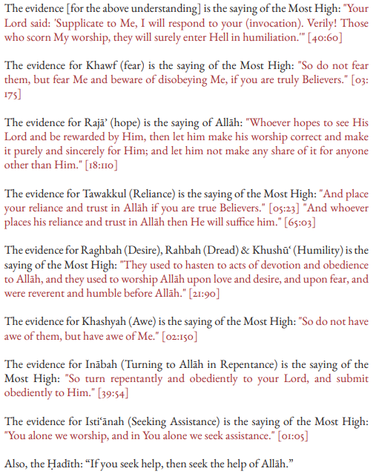
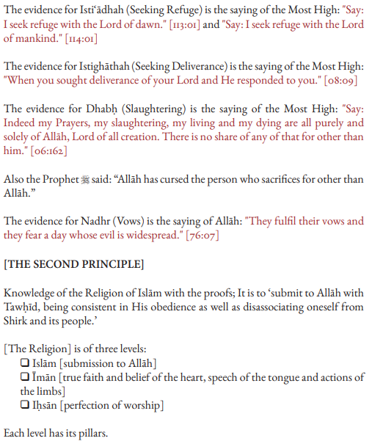
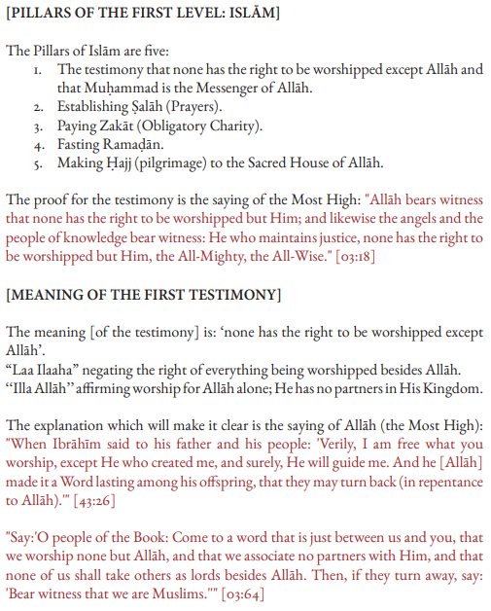
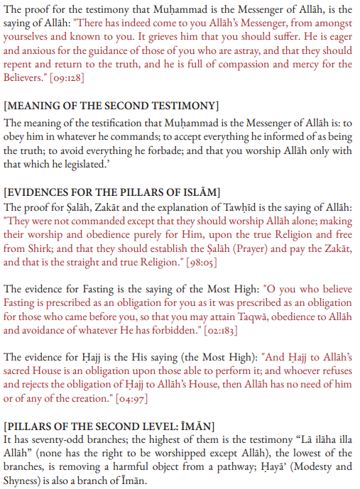
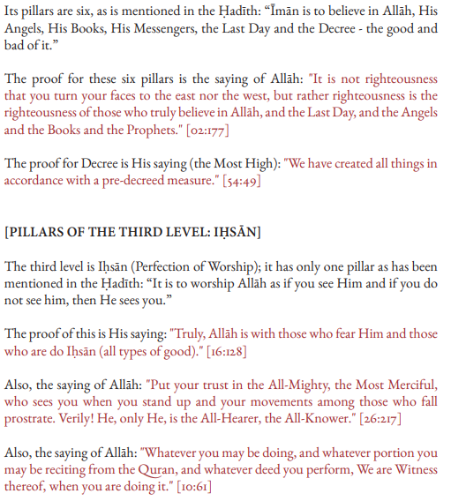
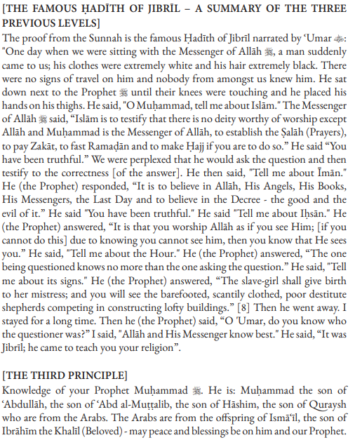
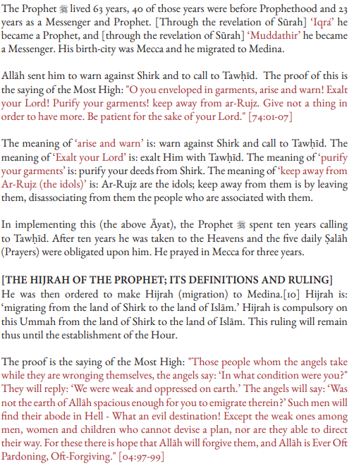
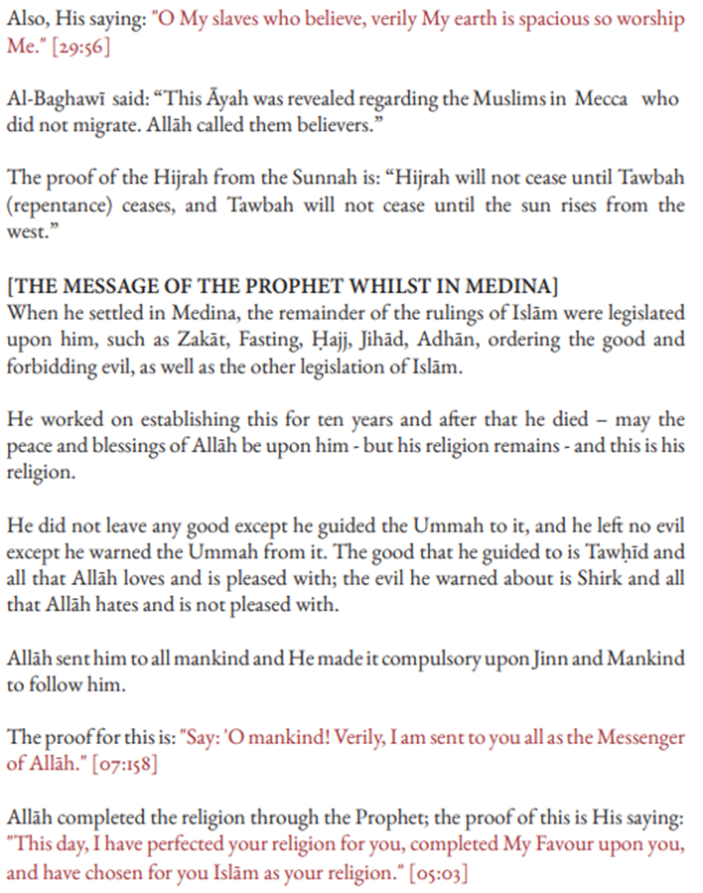
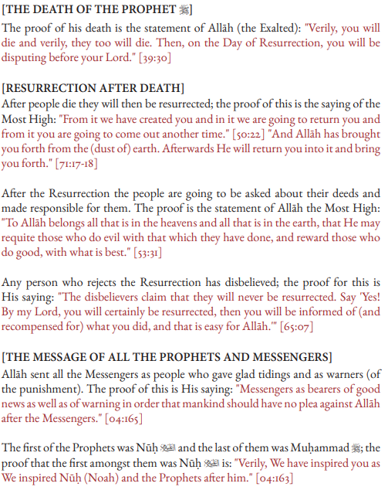
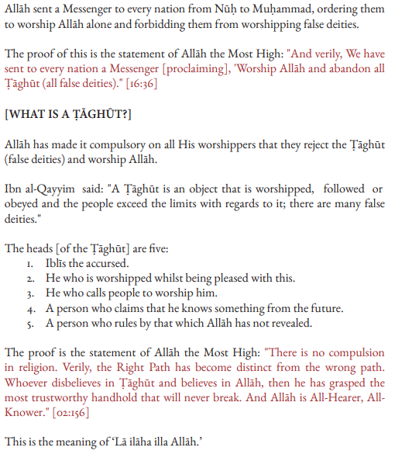
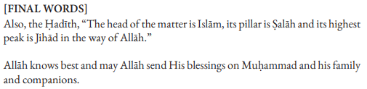

THE SIX FUNDAMENTAL PRINCIPLES
In the name of Allah, the Most Merciful the Bestower of Mercy.
From the most amazing affairs and the greatest signs that demonstrate the ability of al-Maalik (the Sovereign Owner) and al-Ghallaab (the Victorious), are six principles that Allah, the most High, has clearly explained for the common people. [He did this in a manner] above and beyond the thinking of those who doubt. Despite this, many of the clever people of this world and the intelligent ones from the children of Adam erred with regards to them — except a very little few.

The first principle:
A1-Ikhläs (sincerity) in actions, for the sake of Allah alone; He has no partners. Also an explanation of its opposite which is to commit acts of shirk with Allah. Most of the Qur’an - from various angles - is an explanation of this principle. [It has been explained so clearly] that even the most unintelligent of the common people can understand. Despite this, when the situation of most of the Ummah changed to what it is, Shaytän [deceived the people] by making sincerity appear to mean diminishing the status and rights of the righteous people and he made Shirk with Allah to appear to mean loving the righteous people and their followers.

The Second Principle:
The command of Allah to be united upon the religion and the prohibition of division and discord regarding it. Allah has explained this in a very clear manner that even the common people are able to understand. He forbade us from resembling the people who differed and became divided before us and so they were destroyed. He mentioned that He also ordered the Messengers with being united in the religion and forbade them from division and discord due to it. This matter is made clearer by what is found in the Sunnah. Then, from the most strange affairs is that differing in the core principles of the religion as well as its subsidiary branches [appeared as] knowledge and understanding of the religion. As for unity in religion, it became such that nobody spoke about it except a heretic or a mad person.
The Third Principle:
From the perfection and completion of unity is: hearing and obeying the one who has authority over us, even if he is an Abyssinian slave. Allah explained this in a very clear, manifest and sufficient manner, using various means both religious as well as universal. Despite this, this principle became unknown amongst the people who claim knowledge, so how could it be applied and practiced?!

The Fourth Principle:
A clarification of knowledge and the people of knowledge, and Fiqh and the people of Fiqh. Also, a clarification of those who resemble them but are not actually from them. Allah has explained this principle in the beginning of Sürah al-Baqarah; from His saying (meaning),
O Children of Isräil, remember My favor which I have bestowed upon you and fulfil My covenant [upon you] that I will fulfil your covenant [from Mel, and be afraid of [only] Me}
to His saying before the mention of Ibrähim ('alayhi as-saläm)
{O Children of Isräil, remember My favor that I have bestowed upon you and that I preferred you over the worlds} [02:40-47]
This principle is made even more manifest due to the emphatic statements of the Sunnah in which there are many clear statements for even the unintelligent common person.
Despite this, [this very same principle] became from the strangest affairs. Knowledge and Fiqh were seen to be innovations and misguidance, whilst the closest they have to it is mixing truth with falsehood.
Similarly, knowledge that Allah, the most High, has obligated upon creation and praised, is [seen to] only be followed by heretics or insane people and the one who forbids this [true] knowledge, shows animosity towards it and authors in warning against it—he is the scholar and Faqīh.

Fifth The Principle:
An explanation by Allah, may He be Glorified, regarding the Awliyä of Allah; and how He distinguished between them and between those who merely resemble them; in reality they are from the enemies of Allah, hypocrites and disobedient people.
The following verse in Sürah al- Imrän is sufficient for this (meaning):
{Say, [O Muhammad]: "If you truly love Allah, then follow me; [so] Allah will love you and forgive for you your sins." Allah is Forgiving and Merciful} [03:31]
Also the verse in Sürah al-Mäidah (meaning):
{O you who have believed, whoever of you should revert from his religion - Allah will bring forth [in place of them] a people He will love and who will love Him...} [05:54]
Also the verse in Sürah Yünus (meaning),
{Verily, for the Awliyä of Allah there will be no fear for them, nor will they grieve; those who believe and have Taqwa} [10:62]
This then changed with most of the people who claim to have knowledge; claiming they are the ones who guide creation and are the protectors of the Sharī'ah: that they consider the Awliyä to be those who abandon following the Sunnah and whosoever follows it is not from the Awliyä. Similarly, one has to abandon Jihäd, so whoever fights Jihäd is not from the Awliyä. Also, one has to abandon lmän and Taqwa, and whosoever maintains them is not from the Awliyä. O our Lord, we ask You for safety and pardoning, indeed You are the One who hears [and responds] to the supplications.

The Sixth Principle:
Refuting the doubt that Shaytän has placed to abandon the Qur’an and Sunnah, and instead to follow many differing opinions and desires. [The essence of the doubt is] that the Qur’an and Sunnah can only be known by an absolute Mujtahid. And the Mujtahid is the one who has certain qualities and characteristics - to the extent that these qualities would not be completely found even in Abu Bakr and Umar!
So, whoever does not possess these characteristics, he should completely avoid the Qur'än and Sunnah; this being an obligation without any reasoning or doubt; and whoever takes his guidance from the Qur’an and Sunnah is either a heretic or a mad person; this being due to the difficulty in understanding them both.

May Allah be glorified and by His praise, how much has Allah clarified this, both in the Shanah and universal law, and due to [law of] creation as well as His command. [How much as he] refuted this cursed doubt in so many different ways such that it has become from those matters which are known by necessity - yet most people are ignorant of this.
{Already the word has come into effect upon most of them, so they do not believe. Indeed, We have put shackles on their necks, and they are to their chins, so they are with heads [kept] aloft. And We have put before them a barrier and behind them a barrier and covered them, so they do not see. And it is all the same for them whether you warn them or do not warn them - they will not believe. You can only warn one who follows the message and fears the Most Merciful unseen. So, give him good tidings of forgiveness and noble reward} [36:07-11]

In the ending, all praise is due to Allah, the Lord of the Worlds. ay the many peace and blessings Allah be upon our Master Muhammad upon his family and companions until the Day Resurrection.

FORTY NAWAWI HADEETH
Hadeeth One: Actions are but by Intentions
On the authority of Ameer ul-Mu'mineen (the Commander of the Faithful), Aboo Hafs `Umar ibn al-Khattaab radiAllaahu anhu, who said: I heard the Messenger of Allaah sallAllaahu alayhi wa sallam say:
"Actions are but by intentions and every man shall have only that which he intended. Thus he whose migration (Hijrah to Madeenah from Makkah) was for Allaah and His Messenger, his migration was for Allaah and His Messenger, and he whose migration was to achieve some worldly benefit or to take some woman in marriage, his migration was for that for which he migrated."
It is related by the two Imaams of the scholars of Hadeeth, Aboo `Abdillaah Muhammad ibn Ismaa`eel ibn Ibraheem ibn al-Mugheera ibn Bardizbah al-Bukhaaree and Aboo-l-Husain Muslim ibn al-Hajjaaj ibn Muslim al-Qushairee an-Naisaabooree, in their two Saheehs, which are the soundest of compiled books [i.e. the most truthful books after the Book of Allaah].

Hadeeth Two: An Explanation of Islaam, Eemaan and Ihsaan
Also on the authority of `Umar (radi Allaahu 'anhu), who said:
One day while we were sitting with the Messenger of Allaah (sallAllaahu alayhi wa sallam) there appeared before us a man whose clothes were exceedingly white and whose hair was exceedingly black; no signs of journey were to be seen on him and none of us knew him. He walked up and sat down in front of the Prophet (sallAllaahu alayhi wa sallam), with his knees touching against the Prophet's (sallAllaahu alayhi wa sallam) and placing the palms of his hands on his thighs he said: “O Muhammad, tell me about Islaam.”
The Messenger of Allaah (sallAllaahu alayhi wa sallam) said:
“Islaam is to testify that there is no deity worthy of worship but Allaah and Muhammad is the Messenger of Allaah, to perform prayers, to give zakaah, to fast in Ramadaan, and to make the pilgrimage to the House if you are able to do so.”
He said: “You have spoken rightly”
We were amazed at him asking him and saying that he had spoken rightly
He (the man) said: “Tell me about Eemaan.”
He (the Prophet, sallAllaahu alayhi wa sallam) said: “It is to believe in Allaah, His Angels, His Books, His Messengers, and the Last Day, and to believe in divine destiny (qadar), both the good and the evil of it”.
He said: “You have spoken rightly.”
He (the man) said: “Then tell me about Ihsaan.”
He (the Prophet, sallAllaahu alayhi wa sallam) said: “It is to worship Allaah as though you see Him, and if you do not see Him, then (knowing that) truly He sees you.”
He said: “Then tell me about the Hour.”
He said: “The one questioned about it knows no better than the questioner.”
He said: “Then tell me about its signs.”
He said: “That the slave-girl will give birth to her mistress, and that you will see barefooted, naked destitute shepherds competing in constructing lofty buildings.”
He said: then he (the man) left, and I stayed for a time. Then he (the Prophet, sallAllaahu alayhi wa sallam) said:
“O `Umar, do you know who the questioner was?” I said: “Allaah and His Messenger know best.” He said: “It was Jibreel, who came to teach you your religion.”
It was related by Muslim.

Hadeeth Three: The Pillars of Islaam
On the authority of Aboo `Abd ir-Rahmaan `Abdullaah, the son of `Umar ibn al-Khattab radiAllaahu 'anhumaa, who said: I heard the Messenger of Allaah (sallAllaahu alayhi wa sallam) say:
“Islaam has been built on five [pillars]: testifying that there is no deity worthy of worship except Allaah and that Muhammad is the Messenger of Allaah, establishing the salaah (prayer), paying the zakaah (obligatory charity), making the Hajj (pilgrimage) to the House, and fasting in Ramadaan”.
Collected by al-Bukhaari and Muslim.

Hadeeth Four: Deeds are by their Final Actions
On the authority of Aboo `Abd ir-Rahmaan `Abdullaah ibn Mas`ood (radiAllaahu anhu), who said: The Messenger of Allaah (sallAllaahu alayhi wa sallam) and he is the Truthful and the Believed, narrated to us:
“Verily the creation of each one of you is brought together in his mother's womb for forty days in the form of a nutfah (a drop), then he becomes an 'alaqah (clot of blood) for a like period, then a mudghah (morsel of flesh) for a like period, then there is sent to him the angel who blows his soul into him and who is commanded with four matters: to write down his rizq (sustenance), his life span, his actions, and whether he will be happy or unhappy (i.e. whether or not he will enter Paradise).
By the One, other than Whom there is no deity, verily one of you performs the actions of the people of Paradise until there is but an arm’s length between him and it, and that which has been written overtakes him, and so he acts with the actions of the people of the Hellfire and thus enters it. And verily one of you performs the actions of the people of the Hellfire, until there is but an arm’s length between him and it, and that which has been written overtakes him and so he acts with the actions of the people of Paradise and thus he enters it”.
Collected by al-Bukhaari and Muslim.

Hadeeth Five: Rejection of Evil Deeds and Innovations
On the authority of the Mother of the Faithful, Umm `Abdillaah `Aaishah (radi Allaahu 'anhaa) , who said: The Messenger of Allaah (sallAllaau alayhi wa sallam) said:
“He who innovates something in this matter of ours [i.e. Islaam] that is not of it will have it rejected”.
Collected by al-Bukhaari and Muslim
In one version by Muslim it reads:
“He who does an act which we have not commanded, will have it rejected”.

Hadeeth Six: The Halaal is Clear and the Haraam is Clear
On the authority of Aboo `Abdillaah an-Nu`maan the son of Basheer (radiAllaahu 'anhumaa), who said: I heard the Messenger of Allaah (sallAllaahu alayhi wa sallam) say:
“That which is lawful is clear and that which is unlawful is clear, and between the two of them are doubtful matters about which many people do not know. Thus he who avoids doubtful matters clears himself in regard to his religion and his honour, but he who falls into doubtful matters [eventually] falls into that which is unlawful, like the shepherd who pastures around a sanctuary, all but grazing therein. Truly every king has a sanctuary, and truly Allaah's sanctuary is His prohibitions. Truly in the body there is a morsel of flesh, which, if it be whole, all the body is whole, and which, if it is diseased, all of [the body] is diseased. Truly, it is the heart”.
Collected by al-Bukhaari and Muslim.

Hadeeth Seven: The Religion is Naseehah (Sincere Advice)
On the authority of Abu Ruqayya Tameem ibn Aus ad-Daaree (radi Allaahu anhu) that the Prophet (sallAllaahu alayhi wa sallam) said:
“The Deen (religion) is naseehah (advice/sincerity)”
We said “To whom?”
He said: “To Allah and His Book, and His Messenger, and to the leaders of the Muslims and their common folk”.
Collected by Muslim.

Hadeeth Eight: Sanctity of a Muslim
On the authority of the son of 'Umar (radi Allaahu 'anhumaa) that the Messenger of Allaah (sallAllaahu alayhi wa sallam) said:
“I have been ordered to fight against the people until they testify that there is none worthy of Worship except Allaah and that Muhammad is the Messenger of Allaah, and until they establish the Salaah and pay the Zakaah. And if they do that then they will have gained protection from me for their lives and property, unless [they commit acts that are punishable] in Islaam, and their Reckoning will be with Allaah”.
Collected by Bukhaaree and Muslim.

Hadeeth Nine: Obligations are according to Ability
On the authority of Abu Hurairah 'Abd-ur-Rahmaan ibn Sakhr (radiAllaahu 'anhu) who said: I heard the Messenger of Allaah (sallAllaahu alayi wa sallam) say:
“What I have forbidden for you, avoid. What I have ordered you [to do], do as much of it as you can. For verily, it was only the excessive questioning and their disagreeing with their Prophets that destroyed [the nations] who were before you”.
Related by al-Bukhaaree and Muslim.

Hadeeth Ten: Restricting oneself to the Pleasant Halaal
On the authority of Abu Hurairah (radiAllaahu 'anhu) who said: The Messenger of Allaah (sallAllaahu alayhi wa sallam) said:
“Allaah the Almighty is Good and accepts only that which is good. And verily Allaah has commanded the Believers to do that which He has commanded the Messengers. So the Almighty has said:
"O (you) Messengers! Eat of the Tayyibaat [all kinds of Halaal (legal) foods], and perform righteous deeds." [23:51]
and the Almighty has said:
"O you who believe! Eat of the lawful things that We have provided you" [2:172]
Then he mentioned [the case] of a man who, having journeyed far, is dishevelled and dusty, and who spreads out his hands to the sky saying "O Lord! O Lord!", while his food is Haraam (unlawful), his drink is Haraam, his clothing is Haraam, and he has been nourished with Haraam, so how can [his supplication] be answered ?!”
Narrated by Muslim.

Hadeeth Eleven: Being Cautious of the Doubtful
On the authority of Abu Muhammad al-Hasan ibn 'Alee ibn Abee Taalib (radiAllaahu 'anhumaa), the grandson of the Messenger of Allaah (sallAllaahu alayhi wa sallam), and the one much loved by him, who said: I memorised from the Messenger of Allaah (sallAllaahu alayhi wa sallam):
“Leave that which makes you doubt for that which does not make you doubt.”
It was related by at-Tirmidhee and an-Nasaa'ee, with at-Tirmidhee saying that it was a good and sound hadith (Hasan Saheeh).

Hadeeth Twelve: Leaving that which does not concern a Muslim
On the authority of Abu Hurairah (radiAllaahu 'anhu) who said: the Messenger of Allaah (sallAllaahu alayhi wa sallam) said:
“Part of the perfection of one's Islaam is his leaving that which does not concern him.”
A Hasan (Good) Hadeeth which was related by at-Tirmidhee and others in this fashion.

Hadeeth Thirteen: Loves for his Brother that which he Loves for Himself
On the authority of Abu Hamzah Anas bin Maalik (radiAllaahu anhu) - the servant of the Messenger of Allaah (sallAllaahu alayhi wa sallam) - that the Prophet (sallAllaahu alayhi wa sallam) said :
“None of you [truly] believes until he loves for his brother that which he loves for himself.”
It was related by al-Bukhaaree and Muslim

Hadeeth Fourteen: The Prohibition of the Blood of a Muslim and the Reasons for Shedding it
On the authority of Ibn Mas'ood (radiAllaahu anhu) who said : The Messenger of Allaah (sallAllaahu 'alayhi wa sallam) said :
“It is not permissible to spill the blood of a Muslim except in three [instances] : the married person who commits adultery, a life for a life, and the one who forsakes his religion and separates from the community.”
It was related by al-Bukhaaree and Muslim.

Hadeeth Fifteen: Islaamic Manners
On the authority of Abu Hurairah (radiAllaahu anhu) that the Messenger of Allaah (sallAllaahu alayhi wa sallam) said:
“Let him who believes in Allaah and the Last Day speak good, or keep silent; and let him who believes in Allaah and the Last Day be generous to his neighbour; and let him who believes in Allaah and the Last Day be generous to his guest.”
It was related by al-Bukhaaree and Muslim.

Hadeeth Sixteen: The Forbiddance of Anger
On the authority of Abu Hurairah (radiAllaahu anhu)
That a man said to the Prophet (sal Allaahu alayhi wa sallam): “Counsel me", so he (sallAllaahu alayhi wa sallam) said: “Do not become angry.”
The man repeated [his request for counsel] several times, and he (sallAllaahu alayhi wa sallam) said: “Do not become angry.”
It was related by al-Bukhaaree and Muslim.

Hadeeth Seventeen: The Command to Slaughter and Kill in the Best Manner
On the authority of Abu Ya'laa Shaddaad bin Aws (radiAllaahu anhu), that the Messenger of Allaah sallAllaahu alayhi wa sallam said:
“Verily Allaah has prescribed Ihsaan (proficiency, perfection) in all things. So if you kill then kill well; and if you slaughter, then slaughter well. Let each one of you sharpen his blade and let him spare suffering to the animal he slaughters.”
It was related by Muslim.

Hadeeth Eighteen: Good Character
On the authority of Abu Dharr Jundub ibn Junaadah, and Abu 'Abd-ir-Rahmaan Mu'aadh bin Jabal (radiAllaahu anhumaa) that the Messenger of Allaah (sallAllaahu alayhi wa sallam) said:
“Have Taqwaa (Fear) of Allaah wherever you may be, and follow up a bad deed with a good deed which will wipe it out, and behave well towards the people.”
It was related by at-Tirmidhee, who said it was a Hasan (Good) Hadeeth, and in some copies it is stated to be a Hasan Saheeh Hadeeth.
Hadeeth Nineteen: Be mindful of Allaah and He will protect you.
On the authority of Abu 'Abbaas 'Abdillaah bin 'Abbaas (radiAllaahu anhumaa) who said: One day I was behind the Prophet (sallAllaahu alayhi wa sallam) [riding on the same mount] and he said:
“O young man, I shall teach you some words [of advice]: Be Mindful of Allaah and Allaah will protect you. Be Mindful of Allaah and you will find Him in front of you. If you ask, then ask Allaah [alone]; and if you seek help, then seek help from Allaah [alone]. And know that if the Nation were to gather together to benefit you with anything, they would not benefit you except with what Allaah had already prescribed for you. And if they were to gather together to harm you with anything, they would not harm you except with what Allaah had already prescribed against you. The Pens have been lifted and the Pages have dried.”
It was related by at-Tirmidhee, who said it was a Good and Sound Hadeeth. Another narration, other than that of Tirmidhee, reads:
“Be Mindful of Allaah, and you will find Him in front of you. Recognise and Acknowledge Allaah in times of ease and prosperity, and He will Remember you in times of adversity. And know that what has passed you by [and you have failed to attain] was not going to befall you, and what has befallen you was not going to pass you by. And know that Victory comes with Patience, Relief with Affliction, and Hardship with Ease.”

Hadeeth Twenty: Modesty is from Eemaan
On the authority of Abu Mas'ood 'Uqbah bin 'Amr al-Ansaaree al-Badree (radiAllaahu anhu) who said : The Messenger of Allaah (sallAllaahu alayhi wa sallam) said :
“Verily, from what was learnt by the people from the speech of the Earliest Prophecy is: If you feel no shame, then do as you wish.”
It was related by al-Bukhaaree.
Hadeeth Twenty One : Say 'I believe in Allaah' and then be Steadfast
On the authority of Aboo 'Amr - and he is also called Aboo 'Amrah - Sufyaan bin Abdillaah ath-Thaqafee (radiAllaahu anhu) who said:
I said: "O Messenger of Allaah, tell me something about al-Islaam which I can ask of no one but you."
He said: “Say: I believe in Allaah - and then be Steadfast”.
It was related by Muslim.

Hadeeth Twenty Two: Confinement to the Obligatory Deeds is Sufficient to be entered into Paradise
On the authority of Abu 'Abdillaah Jaabir bin 'Abdillaah al-Ansaaree (radiAllaahu anhumaa) that:
A man questioned the Messenger of Allaah (sallAllaahu alayhi wa sallam) and said : “Do you think that if I perform the obligatory Prayers, fast in Ramadaan, treat as lawful that which is Halaal, and treat as forbidden that which is Haraam, and do not increase upon that [in voluntary good deeds], then shall I enter Paradise ?”
He (sallAllaahu alayhi wa sallam) replied: “Yes”.
It was related by Muslim.
The meaning of “forbidden that which is Haraam” is: avoided it.

The meaning of “treat as lawful that which is Halaal” is: do it believing it to be Halaal.

Hadeeth Twenty Three: Hastening to do Good
On the authority of Abu Maalik al-Haarith bin al-Haarith al-Ash'aree (radiAllaahu anhu) who said: The Messenger of Allaah (sallAllaahu alayhi wa sallam) said :
“Purity is half of Eemaan (Faith). 'al-Hamdu lillaah' [Praise be to Allaah] fills the scales, and 'subhaanAllaah' [How far is Allaah from every imperfection] and 'al-Hamdu lillaah' fill that which is between heaven and earth. And the Salaah (Prayer) is a Light, and charity is a Proof, and Patience is Illumination, and the Qur'aan is a Proof either for you or against you. Every person starts his day as a vendor of his soul, either freeing it or causing its ruin.”
It was related by Muslim.

Hadeeth Twenty Four: The Forbiddence of Oppression
On the authority of Abu Dharr al-Ghifaaree (radiAllaahu anhu) from the Prophet (sallAllaahu alayhi wa sallam) from his Lord ('azza wa jall) that He said :
“O My servants ! I have forbidden dhulm (oppression) for Myself, and I have made it forbidden amongst you, so do not oppress one another. O My servants, all of you are astray except those whom I have guided, so seek guidance from Me and I shall guide you. O My servants, all of you are hungry except those whom I have fed, so seek food from Me and I shall feed you.
O My servants, all of you are naked except those whom I have clothed, so seek clothing from Me and I shall clothe you. O My servants, you commit sins by day and by night, and I forgive all sins, so seek forgiveness from Me and I shall forgive you.
O My servants, you will not attain harming Me so as to harm me, and you will not attain benefitting Me so as to benefit Me. O My servants, if the first of you and the last of you, and the humans of you and the jinn of you, were all as pious as the most pious heart of any individual amongst you, then this would not increase My Kingdom an iota.
O My servants, if the first of you and the last of you, and the humans of you and the jinn of you, were all as wicked as the most wicked heart of any indivdual amongst you, then this would not decrease My Kingdom an iota.
O My servants, if the first of you and the last of you, and the humans of you and the jinn of you, were all to stand together in one place and ask of Me, and I were to give everyone what he requested, then that would not decrease what I Possess, except what is decreased of the Ocean when a needle is dipped into it.
O My servants, it is but your deeds that I account for you, and then recompense you for. So he who finds good, let him praise Allaah, and he who finds other than that, let him blame no one but himself.”
It was related by Muslim.

Hadeeth Twenty Five: The Affluent have made off with the Rewards
Also on the authority of Abu Dharr (radiAllaahu anhu) that some people from amongst the Companions of the Messenger of Allaah (sallAllaahu alayhi wa sallam) said to the Prophet (sallAllaahu alayhi wa sallam) :
“O Messenger of Allaah, the affluent have made off with the rewards; they pray as we pray, they fast as we fast, and they give [much] in charity by virtue of their wealth.”
He (sallAllaahu alayhi wa sallam) said :
“Has not Allaah made things for you to give in charity ? Truly every tasbeehah [saying: subhaan Allaah] is a charity, and every takbeerah [saying: Allaahu akbar] is a charity, and every tahmeedah [saying: al-hamdu lillaah] is a charity, and every tahleelah [saying: laa ilaaha illaa Allaah] is a charity. And commanding the good is a charity, and forbidding an evil is a charity, and in the bud'i [sexual act] of each one of you there is a charity.”
They said : “O Messenger of Allaah, when one of us fulfils his carnal desire, will he have some reward for that ?!”
He (sallAllaahu alayhi wa sallam) said : “Do you not see that if he were to act upon it [his desire] in an unlawful manner then he would be deserving of punishment? Likewise, if he were to act upon it in a lawful manner then he will be deserving of a reward.”
It was related by Muslim.

Hadeeth Twenty Six: The Virtue of Reconciling between People, and Judging Justly between them, and Helping them
On the authority of Abu Hurairah (radiAllaahu anhu), who said: The Messenger of Allaah (sallAllaahu alayhi wa sallam) said:
“Every joint of a person must perfom a charity each day that the sun rises. To judge justly between two people is a charity. To help a man with his mount, lifting him onto it or hoisting up his belongings onto it, is a charity. And the good word is a charity. And every step that you take towards the Prayer is a charity. And removing a harmful object from the road is a charity.”
It was collected by al-Bukhaaree and Muslim.

Hadeeth Twenty Seven: Righteousness is in Good Character
On the authority of an-Nawwaas bin Sam'aan (radiAllaahu anhu) that the Prophet (sallAllaahu alayhi wa sallam) said:
“Righteousness is in good character, and wrongdoing is that which wavers in your soul, and which you dislike people finding out about.”
It was related by Muslim.
Also on the authority of Waabisah bin Ma'bad (radiAllaahu anhu) who said: I came to the Messenger of Allaah (sallAllaahu alayhi wa sallam) and he said : “You have come to ask about righteousness”.
I said : “Yes”.
He said : “Consult your heart. Righteousness is that about which the soul feels at ease and the heart feels tranquil. And wrongdoing is that which wavers in the soul and causes uneasiness in the breast, even though people have repeatedly given their legal opinion [in its favour].”
This is a Hassan (good) hadith collected by Imam Ahman ibn Hanbal and Daarimy with a sound chain of narrators.

Hadeeth Twenty Eight : The Obligation of Binding Oneself to the Sunnah
On the authority of Abu Najeeh al-'Irbaad ibn Saariyah (radiAllaahu anhu) who said :
The Messenger of Allaah (sallAllaahu alayhi wa sallam) gave us a sermon by which our hearts were filled with fear and tears came to our eyes. So we said: "O Messenger of Allaah ! It is as though this is a farewell sermon, so counsel us".
He said: “I counsel you to have taqwaa (fear) of Allaah, and to listen and obey [your leader], even if a slave were to become your Ameer. Verily he among you who lives long will see great controversy, so you must keep to my Sunnah and to the Sunnah of the Khulafaa' ar-Raashideen (the Rightly Guided Caliphs), those who guide to the right way. Cling to it stubbornly [literally: with your molar teeth]. Beware of newly invented matters [in the religion], for verily every bid'ah (innovation) is misguidance.”
It was related by Abu Dawood and at-Tirmidhee, who said that it was a good and sound Hadeeth.

Hadeeth Twenty Nine: That which Enters One into Paradise
On the authority of Mu'aadh bin Jabal (radiAllaahu anhu) who said:

I said: “O Messenger of Allaah, tell me of an act which will take me into Paradise and will keep me away from the Hell Fire”.
He said : “You have asked me about a great matter, yet it is easy for him for whom Allaah makes it easy : Worship Allaah, without associating any partners with Him; establish the Prayer; pay the Zakaah; fast in Ramadaan; and make the Pilgrimage to the House.”
Then he said : “Shall I not guide you towards the Means of Goodness ? Fasting is a shield; charity wipes away sin as water extinguishes fire; and the Praying of a man in the depths of the Night.”
Then he recited :
“[Those] who forsake their beds, to invoke their Lord in fear and hope, and they spend (charity in Allaah's Cause) out of what We have bestowed on them. No person knows what is kept hidden for them of joy as a reward for what they used to do.” [Soorah as-Sajdah, 16-17]
Then he said: “Shall I not inform you of the head of the matter, its pillar and its peak?”
I said : “Yes, O Messenger of Allaah.”
He said : “The head of the matter is Islaam, its pillar is the Prayer and its peak is jihaad.”
Then he said : “Shall I not tell you of the foundation of all of that ?”
I said : “Yes, O Mesenger of Allaah.”
So he took hold of his tongue and said : “Restrain this.”
I said : “O Prophet of Allaah, will we be taken to account for what we say with it?”
He said: “May your mother be bereaved of you, O Mu'aadh! Is there anything that throws people into the Hell Fire upon their faces - or : on their noses - except the harvests of their tongues?”
It was related by at-Tirmidhee, who said it was a good and sound hadeeth.

Hadeeth Thirty: The Rights of Allaah
On the authority of Abu Tha'labah al-Kushanee - Jurthoom bin Naashir (radiAllaahu anhu) - that the Messenger of Allaah (sallAllaahu alayhi wa sallam) said:
“Verily Allaah ta'aalaa has laid down Religious Obligations (faraa'id), so do not neglect them; and He has set limits/boundaries, so do not overstep them; and He has Forbidden some things, so do not violate them; and He has remained silent about some things, out of compassion for you, not forgetfulness - so do not seek after them.”
A Hasan hadeeth collected by ad-Daaraqutnee and others.

Hadeeth Thirty One: The Reality of Asceticism
On the authority of Abu al-'Abbaas Sahl bin Sa'ad as-Saa'idee (radiAllaahu anhu) who said:
A man came to the Prophet (sallAllaahu alayhi wa sallam) and said: “O Messenger of Allaah, direct me to an act which, if I do it, [will cause] Allaah to love me and the people to love me.”
So he (sallAllaahu alayhi wa sallam) said:
“Renounce the world and Allaah will love you, and renounce what the people possess and the people will love you.”
A Hasan hadeeth related by Ibn Maajah and others with good chains of authorities.

Hadeeth Thirty Two: No Harming nor Reciprocating Harm
On the authority of Abu Sa'eed Sa'ad bin Maalik bin Sinaan al-Khudree (radiAllaahu anhu) that the Messenger of Allaah (sallAllaahu alayhi wa sallam) said:
“There should be neither harming nor reciprocating harm.”
A Hasan hadeeth related by Ibn Maajah, ad-Daaraqutnee and others as a musnad hadeeth. It was also related by Maalik in al-Muwatta in mursal form from 'Amr bin Yahyaa, from his father from the Prophet (sallAllaahu alayhi wa sallam), but leaving Abu Sa'eed from the chain. And it has other chains of narrations that strengthen one another.

Hadeeth Thirty Three: The Onus of Proof is on the Claimant and The Taking of an Oath is on the Denier
On the authority of Ibn 'Abbaas, radiAllaahu anhumaa, that the Messenger of Allaah (sallAllaahu alayhi wa sallam) said:
“Were people to be given everything that they clamied, men would [unjustly] claim the wealth and lives of [other] people. But, the onus of proof is upon the claimant, and the taking of an oath is upon him who denies.”
A Hasan hadeeth collected by al-Baihaqee and others in this form, and part of it is in the two Saheehs.
Hadeeth Thirty Four: Forbidding the Evil is from Eemaan
On the authority of Abu Sa'eed al-Khudree (radiAllaahu anhu) who said: I heard the Messenger of Allaah (sallAllaahu alayhi wa sallam) say:
“Whosoever of you sees an evil, let him change it with his hand; and if he is not able to do so, then [let him change it] with his tongue; and if he is not able to do so, then with his heart - and that is the weakest of faith.”
It was related by Muslim.

Hadeeth Thirty Five: The Brotherhood of Islaam
On the authority of Abu Hurairah (radiAllaahu anhu) who said: The Messenger of Allaah (sallAllaahu alayhi wa sallam) said:
“Do not envy one another, and do not inflate prices for one another, and do not hate one another, and do not turn away from one another, and do not undercut one another in trade, but [rather] be Slaves of Allaah and Brothers [amongst yourselves].
A Muslim is the brother of a Muslim: he does not oppress him, nor does he fail him, nor does he lie to him, nor does he hold him in contempt. Taqwaa (Piety) is right here [and he pointed to his chest three times]. It is evil enough for a man to hold his brother Muslim in contempt. The whole of a Muslim is inviolable for another Muslim: his blood, his property, and his honour.”
It was related by Muslim.

Hadeeth Thirty Six: The Virtue of Gathering for the Recitation of The Qur'aan, and for the Remembrance of Allaah
On the authority of Abu Hurairah (radiAllaahu anhu) that the Prophet (sallAllaahu alayhi wa sallam) said :
“Whoever removes a worldly grief from a believer, Allaah will remove from him one of the griefs of the Day of Resurrection. And whoever alleviates the need of a needy person, Allaah will alleviate his needs in this world and the Hereafter.
Whoever shields [or hides the misdeeds of] a Muslim, Allaah will shield him in this world and the Hereafter. And Allaah will aid His Slave so long as he aids his brother. And whoever follows a path to seek knowledge therein, Allaah will make easy for him a path to Paradise.
No people gather together in one of the Houses of Allaah, reciting the Book of Allaah and studying it among themselves, except that Sakeenah (Tranquility) descends upon them, and Mercy envelops them, and the angels surround them, and Allaah mentions them amongst those who are with Him. And whoever is slowed down by his actions, will not be hastened forward by his lineage.”
It was related by Muslim in these words.

Hadeeth Thirty Seven: The Grace of Allaah and His Mercy
On the authority of Ibn 'Abbaas, radiAllaahu anhuma, from the Messenger of Allaah, sallAllaahu alayhi wa sallam, from what he has related from his Lord, tabaaraka wa ta'aalaa, that He said:
“Verily Allaah ta'aalaa has written down the Good deeds and the Evil deeds, and then explained it [by saying]: Whosoever intended to perform a Good deed, but did not do it, then Allaah writes it down with Himself as a complete Good deed. And if he intended to perform it and then did perform it, then Allaah writes it down with Himself as from ten Good deeds upto seven hundred times, upto many times multiplied. And if he intended to perform an Evil deed, but did not do it, then Allaah writes it down with Him as a complete Good deed. And if he intended it [ie. the evil deed] and then performed it, then Allaah writes it down as one Evil deed.”
It was related by al-Bukhaaree and Muslim in their two Saheehs in these words.
Imaam An-Nawawi then said:
So look [at this], my brother, and may Allaah grant us the ability to recognise the immense benevolence of Allaah ta'aalaa, and to contemplate these words. And His statement "with Himself" indicates His interest and concern for it. And His statement "a complete [Good deed]" is for emphasis and expressing the strength of His concern. And He said regarding the Evil deed that one intends to do but then leaves acting upon it: "Allaah writes it down with Him as a complete Good deed", so He emphasised it with completeness. And if he acts upon it: "then Allaah writes it down as one Evil deed", so He emphasised its smallness by mentioning it as a single deed, and He did not describe it with 'completeness'. So for Allaah is all Praise and Grace, subhaanahu, and we cannot enumerate His Praises. And from Allaah is the tawfeeq [guidance] for attaining His Pleasure.

Hadeeth Thirty Eight: The Worship of Allaah is the Means of Attaining Nearness to Him and His Love
On the authority of Abu Hurairah (radiAllaahu anhu) who said: The Messenger of Allaah (sallAllaahu alayhi wa sallam) said: Verily Allaah ta'aalaa has said:
“Whosoever shows enmity to a walee (friend) of Mine, then I have declared war against him. And My servant does not draw near to Me with anything more loved to Me than the religious duties I have obligated upon him. And My servant continues to draw near to me with nawaafil (supererogatory) deeds until I Love him. When I Love him, I am his hearing with which he hears, and his sight with which he sees, and his hand with which he strikes, and his foot with which he walks. Were he to ask [something] of Me, I would surely give it to him; and were he to seek refuge in Me, I would surely grant him refuge.”
It was related by al-Bukhaaree

Hadeeth Thirty Nine: Leniency for the One who Errs, the One who Forgets, and the One who is Forced
On the authority of Ibn 'Abbaas (radiAllaahu anhumaa) that the Messenger of Allaah (sallAllaahu alayhi wa sallam) said:
“Verily Allaah has pardoned [or been lenient with] for me my Ummah : their mistakes, their forgetfulness, and that which they have been forced to do under duress.”
A Hasan hadeeth collected by Ibn Maajah, and al-Bayhaqee and others.

Hadeeth Fourty: The World is the Means and the Sowing-Field for Attaining the Hereafter
On the authority of 'Abdullaah bin 'Umar radiAllaahu anhumaa, who said: The Messenger of Allaah (sallAllaahu alayhi wa sallam) took me by the shoulder and said:
“Be in this world as though you were a stranger or a wayfarer.”
Ibn 'Umar (radiAllaahu anhumaa) used to say:
“In the evening do not expect [to live until] the morning, and in the morning do not expect [to live until] the evening. Take [advantage of] your health before times of sickness, and [take advantage of] your life before your death.”
Collected by al-Bukhaaree.
Hadeeth Fourty One: The Sign of Faith
On the authority of Abu Muhammad 'Abdullaah bin 'Amr bin al-'Aas (radiAllaahu 'anhumaa) who said: The Messenger of Allaah (sallAllaahu alayhi wa sallam) said:
“None of you [truly] believes until his desires are subserviant to that which I have brought.”
[Imaam an-Nawawi says:] We have related it in Kitaab al-Hujjah with a Saheeh chain of narrators.

Hadeeth Fourty Two: The Expanse of the Forgiveness of Allaah
On the authority of Anas (radiAllaahu anhu) who said: I heard the Messenger of Allaah (sallAllaahu alayhi wa sallam) say, Allaah (the Almighty) has said:
“O Son of Aadam, as long as you invoke Me and ask of Me, I shall forgive you for what you have done, and I shall not mind.
O Son of Aadam, were your sins to reach the clouds of the sky and you then asked forgiveness from Me, I would forgive you.
O Son of Aadam, were you to come to Me with sins nearly as great as the Earth, and were you then to face Me, ascribing no partner to Me, I would bring you forgiveness nearly as great as it [too].”
Collected by at-Tirmidhee, who said that it was a Hasan hadeeth.

THE IMPORTANT LESSONS
Introduction
Ibn Baaz –may Allah have mercy on him- said: All praise and thanks are only for Allah, the Lord of everything that exists. The good end is for the obedient slaves of Allah. May Allah praise and send peace upon his slave and messenger, our prophet Muhammad, his family, and all of his companions. These words are about some of the obligations upon every Muslim regarding the religion and I have named it: "The Important Lessons for Every Muslim".

Lesson One
The Opening Chapter (Al Faatiha) and some short chapters The Opening Chapter, Al Faatiha, and some short chapters from Surah Az-Zalzalah to Surah An-Naas; reading it correctly to a Qur'an teacher, memorizing it, and knowing that which is obligatory to understand.

Lesson Two: The Pillars of Islam
The first and greatest pillar is the Testimony: "There is no deity that should be worshipped in truth except Allah and Muhammad is the messenger of Allah". Their meaning will be explained along with the conditions of "There is no god that should be worshiped in truth except Allah". Its meaning: "There is no god" is a negation of everything that is worshipped besides Allah. "Except Allah" affirms the worship for Allah alone. The conditions of "la ilaah illa Allah" are:
- Knowledge, negates ignorance.
- Certainty, negates doubt.
- Sincerity, negates Shirk.
- Truthfulness, negates lying.
- Love, negates hate.
- Submission, negates leaving it.
- Acceptance, negates rejection.
- Disbelieving in everything worshiped besides Allah.

Lesson Three: The Pillars of Eemaan
Its pillars are six: That you believe in Allah, His angels, His books, His Messengers, the Last Day, and that you believe in Al-Qadar (Divine Pre-Decree) – the good of it and the bad of it is from Allah.

Lesson Four: The Categories of Tawheed and Shirk
The categories of Tawheed are three: Lordship, Worship, and Names and Attributes.
Tawheed of Lordship: It is believing that surely Allah is the Creator of everything and the Manager of the affairs of His creations; He has no partners in any of that.
Tawheed of Worship: It is to believe that Allah is the only god that should be worshipped without any partners. This is the meaning of 'La ilaha ila Allah'. All of the acts of worship such as the prayer, fasting, and other than them. It is a must to perform them sincerely for Allah alone. It is not permissible to do any act of worship for other than Allah.
Tawheed of the Names and Attributes: It is to believe in everything which is mentioned in the Qur'an and the authentic statements of our Prophet regarding the names and attributes of Allah; to affirm them for Allah in a way that is befitting to Him the Most Perfect without distorting their meaning, denying them, describing them, or giving examples. Allah says “Say, "He is Allah, who is One [and Only]. Allah—the Sustainer needed by all. He neither begets, nor was He begotten, and there is none comparable to Him." (112:1-4). He also says "There is nothing like Him and He is the All Hearing the All Seeing” (42:11).
Some of the scholars have divided Tawheed in 2 categories; combining Tawheed of the Names and Attributes with Tawheed of Lordship. That is also correct.

The categories of worshiping other than Allah are likewise three: Major Shirk, Minor Shirk, and Hidden Shirk.
Major Shirk: It destroys one's good deeds and leads to the eternal punishment if one dies without repenting. Allah says: " Had they associated others with Him ˹in worship˺, their good deeds would have been wasted" (6:88). He also says: “It is not for the polytheists to maintain the mosques of Allah while they openly profess disbelief. Their deeds are void, and they will be in the Fire forever" (9:17). Whoever dies without repenting from it, will not be forgiven and Paradise is prohibited. Allah says: “Surely, Allah does not forgive associating others with Him ˹in worship˺, but forgives anything else of whoever He wills" (4:48). He also says: “Whoever associates others with Allah ˹in worship˺ will surely be forbidden Paradise by Allah. Their home will be the Fire. And the wrongdoers will have no helpers” (5:72).
From the examples: Supplicating to the dead and idols, seeking their help, making oaths to them, sacrificing for them, etc.
Minor Shirk: That which has been called Shirk in the Qur'an and Sunnah; however, it is not Major Shirk. Such as showing off with a part of acts of worship, swearing by other than Allah, saying "whatever Allah wills and so and so", etc.
The Prophet صلى الله عليه وسلم has said: "That which I fear the most for you is Minor Shirk". When he was asked about it, he said: "It is showing off with acts of worship". He has also said: "Whoever swears by other than Allah has committed Shirk". He has also said: "Do not say 'whatever Allah wills and so and so'. Rather, say: 'whatever Allah wills then so and so" (Abu Dawood, Authentic). A Muslim does no apostate due to this, nor is one punished eternally for it. Rather, it negates the completion of Tawheed.
The Hidden Shirk: The Prophet صلى الله عليه وسلم has said: "Should I not inform you of that which I fear for you more than the Dajjaal? They said: Of course O Messenger of Allah! He said: "Hidden Shirk; A person gets up to pray and beautifies the prayer when s/he sees others watching him".
It is correct to divide Shirk in 2 categories: Major and Minor. The Hidden Shirk could be present in both of them. It is present in the Major Shirk of the hypocrites since they hide disbelief and show off with Islam out of fear for themselves etc. It is also present in the Minor Shirk of the Muslims when they show off with a part of their worship as mentioned in the above Hadith. Allah is the granter of success.

Lesson Five: Ihsaan
The pillar of Ihsaan: It is to worship Allah as if you see Him, even though we do not see Him in this life, He sees us.

Lesson Six: Pre-Conditions of the Prayer
Prayer has nine conditions:
- Islam
- Sanity
- Tamyeez (Age of differentiating)
- Having Wudu
- Removing Najaasah/impurities
- Covering the Private Parts
- Entering of the time of prayer
- Facing the Ka'bah
- Intention

Lesson Seven: Pillars of the Prayer
The pillars of the prayer are forteen:
- Standing if able
- First Takbeer
- Reciting Al Faatihah
- Bowing
- Standing Straight after Bowing
- Prostrating upon 7 body parts
- Getting up from prostration
- Sitting between the two prostrations
- Tranqulity in all of the positions
- The order of the pillars
- The Final Tashahud
- The Sitting for the Final Tashahud
- Making Du'a for the Prophet ﷺ
- Giving Salam on both sides

Lesson Eight: Obligations of the Prayer
They are eight:
- All of the Takbeers except the first one (which is a pillar).
- Saying: "Allah answers those who praise him", (Sam’i Allahu Leman Hamdidah) for Imam and the one praying alone.
- Saying: "Our Lord to You belongs all praise", (Rabbana Wa Lakal Hamd), for Everyone.
- Saying: "My Lord the Greatest is Perfect" (Subhana Rabbee al-Adheem) while bowing.
- Saying: "My Lord the Highest is Perfect" (Subhana Rabbee al-A’ala) while prostrating.
- Saying: "O my Lord, forgive me" (Rabbi-iGhfir-lee) between the two prostrations.
- The first Tashahud.
- Sitting for the first Tashahud.

Lesson Nine: The Tashahud
Its meaning is: "All compliments, prayers, and pure words are due to Allah. Peace be upon you, O Prophet, and the mercy of Allah and His blessings. Peace be upon us and upon the righteous slaves of Allah. I bear witness that no god should be worshipped except Allah and I bear witness that Muhammad is His slave and Messenger". Then one makes du'a for the Prophet صلى الله عليه وسلم and says: " O Allah, send prayers upon Muhammad and upon the family of Muhammad, as You have sent prayers upon Ibraaheem and the family of Ibraaheem, You are surely Worthy of Praise, Full of Glory. O Allah, bless Muhammad and the family of Muhammad as You have blessed Ibraaheem and the family of Ibraaheem, You are surely Worthy of Praise, Full of Glory". Then one seeks refuge in the last Tashahud: "O Allah, I seek refuge in You from the torment of Hell, I seek refuge in You from the torment of the grave, I seek refuge in You from the trials of life and death, and I seek refuge in You from the tribulation of the Dajjal" (Bukhari and Muslim). Then one makes any du'a especially those which the Prophet has made such as "O Allah help me to remember You, thank You, and worship You in the best way. O Allah, I have greatly oppressed myself, no one can forgive sins except You, so forgive me with a forgiveness from Yourself and have mercy on me. You are surely the Most Forgiving and the Most Merciful". After the first Tashahud one may stand for the third unit of prayer or make du'a for the Prophet and then stand due to the general Hadith mentioned on the topic.

Lesson Ten: The Recommended acts of the Prayer
- The opening du’aa’
- Placing the right hand over the left on the chest while standing before and after bowing.
- Raising both hands with fingers slightly apart, level with the shoulders or the ears with the first Takbeer, bowing, raising from bowing, and when standing for the third unit.
- Saying the statements more than once while bowing and prostrating.
- Saying more than "Rrabana wa laka-lHamd" after raising from bowing and "Rrabee ghfir lee" between the two prostrations.
- Making the head straight with the back while bowing.
- Keeping the elbows away from the sides, and the belly from the thighs, and the thighs from the calves while prostrating.
- Raising the forearms away from the ground while prostrating.
- Sitting on the left foot while it is flat on the ground and setting up the right foot in the first Tashahud and between the two prostrations.
- Sitting on the ground in the last Tashahud in a four or three unit prayer and putting the left foot under the right leg and setting up the right foot.
- Pointing with the index finger in the first and second Tashahud from the time one sits until the end of the Tashahud, and moving it while making supplication.
- Supplicating and sending blessings upon our Prophet and his family as well as Ibrahim and his family in the first Tashahud.
- Supplicating at the end of the Last Tashahud.
- Reciting out loud in the Fajr prayer, Jum'ah, E'id, 'Asking for Rain', and the first two units of 'Ishaa and Maghrib.
- Reciting quietly in Thuhr, 'Asr, third unit of Maghrib, and the last two units of 'Ishaa.
- Reading ayah(s)/surah(s) after Al Faatihah. As well as all the other recommended actions narrated such as keeping the fingers spread on the knees while bowing.
Lesson Eleven: Nullifiers of the Prayer
They are eight:
- Intentional speaking while remembering and knowing: Forgetting or not knowing does not invalidate the prayer
- Laughing
- Eating
- Drinking
- Exposing the private parts
- Deviating a lot from the direction of the Qiblah
- Continuous unnecessary movements while praying
- Breaking Wudu

Lesson Twelve: Conditions of Ablution
They are ten:
- Islam.
- Sanity.
- Age of Differentiation.
- Intention.
- Continuous intention so one does not intend discontinuing it until one completes the ablution.
- The ceasing of the actions that nullify the ablution.
- Cleaning the private parts after using the washroom with water or clean dry objects.
- The water must be clean and permissible to use.
- Removing from the skin anything which may prevent the water from reaching it.
- The prayer time has entered; for the one who nullifies the ablution continuously.

Lesson Thirteen: Obligatory Acts of Ablution
They are six:
- Washing the face, rinsing the mouth, cleaning the nose
- Washing the arms from the finger tips to and including the elbows.
- Wiping the entire head and the ears.
- Washing the feet including the ankles.
- Washing the parts in order.
- Continuity.
It is recommended to wash the face, arms, feet, mouth, and nose three times. The obligation is one time. As for wiping the head then it is to be done only once as the authentic Hadith show.

Lesson Fourteen: Nullifiers of Ablution
They are six:
- Whatever exits from the two private parts.
- The exiting impure substances from other parts of the body.
- Losing consciousness due to sleep or other than it.
- Touching the private parts, front or back, without a barrier.
- Eating camel's meat.
- Leaving Islam.
Important Point:
As for washing a dead body: The correct opinion is that it does not nullify the ablution. This is the opinion of most of the scholars due to the lack of evidence to prove that. However, if the hand of the one who is washing the dead body accidentally touches the private part of the dead person without a barrier, it is a must to make ablution. Likewise, it is a must not to touch the private parts of the dead person except behind a barrier.
Moreover, touching a woman does not nullify the ablution whether it is with desire or without desire according to the correct opinion; as long as nothing comes out of his private part. This is since the Prophet صلى الله عليه وسلم kissed some of his wives and prayed without making ablution. As for the saying of Allah: "or you have touched women" it means: had relations with them according to the correct opinion which is also the opinion of Ibn Abas –may Allah be pleased with him- and other early and later scholars.

Lesson Fifteen: Adorning Oneself with Islamic Qualities
Such as truthfulness, honesty, abstinence, modesty, courage, generosity, loyalty, staying away from everything prohibited by Allah, being a good neighbour, helping those in need as much as possible, and other manners legislated by the Qur'an and Sunnah.

Lesson Sixteen: Practicing Islamic Etiquettes
Giving Salaam, being cheerful, eating and drinking with the right hand, saying "bismi-lah / I begin by seeking help and blessings with the names of Allah" before eating and drinking, saying "alhamdu lilah / all praise and thanks are for Allah" after eating or drinking, saying "alhamdu lilah" when sneezing, saying "yarhamuk Allah / May Allah have mercy on you", when we hear a person sneeze and says "alhamdu lilah", visiting the sick, praying the funeral prayer and following the funeral. Likewise, practicing the Islamic etiquettes when entering and exiting the Masjid and the house, when traveling, with the parents, relatives, neighbors, with elders, youth, congratulating for a newborn, asking blessing for a married couple, offering condolences, and other Islamic etiquettes such as when wearing clothes, taking them off, etc.

Lesson Seventeen: Warning from Shirk and other Sins
The seven Destructive Sins: Shirk or Worshipping others beside Allah, magic, killing an innocent soul which Allah has prohibited to kill except with an Islamic excuse, interest, wrongfully consuming the wealth of the orphan, running away from the battlefield, accusing chaste believing women. Likewise; disobeying the parents, breaking the family ties, bearing false witness, taking false oaths, harming the neighbor, spilling people's blood, taking their wealth, violating their honor, taking intoxicants, gambling, backbiting, tale-carrying, and other major sins prohibited by Allah and His Messenger.

Lesson Eighteen: Preparing The Dead Body, Praying, And Burial
- It is recommended for those present to remind the person dying to say "La ilaha ilaa Allah"; due to the saying of the Prophet صلى الله عليه وسلم:" Instruct those dying to say La ilaha ilaa Allah". The meaning of the Hadith is to remind those upon whom the signs of death are apparent.
- Once death is confirmed, the eyes should be closed and the beard tightened, as indicated in the Sunnah.
- It is obligatory to wash the dead Muslim body, except the martyr who died in the battlefield; such as are not washed nor are they prayed upon, rather they are buried with their clothes on since the Prophet صلى الله عليه وسلم did not wash the martyrs of Uhud nor did he pray on them.
- Description of washing the dead body: The private parts are covered. Then s/he is slightly raised, and the stomach squeezed gently. The one washing the body wraps a cloth to his own hand and washes the body with it. Then he makes wudoo for the dead person similar to the wudu of the prayer. Then his head and beard is washed with water and sidr or something similar to it. Then he washes his right side and then the left side three times; every time he passes his hand by his stomach. If anything comes out, he washes it. Then one blocks the passage with a piece of cotton or something similar. If it does not stop excrement from coming out, then with earth mixed with water or the contemporary clinical materials used such as plasters etc. Then he repeats his Wudu. If washing the body parts three times is not sufficient, he can wash them five or seven times each. Then the body is dried with a cloth. Scent is applied to the armpits, the bottom part of the thighs, and the parts one prostrates on. It is better if scent is applied to the entire body. Incense should also be applied to the shrouds. If the mustache and the nails are long, they could be shortened or left alone. The hair should not be let loose, around the private parts should not be shaved, nor should one be circumcised due to the lack of evidence to support that. The women's hair should be braided into three parts and should hang down behind her.
- Shrouding the dead person: The best is to shroud the man in three pieces of white cloth; no shirt nor head turban, as the Prophet صلى الله عليه وسلم was clothed. He should be wrapped on it gradually. It is fine if one is buried on a shirt, pants, and a sheet. The women should be shrouded in five pieces of cloth; a long shirt, head cover, a waist wrapper, and two pieces of cloth that are wrapped around her. A small boy is shrouded in one to three piece of cloth and a small girl is shrouded in one long shirt and two pieces of cloth. The obligation for everyone is one piece of cloth that covers the entire body. However, if the deceased is in the state of Ihram, then he should be washed with water and sidr. He should be shrouded with the two pieces of cloth he has on or other than his. His head and face should not be covered, nor should scent be applied to him, since they will surely be resurrected on the Day of Judgment saying the Talbiyah; this has been narrated authentically from the Prophet صلى الله عليه وسلم. If the one in the state of Ihram is a woman is shrouded like others; however, scent should not be applied to her, her face should not be covered with the face veil, nor her hands with gloves. However, her face and hands should be covered with the shroud she is wrapped with as is described previously how to prepare the deceased women.
- The most deserving of washing it, leading the prayer, and burying it: The one the deceased has appointed in the will, then the father, then the grandfather, then his closest relatives. This is regarding a man. The most deserving of washing the woman: The one she has appointed in her will, then the mother, the grandmother, then the closest female relatives. The spouses may wash one another; since the wife of Abu Bakr had washed him and Faatimah was washed by Ali –may Allah be pleased with them.
- How to pray on the deceased person? Say "Allahu Akbar" and read Surah Al Faatihah. If one reads another Surah, verse, or two verses then that is acceptable due to the authentic Hadith narrated by Ibn Abbaas. Say "Allahu Akbar" the second time and supplicate for the Prophet صلى الله عليه وسلم similar to the supplication on Tashahud. Then say "Allahu Akbar" and say: “O Allah forgive our living and our dead, those present and those absent, our males and our females. O Allah, whoever you allow to live from us, keep them alive as Muslims, and whoever You cause to die, allow them to die upon Emaan. O Allah, forgive him, have mercy on him, excuse him, pardon him, make his reception honorable, and expand his entry. Cleanse him with water, snow, and ice. Purify him of sin as a white robe is purified of filth. Exchange his home for a better home, his family for a better family, his spouse for a better spouse, admit him into the Garden, protect him from the punishment of the grave and the torment of the Fire. Make his grave spacious and bright. O Allah do not prevent us from his reward and do not misguide us after him". Then one says "Allahu Akbar" for the fourth time and gives one salaam to the right side. It is recommended to raise the hands every time one says "Allahu Akbar". If the deceased is a female, the pronoun in the supplication is changed to a feminine pronoun "O Allah forgive her…". If it is two, the dual form is used. If many, the plural form is used. If it is a child, instead of asking for forgiveness, we say "O Allah, make him a forerunner and a treasure for his parents and an accepted intercessor. O Allah, make their scales of good deeds heavy through him and magnify their reward. Make him join the righteous of the believers. Place him under the care of Ibrahim –may Allah praise and send him peace- and save him by Your mercy from the torment of Hell". It is from the Sunnah for the Imam to stand by the head of the body if it is a man, and in the middle if it is a woman. If there is more than one deceased person, the Imam should stand right behind the man and the woman should be closer to the Qiblah. If there is also children with the both of them, the boy should be before the woman and the girl after her. The head of the boy should be straight with the man's head, the girls head should be at the same level as the woman's head, and the woman's waist should be by the man's head. The people praying should all be behind the Imam; unless one person cannot find a place behind the Imam, then he can stand on his right side.
- How to bury the deceased? The Sunnah is to dig the grave until the waist of the man, to have another opening inside the grave on the direction of the Qiblah, to put the deceased in this opening on the right side, and to untie the knots and leave them there. The face should not be exposed whether it is a male or a female. Then bricks should be put behind him to protect the body from the earth. If bricks cannot be found, anything else which will prevent the earth hitting the body directly such as stones, plates, or wood. It is recommended to say "Bismi-lah,wa 'alaa milati rrasuli-lah / In the Name of Allah and according to the way of the Messenger of Allah". The earth above the grave should be one hand span, small pebbles should be put on top of it, and it should be watered if possible. It is also recommended for those following the funeral to stand at the grave and supplicate for the dead person since the Prophet صلى الله عليه وسلم used to stand at the grave after burying the deceased and say: "Ask forgiveness for your brother and ask for him to remain firm, since now he will be questioned".
- It is also allowed for the one who did not pray on it to pray on it after burying it since the Prophet صلى الله عليه وسلم did that. That is if the period between the burial and the prayer is less than a month; otherwise, it is not allowed. The Prophet صلى الله عليه وسلم did not pray for anyone after a month had passed by.
- It is not allowed for the family of the deceased to make food for the people due to the saying of the noble companion Jareer ibn Abdilah Al Bajalee: "We would consider gathering at the deceased's family and making food after the burial from the prohibited mourning". As for making food for them or for their guests, then that is allowed. It is allowed for the relatives and the neighbors to make food for them since when the Prophet صلى الله عليه وسلم heard about the death of Ja'far ibn Abee Taalib in Shaam, ordered his family to make food for the family of Ja'far and said: "It has come to them that which will keep them busy". It is acceptable for the family of the deceased to invite their neighbors or other than them to eat from the food that has been gifted to them. There is no specific time specified in the Islamic sources.
- It is not allowed for the woman to mourn the deceased more than three days except for her husband; it is a must upon her to mourn him four months and ten days. However, if she is pregnant, then until she gives birth due to this being established authentically from the Sunnah of the Prophet صلى الله عليه وسلم. The man is not allowed to mourn any of his relatives or other than them.
- It is recommended for the men to visit the graveyard once in a while to supplicate for them, ask mercy for them, and to remember death and what comes after it due to the saying of the Prophet صلى الله عليه وسلم:" Visit the graveyard as it will remind you the next life". He used to teach his noble companions to say when visiting the graves: "Peace be upon you O inhabitants of the graves from the Believers and the Muslims. We will surely join you. We ask Allah to excuse us and you. May Allah have mercy upon the first to come here and the later ones". It is not befitting for the women to visit the graves since the Prophet صلى الله عليه وسلم "cursed the women that frequently visit the graves". Moreover, it is feared that visiting the graves will be difficult upon them to remain patient. Likewise, it is not allowed for them to follow the funeral to the graveyard, since the Prophet صلى الله عليه وسلم ordered them not to do that. As for the prayer in the Masjid or the prayer place, then it is Islamically correct for both men and women.
This is the end; May Allah praise and send peace to our Prophet Muhammad, his family, and companions.

SUMMARY OF [THE TEN] RIGHTS CALLED FOR BY FITRAH (INSTINCT/NATURAL DISPOSITION)
The Rights of Allah the Most High:
To worship Him Alone without any partners, and that you be a humble, submissive worshipper to Him, obeying His commands, avoiding His prohibitions, and believing in what He informed us about. It is a perfect Aqeedah (Islamic creed), belief in the truth, and righteous fruitful deeds. It's an Aqeedah based on love and glorification; its fruit is sincerity and perseverance.

The Rights of the Messenger of Allah ﷺ:
The right of the Messenger of Allah is to be honored, respected, and glorified appropriately without exaggeration nor deficiency. Also believing him in what he has informed us about past and future events, doing what he commanded us to do, avoiding what he prohibited, believing that his guidance is the perfect guidance, and defending his Sharee'ah (Islamic legislation) and guidance.

The Rights of the Parents:
Be righteous to them by treating them with goodness in word and deed, with money and the body, and obeying their commands in that which is not disobedience to Allah and doesn't cause any harm to you.

The Rights of Children:
- Upbringing: it is the development of religion and morals in their hearts to a high standard.
- To spend on them in a reasonable manner, without extravagance nor negligence.
- Not to give preference to any of them over the other in spending and gifts.

The Rights of Relatives:
To kindly uphold kinship ties by using social position, physical efforts to benefit them, and financially depending on how close and needy they are.
The Rights of Spouses:
To live with each other in a kind manner and give the right that is due to him with tolerance and ease without any compulsion or procrastination in fulfilling each rights. Among the rights of the wife over her husband: that he fulfils the duty of spending on her in terms of food, drink, clothing, housing and so on, and that he treats all his wives equally. Among the husband's rights over his wife: that she obeys him in that which is not disobedience of Allah, protects his secrets and wealth, and does not do something that would spoil his complete enjoyment.

The Rights of Rulers and Subjects:
The rights of the subjects on the rulers: to carry out the trust that Allah has given them and obligated upon them, such as advising their subjects and taking them on the right path that guarantees their benefit in this world and the hereafter, and that is by following the path of the believers. "Ihe rights of rulers over the subjects are: advising them in what a person is responsible for in their affairs, reminding them if they become negligent, making Du'aa for them if they deviate from the truth, obeying their commands in that which is not disobedience to Allah, and helping them.

The Rights of the Neighbors:
A neighbor is someone who lives close to you. You should be good to him with what you can using money, social position, and help. You should also refrain from any verbal or physical harm.
- If he is a relative and a Muslim, he has three rights: the right of the neighbor, the right of kinship, and the right of Islam.
- If he is a Muslim but not a relative, he has two rights: the right of the neighbor and the right of Islam.
- Likewise, if he is a relative and is not a Muslim, he has two rights: the right of the neighbor and the right of kinship.
- If he is not related and is a non-Muslim, he has only one right: the right of the neighbor.

The Rights of Muslims in General:
From them is: giving Salam; if he invites you, accept the invitation; if he asks you for advice, advise him; if he sneezes and says 'Alhamdulillah', say 'Yarhamukallah'; if he is sick, visit him; if he dies, follow his funeral; avoid causing him any harm. The rights of a Muslim over a Muslim are many, and they can be summarized in meaning by the Prophet's saying: "A Muslim is a brother to a Muslim." Fulfilling the requirements of this brotherhood will make a person strive to seek all goodness for his Muslim brother and avoid anything that harms him.

The Rights of non-Muslims:
A Muslim ruler must rule over them with the law of Islam in their lives, wealth, and honor, set limits on them according to what is Haram (forbidden), and he must protect them and not harm them. The disbelievers must be distinguished from Muslims in dress code. Also, they must not show (i.e., publicly) anything objectionable in Islam or any of the rituals of their religion, like the bell or the cross.

AL-‘AQĪDAH AL-WĀSIṬĪYAH

In the name of Allah, Entirely Merciful, the Especially Merciful.
All praise is due to Allah, who sent His messenger with guidance and the religion of truth, to make it manifest over all religions. Sufficient is Allah as a witness.
I bear witness there is no God worthy of worship in truth but Allah alone, without any partners, establishing by it His oneness.
And I bear witness that Muhammad is His servant and His messenger, peace and blessings of Allah be upon him, his family, and his companions with abundant peace.
To proceed: This is the creed of the saved and victorious group until the establishment of the Hour, Ahl al-Sunnah wal Jamā’ah (the people and united community of the Prophetic Tradition).

The foundations of faith and its six pillars
It is to have faith in Allah, His angels, His books, His messengers, the Resurrection after death, and faith in the good and evil of providence.

Fundamental principles of faith in the names of Allah and His attributes
Part of faith in Allah is to have faith in the way He described Himself in His honorable book and in the way described by His messenger Muhammad, peace and blessings be upon him, without distortion and negation, and without asking ‘how’ or likening Him to something else.
Rather, they believe that for Allah ‘there is nothing like Him, and He is the Hearing, the Seeing.’ (42:11)
They do not nullify what He was described with, nor do they distort the words from their proper places. They do not blaspheme against the names of Allah and His verses, nor do they ascribe a modality to Him, nor do they compare His attributes to those of His creation.
For He, glory be to Him, has no likeness, no comparison, and no partner.
Nor is He measureable in analogy with His creation, glory be to Him, the Exalted.
Indeed, He knows Himself best, as well as everything else. He is the most truthful in speech, the best in address to His creation. Thus, His messengers are truthful and affirm the truth, differing from those who speak of what they do not know.
For this reason, He said, ‘Glory be to your Lord, Lord of honor, over what they ascribe, and peace be upon the messengers, and all praise is due to Allah, the Lord of the worlds,’ (37:180-182). He glorified Himself above what was described by those who opposed the messengers. He sent peace upon the messengers, as they described Allah free of any of the defects or faults that they claimed for Him.
He, glory be to Him, combined what He described and named for Himself between negation and affirmation.
Hence, Ahl al-Sunnah wal Jamā’ah do not deviate from what the messengers brought. Indeed, it is the straight path, the path of those whom Allah has favored among the prophets, the truthful, the martyrs, and the righteous.

Faith in what Allah described for Himself in His Book
Included in the entirety of this is what Allah described for Himself in Sūrat al-Ikhlāṣ, which is equal to a third of the Quran, wherein He says, ‘Say: He is Allah, the One. Allah, the Eternal Refuge. He does not give birth, nor was He born. And there is no comparison with Him.’ (112:1-4)
And what He described Himself with in the greatest verse in His book, wherein He says, ‘Allah, there is no God worthy of worship in truth but Him, the Living, the Sustainer. Neither drowsiness overtakes Him, nor sleep. To Him belongs whatever is in the heavens and whatever is on the earth. Who can intercede with Him except with His permission? He knows what is before them and what will be after them, and they encompass not a thing of His knowledge except for what He wills. His footstool extends over the heavens and the earth, and their preservation tires Him not, for He is the Exalted, the Almighty.’ (2:255)
For this reason, whoever had read this verse in the night, Allah will not cease to guard him and Satan will not approach him until morning.

Attribute of life
And His saying, glory be to Him, ‘Rely upon the Living, He who never dies.’ (25:58)

Attribute of knowledge
And His saying, glory be to Him, ‘He is the First and the Last, the Manifest and the Hidden, and He has knowledge over all things.’ (57:3)
‘He is the Knowing, the Wise.’ (66:2)
‘He is the Wise, the Aware. He knows what enters the earth and what comes out from it and what descends from the heavens and what ascends therein.’ (34:1-2)
‘With Him are the keys of the Unseen, none knows them but Him. He knows what is on land and in the sea. No leaf falls but that He knows it. No grain is there within the darknesses of the earth, nor any moist or dry thing but that it is in a clear record.’ (6:59)
‘No female carries a child or gives birth but that He knows it,’ (41:47).
‘That you would know Allah has power over all things and that Allah encompasses all things in Knowledge.’ (65:12)

Attribute of might
And His saying, ‘Verily, Allah is the Provider, possessor of strength and might.’ (51:58)

Attributes of hearing and seeing
And His saying, ‘There is nothing like him, and He is the Hearing, the Seeing.’ (42:11)
‘Verily, excellent is that with which Allah admonishes you. Verily, Allah is ever hearing and seeing.’ (4:58)

Attribute of will
‘Were it not that you entered your garden and said: As Allah has willed, there is no power but with Allah.’ (18:39)
‘If Allah had willed, they would not have fought each other, but Allah does what He wills.’ (2:253)
‘Lawful for you are the animals of grazing livestock, except for that which is recited to you, hunting not being permitted while you are in the state of pilgrimage. Verily, Allah judges as He wills.’ (5:1)
‘Whoever Allah intends to guide, He opens his heart to Islam. Whoever Allah intends to misguide, He makes his heart constricted as if he were ascending into the sky.’ (6:125)

Attribute of love
And His saying, ‘Do good, for Allah loves those who do good.’ (2:195)
‘Be fair, for Allah loves those who are fair.’ (49:9)
‘As long as they are upright to you, be upright to them. Verily, Allah loves the righteous.’ (9:7)
‏‘Verily, Allah loves those who repent and He loves those who purify themselves.’ (2:222)
‘Say: If you love Allah, follow me and Allah will love you.’ (3:31)
‘Allah will soon bring forth a people whom He loves and they love Him.’ (5:54)
‘Verily, Allah loves those who fight in His path in ranks, as if they were a firm structure.’ (61:4)
‘He is the Forgiving, the Loving.’ (85:14)

Attribute of mercy
And His saying, ‘In the name of Allah, the Entirely Merciful, the Especially Merciful.’ (1:1)
‘Our Lord, You have encompassed all things in mercy and knowledge.’ (40:7)
‘He is ever merciful to the believers.’ (35:43)
‘My mercy surrounds all things.’ (7:156)
‘Your Lord has prescribed mercy for Himself.’
‘He is the Forgiving, the Merciful.’ (10:107)
‘Thus, Allah is the best of guardians and He is the most merciful of those who show mercy.’ (12:64)

Attribute of pleasure
And His saying, ‘Allah is pleased with them and they are pleased with Him.’ (5:119)

Attributes of anger, displeasure, disapproval, and hatred
And His saying, ‘Whoever deliberately kills a believer, then his recompense is Hell to abide therein, and Allah is angry with him and has cursed him.’ (4:93)
‘That is because they followed what displeased Allah and they hated His pleasure.’ (47:28)
‘So when they angered Us, We took retribution from them.’ (43:55)
‘Rather, Allah disliked them being sent, so He held them back.’ (9:46)
‘Greatly detested in the sight of Allah is that you say what you do not do.’ (61:3)

Attribute of coming
And His saying, ‘Are they waiting for Allah to come to them in the shade of the clouds, or the angels, and the matter would be settled?’ (2:210)
‘Are they waiting for the angels to come, or for your Lord to come, or for some of the signs of your Lord?’ (6:158)
‘Nay, when the earth has been pounded with a great pounding and your Lord and the angels come row upon row.’ (89:21-22)
‘And the Day the heavens will break open with clouds and the angels descend, one after another.’ (25:25)

Attribute of the face of Allah, glory be to Him
And His saying, ‘The face of your Lord will remain, possessor of majesty and honor.’ (55:27)
‘All will perish except His face.’ (28:88)

Affirming the hands of Allah the Exalted
And His saying, ‘What stopped you from prostrating to what I created with My own hands?’ (38:75)
‘The Jews say the hand of Allah is tied. It is their hands which are tied and they are cursed for what they have said. Rather, His hands are outspread, spending as He wills.’ (5:64)

Affirming the eyes of Allah the Exalted
And His saying, ‘Be patient with the judgment of your Lord, for you are under Our eyes.’ (52:48)
‘We carried him on planks and nails, sailing under Our eyes as a recompense for him who was denied.’ (54:13-14)
‘I bestowed upon you love from Me that you would be brought up under My eye.’ (20:39)

Attributes of hearing and seeing of Allah the Exalted
And His saying, ‘Allah heard the speech of the one who argues with you concerning her husband and directs her complaint to Allah. Allah hears your dialogue, for Allah is hearing and seeing.’ (58:1)
‘Allah has heard the word of those who say Allah is poor, yet We are rich.’ (3:181)
‘Or do they think that We do not hear their secrets and private conversations? Nay, our messengers are with them recording.’ (43:80)
‘Verily, I am with you both. I hear and I see.’ (20:46)
‘Does he not know that Allah sees?’ (96:14)
‘He who sees you when you stand and you turn in prostration. Verily, He is the Hearing, the Knowing.’ (26:217)
‘And say: Work as you wish, for Allah will see your deeds, as will His messenger and the believers.’ (9:105)

Attributes of planning, plotting, and contrivance as befitting His Majesty
And His saying, ‘He is severe in contrivance.’ (13:13)
‘They planned and Allah planned, and Allah is the best of planners.’ (3:54)
‘They prepared a plan and We prepared a plan, while they did not perceive it.’ (27:50)
‘Verily, they plotted a great plot and I plotted a great plot.’ (86:15-16)

Attributes of pardon, forgiveness, mercy, honor, and power
And His saying, ‘If you show good, or conceal it, or pardon a wrong, then Allah is ever pardoning and powerful.’ (4:149)
‘Let them pardon and overlook. Would you not love for Allah to forgive you? And Allah is forgiving and merciful.’ (24:22)
‘To Allah belongs honor, and to His messenger and the believers.’ (63:8)
And His saying about Iblīs (Satan), ‘By Your honor, I will mislead them altogether.’ (38:82)
And His saying, ‘Blessed is the name of your Lord, possessor of majesty and honor.’ (55:78)

Verses of the negating attributes regarding the transcendence of Allah and negating comparison with Him
And His saying, ‘Worship Him and be steadfast in His worship. Do you know of anything similar to Him?’ (19:65)
‘And there is nothing comparable to Him.’ (112:4)
‘So do not make partners with Allah while you know.’ (2:22)
‘Among people are those who take partners besides Allah, loving them as they love Allah.’ (2:165)
‘Say: All praise is due to Allah, who has not taken a son and has no partner in the dominion, who needs no guardian due to weakness, so exalt Him with great exaltation.’ (17:111)
‘Whatever is in the heavens and on the earth glorifies Allah. To Him belongs the dominion and all praise, and He has power over all things.’ (64:1)
‘Blessed is He who revealed the Criterion (the Quran) upon His servant that he would warn the worlds, He to whom belongs the dominion of the heavens and the earth and has not taken a son and has no partner in the dominion. He has created all things and measured them with precise measurement.’ (25:1-2)
‘Allah has not taken a son, nor is there a god alongside Him. If so, each god would have taken what it created and some would have surpassed others. Glory be to Allah above what they describe. Knower of the Unseen and the seen, Exalted is He above what they associate.’ (23:91-92)
‘So do not strike comparisons for Allah. Verily, Allah knows and you do not know.’ (27:74)
‘Say: My Lord has only forbidden immoralities, what is public of them and what is private, and sin, transgression without right, that you associate with Allah that to which He has not delegated authority, and that you say about Allah what you do not know.’ (7:33)

Rising of Allah above His Throne
And His saying, ‘The Merciful rose above the Throne.’ (20:5)
And His saying, ‘Then, He rose over the Throne,’ (7:54) in six places in the Quran.

Affirming the highness of Allah over His creatures
And His saying, ‘O Jesus, I will take you and raise you unto Me.’ (3:55)
‘Rather, Allah raised him unto Himself.’ (4:158)
‘To Him ascend good words, and righteous deeds are raised to Him.’ (35:10)
‘(Pharaoh said): O Haman, build me a tower that I might reach the ways of the heavens, that I might see the God of Moses, yet I suspect he is a liar.’ (40:36)
‘Do you feel secure from He who is in the heavens that the earth would swallow you and, behold, it quakes? Or do you feel secure from He who is in the heavens that He might rain stones upon you? You will soon know how was the warning!’ (67:16-17)

Affirming the omnipresence of Allah with His creation (by His Knowledge, not His Essence)
And His saying, ‘He is with you wherever you are, for Allah sees what you are doing.’ (57:4)
‘There is in no private conversation of three but that He is the fourth of them, nor are there five but that He is the sixth of them, and no less than that and no more but that He is with them wherever they are. Then, He will inform them of what they did on the Day of Resurrection. Verily, Allah knows all things.’ (58:7)
‘Do not grieve, for Allah is with us.’ (9:40)
‘I am with you both, I hear and I see.’ (20:46)
‘Verily, Allah is with those who are mindful of him and those who do good.’ (27:128)
‘Be patient, for Allah is with the patient.’ (8:46)
‘How many small bands of people overcome large bands by the permission of Allah? And Allah is with the patient.’ (2:249)

Affirming the speech of Allah
And His saying, ‘Who is more truthful in speech than Allah?’ (4:87)
‘Who is more truthful in statements than Allah?’ (4:122)
‘When Allah said: O Jesus son of Mary…’ (5:116)
‘The word of your Lord will be fulfilled in truth and justice.’ (6:115)
‘Allah spoke to Moses with decisive speech.’ (4:164)
‘Among them (the prophets) are those to whom Allah spoke.’ (2:253)
‘When Moses came at Our appointed time, his Lord spoke to him.’ (7:143)
‘We called him from the right side of the mountain and We approached him privately.’ (19:52)
‘When your Lord called to Moses: Go to the oppressive people.’ (26:10)
‘Their Lord called them both, saying: Did I not forbid you from the tree?’ (7:22)
‘The Day He will call them, saying: What was your answer to the messengers?’ (28:65)
‘If one of the idolaters seeks your protection, then grant him protection that he might hear the word of Allah.’ (9:6)
‘A sect among them had heard the word of Allah, then they distorted it after understanding it while they knew.’ (2:75)
‘They desire to replace the word of Allah. Say: Never will you follow us. Such did Allah say before.’ (48:15)
‘Recite what has been revealed to you from the book of your Lord. There is none to change His words.’ (18:27)
‘Verily, this Quran narrates to the children of Israel most of that over which they disagree.’ (27:76)

Affirming the Quran was revealed from Allah the Exalted
And His saying, ‘This is a blessed book which We have revealed.’ (6:92)
‘If We had sent this Quran down upon a mountain, you would have seen it humbled and rendered asunder from the fear of Allah.’ (59:12)
‘When we replace a verse in place of another, and Allah knows best what He has revealed, they say: Indeed, you are a fabricator! Rather, most of them do not know. Say: It has been sent down by the Holy Spirit from your Lord in truth, to make firm those with faith and as guidance and glad tidings for the Muslims. We know that they say: Indeed, he has been taught by a man! Yet the tongue of the one they speak of is foreign, while this is in a clear Arabic language.’ (16:101-102)

Affirming the looking of the believers at their Lord on the Day of Resurrection
And His saying, ‘Faces on that Day will be radiant, looking at their Lord.’ (75:22-23)
‘On adorned couches, looking.’ (83:23)
‘For those who do good is the best and even more.’ (10:26)
‘They will have whatever they desire therein and with Us is even more.’ (50:35)
There is much on this topic in the book of Allah. Whoever contemplates over the Quran, seeking guidance from it, the path of truth will be made clear to him.

Faith in what the Messenger, peace and blessings be upon him, described his Lord with
Thereafter, there is what is in the Sunnah of the Messenger of Allah, peace and blessings be upon him, for the Sunnah explains the Quran, clarifies it, gives indication and expression to it. Whatever the Messenger described about his Lord, Mighty and Majestic, in the authentic prophetic narrations, which were received and accepted by the people of knowledge, is obligatory to have faith in.

Affirming the descent of Allah to the worldly heaven
Among that is the likes of his saying, peace and blessings be upon him, ‘Our Lord descends to the worldly heaven in the last remaining third of every night and He says: Who is calling upon Me that I may answer? Who is asking Me that I might give? Who is seeking My forgiveness that I may forgive him?’ It is agreed upon.

Affirming the rejoicing of Allah, Mighty and Majestic
And his saying, peace and blessings be upon him, ‘Allah is more delighted by the repentance of his servant than if one of you were to find his camel after he had lost it in the desert wilderness.’ It is agreed upon.

Affirming the laughter of Allah
And his saying, peace and blessings be upon him, ‘Allah laughs at two men, one who killed the other, yet both of them enter Paradise.’ It is agreed upon.

Affirming the wonder of Allah and other attributes
And his saying, peace and blessings be upon him, ‘Your Lord wonders at the despair of His servants, for his good is near. He looks at you continuing to despair, so He continues to laugh knowing that relief is coming soon.’ It is a fair tradition.

Affirming the leg or foot of Allah
And his saying, peace and blessings be upon him, ‘Hell will continue to be filled and will say: Are there any more? Until the Lord of honor places His leg (and in another narration: His foot) over it and some of its parts retreat from each other and it says: Enough! Enough!’ It is agreed upon.

Affirming the speech and voice of Allah
And his saying, peace and blessings be upon him, “Allah the Exalted will say: O Adam! Adam will say: I am here at Your pleasure. A raised voice will call out: Verily, Allah commands you to send a group of your progeny to the Hellfire.’ It is agreed upon.
And his saying, peace and blessings be upon him, “There is none among you but that his Lord will speak to him without any translator between them.’ (It is agreed upon.)

Affirming the highness of Allah and other attributes
And his saying, peace and blessings be upon him, regarding incantations for the sick, ‘Our Lord is Allah, who is in the heavens. Holy is Your name, Your command is in the heavens and on the earth. As Your mercy is in the heavens, place Your mercy upon the earth. Forgive our mistakes and our sins. You are the Lord of all who are good. Send down mercy from Your mercy, healing from Your healing, upon this pain that it might pass.’ It is a fair tradition narrated by Abu Dawud and others.
And his saying, peace and blessings be upon him, ‘Will you not trust me while I am trusted by Him in the heavens?’ It is an authentic tradition.
And his saying, peace and blessings be upon him, ‘The Throne was above water, and Allah is above the Throne. He knows what you do.’ It is a fair tradition narrated by Abu Dawud and others.
And his saying, peace and blessings be upon him, to the slave girl, ‘Where is Allah?’ She said, ‘In the heavens.’ He said, ‘Who am I?’ She said, ‘You are the Messenger of Allah.’ He said, ‘Free her, for she is a believer.’ It was narrated by Muslim.

Affirming the omnipresence of Allah
And his saying, peace and blessings be upon him, ‘Among the best of faith is to know that Allah is with you wherever you are.’ It is a fair tradition.

Affirming the presence of Allah in front of one who prays
And his saying, peace and blessings be upon him, ‘When one of you stands to pray, let him not spit to his front, nor to his right, for Allah is in front of him. Rather, let him spit to his left or beneath his feet.’ It is agreed upon.

Affirming the highness of Allah and other attributes
And his saying, peace and blessings be upon him, ‘O Allah, Lord of the heavens and Lord of the earth, Lord of the Great Throne, our Lord and the Lord of all things, the Splitter of the grain and the seed, the Revealer of the Torah, the Gospel, and the Quran, I seek refuge in You from the evil of myself and the evil of every creature whose forelock You hold. O Allah, You are the First, there is nothing before You. You are the Last, there is nothing after You. You are the Manifest, there is nothing above You. You are the Hidden, there is nothing beyond You. Relinquish my debts and enrich me from poverty.’ It was narrated by Muslim.

Affirming the nearness of Allah the Exalted
And his saying, peace and blessings be upon him, when they raised their voices in supplication, ‘O people, be gentle with yourselves for you are not calling upon one who is deaf or absent. Rather, you are calling upon the Hearing, the Seeing. Verily, the One you call upon is closer to you than the neck of your riding animal.’ It is agreed upon.

Affirming the looking of the believers at their Lord
And his saying, peace and blessings be upon him, ‘Verily, you will see your Lord as you see the full moon at night. You will have no difficulty seeing Him. If you are able to avoid missing a prayer before sunrise and before sunset, then do so.’ It is agreed upon.

The middle way of Ahl al-Sunnah wal Jamā’ah between the sects of the Muslim nation
For the likes of these traditions which were reported by the Messenger of Allah, peace and blessings be upon him, from his Lord and about Him, the saved group Ahl al-Sunnah wal Jamā’ah believe in all of that, just as they believe in what Allah related in His book, without distortion or negation, and without ascribing a modality or making comparisons with creation.
Rather, they take the middle path regarding the sects of the Muslim nation, just as the Muslim nation is in the middle of all nations. They are in the middle regarding the attributes of Allah, glory be to Him, the Exalted, between the people of negation (al-Jahmīyah) and the people of anthropomorphism (al-Mushabbihah). They are in the middle regarding the actions of Allah, between the fatalists (al-Jabrīyah) and those who deny providence (al-Qadarīyah).
On the topic of the threat of Allah (of punishment on Judgment Day), they are between those who deny the harm of major sins (al-Murji’ah) and those who deny the forgiveness of Allah (al-Wa’īdīyah), among those who deny providence and others.
On the topic of including people in the fold of the faith and the religion, they are between the extreme literalists (al-Ḥarūrīyah) and extreme rationalists (al-Mu’tazilah), and between those who deny that actions are part of faith and those who affirm determinism.
Regarding the companions of the Messenger of Allah, peace and blessings be upon him, they are between those who rejected Mu’āwīyah (al-Rāfiḍah) and those who rebelled against ‘Alī (al-Khawārij).

Part of faith in Allah is that He, glory be to Him, is above the heavens over the Throne
Included in what we mentioned of faith in Allah is faith in what Allah related in His book, what is unanimously reported from His messenger, peace and blessings be upon him, and what the Muslim nation’s righteous predecessors came to consensus upon.
Among it is that He, glory be to Him, is above His heavens, over the Throne, transcendent over His creation. And He, glory be to Him, is with them wherever they are. He knows what they do, as this is all mentioned in His saying, ‘It is He who created the heavens and the earth in six days, then He rose above the Throne. He knows what enters the earth and what comes out from it and what descends from the sky and what ascends therein. He is with you wherever you are, for Allah sees what you are doing.’ (57:4)
His saying, ‘He is with you,’ does not mean that He is mingling within the Creation, for this is not what is necessitated by the language. Rather, the moon is a sign among the signs of Allah even to the smallest of His creatures. It is placed in the heavens and it is ‘with the traveler or resident’ wherever they are.
And He, glory be to Him, is above His Throne, observing His creation, guarding over them, and aware of them, including other features of His Lordship. All of this discourse, which Allah mentioned, such that He is above the Throne and that He is with us, is true in its reality.
It is in no need of distortion. Rather, it should be preserved against false speculation, such as one who speculates that the literal meaning of His saying, ‘In the heavens,’ is that the heavens contain Him or limit Him. This is false according to the consensus of the people of knowledge and faith.
For the footstool of Allah extends over the heavens and the earth. He keeps the heavens and the earth from passing away and He keeps the heavens from falling to the earth. Among His signs are that the heavens and the earth are sustained by His command.

Part of faith in Allah is that He is near to His creation
Included in all of that is faith in His nearness and answering supplications, as all this is mentioned in His saying, ‘If My servants ask you about me, then verily I am near,’ (2:186). And his saying, peace and blessings be upon him, ‘Verily, He whom you call upon is closer to you than the neck of your riding animal.’ And what is mentioned in the Book and the Sunnah of His nearness and His omnipresence do not negate what we mentioned of His highness and transcendence. For He, glory be to Him, is not like anything else in all of His qualities. He is exalted in His proximity and near in His transcendence.

Faith in the Quran as the revealed, uncreated Speech of Allah
Part of faith in Allah and His books is faith that the Quran is the word of Allah, revealed and uncreated. It originated from Him and to Him it will return. And that Allah speaking it is reality, and that this Quran which was revealed to Muhammad, peace and blessings be upon him, is the word of Allah in reality, not the speech of anyone else.
It is not permissible to claim it is an allegory of the of the word of Allah, or an expression of it. Rather, if people read it or write it in the scriptural copy (al-muṣḥaf), that does not exclude it from being the word of Allah the Exalted in reality, for speech is only attributed in reality to whoever said it first and not to the one who later announced it or declared it.
It is the speech of Allah, its letters and its meaning. The speech of Allah is not letters without meaning, nor meaning without letters.

Faith that the believers will see their Lord on the Day of Resurrection
Included also in what we mentioned of faith in Him, His books, His angels, and His messengers, is faith that the believers will see Him on the Day of Resurrection with the vision of their eyes, just as they see the sun on a clear day without clouds. Just as they see the full moon at night, they will have no difficulty in seeing Him. They will see Him, glory be to Him, while in the courts of the Resurrection, and they will see Him after they have entered Paradise, as Allah the Exalted wills.

Faith in everything the Prophet, peace and blessings be upon him, reported of what occurs after death
Part of faith in the Last Day is to have faith in everything reported by the Prophet, peace and blessings be upon him, of what comes after death, so they believe in the trials of the grave, in the punishment of the grave and its blessings. As for the trial, people will be interrogated in their graves. It will be said to a man, ‘Who is your Lord? What is your religion? Who is your prophet?’
Allah will keep firm those who had faith in the unshakable word in this worldly life and in the Hereafter. The believer will say, ‘My Lord is Allah, Islam is my religion, and Muhammad, peace and blessings be upon him, is my prophet.’ As for one who doubted, he will say, ‘Oh oh! I do not know! I heard people saying something so I said it!’ Then he will be struck with an iron bar and he will scream. It will be heard by everything except human beings, for if they heard it, they would faint.

The Greater Resurrection and its horrors
Then after this trial, whether it is blessed or whether it is punishment, the Greater Resurrection will be established and the souls will return to their bodies.
The Resurrection will be established, which Allah conveyed in His book and on the tongue of His messenger, peace and blessings be upon him, and over which the Muslims have a consensus. People will rise from their graves in front of their Lord barefoot, naked, and uncircumcised. The sun will draw near to them and sweat will pour over them. Then, the scales will be set up that the deeds of the servants would be weighed, ‘Thus, whoever has his scale heavy (with good deeds), those are among the successful, and whoever has his scale light (with good deeds), they are those who have lost their souls to abide in Hell.’ (23:102-103)
The records will be distributed, and they are the written copies of deeds. One will take his book in his right hand and another will take his book in his left hand or from behind his back. As He said, glory be to Him the Exalted, ‘For every person We have imposed his fate upon his neck, and We will produce for him on the Day of Resurrection a record which he will encounter, spread open. (It will be said): Read your book! Sufficient is your soul today to take you to account!’ (17:13-14)
Allah will hold the creation to account. He will meet privately with His faithful servant and confess his sins, as is described in the Book and the Sunnah. As for the unbelievers, they will not be held to account in the same way as one whose good and evil deeds are balanced, for they have no good deeds at all. Rather, their evil deeds deeds will be counted and calculated, such that they stand over them and confess to them.
And in the courts of the Resurrection is the Basin (al-ḥawḍ) belonging to the Prophet, peace and blessings be upon him, the water of which is whiter than milk and sweeter than honey. Its drinking vessels are as numerous as the stars, the length and width of a month of travel. Whoever drinks from it will never be thirsty again.
The straight and narrow path (al-ṣirāṭ) is erected over the top of Hell. It is a bridge between Paradise and Hellfire. People will pass over it according to the measure of their deeds. Among them are those who will pass in the blink of an eye, and among them are those who pass like a flash of lightning. Among them are those who pass like the wind, and among them are those who pass like a valiant steed.
Among them are those who pass as if they were riding a camel, and among them are those running quickly, or walking quickly, or crawling slowly. Among them are those who are caught and thrown into Hell. For over the bridge are hooks to catch people according to their deeds. Whoever passes over the narrow path will enter Paradise. When they have traversed it, they will stop over an arch between Paradise and Hellfire where they will settle any disputes between each other. When they are polished and cleansed, they will be given permission to enter Paradise.
The first to open the gate of Paradise will be Prophet Muhammad, peace and blessings be upon him, and the first among nations to enter Paradise will be his nation.
He, peace and blessings be upon him, will have three intercessions during the Resurrection. As for the first intercession, he will intercede on behalf of those held behind until matters are settled between them, after the prophets Adam, Noah, Abraham, Moses, and Jesus the son of Mary have passed on the intercession and it is left to him.
As for the second intercession, he will intercede on behalf of the people of Paradise to enter Paradise. These two intercessions are specific to him.
As for the third intercession, he will intercede for those who deserve Hellfire. This intercession is for him and the rest of the prophets, the truthful, and others. He will intercede for those who deserve Hellfire, that they would not enter it. He will intercede for those who have entered it to be taken out of it, and Allah will take people out of Hellfire without any intercession at all. Rather, it is only due to His grace and His mercy. There will remain space in Paradise unoccupied by those who entered it from the people of this world, so Allah will produce more people and they will enter Paradise.
The topics included in the abode of the Hereafter are the reckoning, the reward, the punishment, Paradise, and Hellfire. The details are mentioned in the revealed books from heaven, the traces of knowledge left behind by the prophets, and in the knowledge inherited from Muhammad, peace and blessings be upon him, which is satisfactory and sufficient. Whoever seeks it will find it.

Faith in providence, its good and its evil
The saved group among Ahl al-Sunnah wal Jamā’ah has faith in providence, its good and its evil. Faith in providence has two aspects and each aspect contains two matters.
The first aspect is faith that Allah has (perfect) knowledge of the creation. They act under His timeless knowledge, which He described as infinite and eternal. He knows all of their circumstances of obedience, disobedience, provision, and life spans. Thereafter, Allah wrote in the Preserved Tablet (al-lawḥ al-maḥfūẓ) the destinies of the creation.
The first thing Allah created was the Pen. He said to it, ‘Write!’ It said, ‘What shall I write?’ Allah said, ‘Write what will be until the Day of Resurrection.’ Thus, whatever befalls a human being could never be missed by him, and whatever is missed by him could never befall him. The Pen has been lifted and the pages have dried, as He the Exalted said, ‘Do you not know that Allah knows what is in the heavens and on the earth? Verily, that is in a book and it is certainly easy for Allah,’ (22:70). And He said, ‘Nothing afflicts you of calamities on the earth, nor within yourselves, but that it is in a book before it is brought about. Verily, that is easy for Allah.’ (57:22)
This decree is according to His knowledge, glory be to Him, in situations both general and specific. He has written in the Preserved Tablet whatever He wills. When He creates a body before blowing the spirit into it, He dispatches an angel and commands him to write four decrees. It is said to him, ‘Write his provision, his life span, his deeds, and whether he is damned or blessed,’ and so on. This decree was rejected in the past by the extremist al-Qadarīyah sect, but few reject it today.
The second aspect is the will of Allah, its execution, and His all-inclusive power. It is faith that whatever Allah wills comes to pass, and whatever He does not will does not come to pass, and that whatever is in the heavens or on the earth, of movement or stillness, only occurs by the will of Allah, glory be to Him. Nothing occurs in His dominion if He does not intend it.
And that He, glory be to Him, has power over all things that exist and do not exist. There are no creatures on the earth, nor anything in the heavens, except that Allah is its Creator, glory be to Him. There is no Creator other than Him, nor is there a Lord besides Him. Along with that, He has commanded the servants to obey Him and to obey His messengers. He prohibited them from disobeying Him.
He, glory be to Him, loves the righteous, the good-doers, and the just. He is pleased with those who have faith and perform good deeds. He does not love unbelievers and He is not pleased with sinful people. He has not commanded immorality, nor is He pleased with the unbelief of His servants, nor does He love corruption.
The deeds of the servants are done by them in reality and Allah creates their deeds. The servant can be a believer, an unbeliever, righteous, wicked, praying, or fasting. The servants have a measure of ability over their actions and they have will. Allah created them, their abilities, and their wills. As He the Exalted said, ‘For whoever among you wills to be upright, yet you do not will except that Allah wills, the Lord of the worlds.’ (81:28-29)
This aspect of providence was denied by the majority of the al-Qadarīyah, who were named by the Prophet, peace and blessings be upon him, as the fire-worshipers (al-Majūs) of this nation. It was exaggerated by some people who otherwise affirmed it, to the extent that they deprived the servant of his agency and his choices, thereby removing from the actions and rulings of Allah their wisdom and their benefit.

Religion and faith are words and actions
Among the fundamentals of Ahl al-Sunnah wal Jamā’ah is that religion and faith are words and actions, words in the heart and on the tongue, and actions in the heart, on the tongue, and on the limbs. And that faith increases with obedience and decreases with disobedience.
And they, despite this, do not excommunicate those who pray towards Mecca (Ahl al-Qiblah) because of absolute disobedience and major sins, as is done by the rebels. Rather, the brotherhood of faith is affirmed despite disobedience, as He said, glory be to Him, ‘Whoever pardons his brother for something and follows it with good,’ (2:178). And He said, ‘If two parties among the believers fight each other, then reconcile between them. If one of them transgresses against the other, then fight those who transgressed until they return back to the command of Allah. If they return back, then reconcile between them both in justice and fairness. Verily, Allah loves those who are fair. Verily, the believers are only brothers, so reconcile between your brothers.’ (49:9-10)
They do not entirely expel the stubborn sinner from the fold of the faith, nor do they claim he will abide in Hellfire forever, as is said by the rationalists. Rather, the sinner is included in the fold of faith, as He said, ‘Then free a believing slave,’ (4:92).
Yet he is not included in the name ‘faith’ unconditionally, as in His the Exalted’s saying, ‘Verily, the believers are only those who, when Allah is mentioned, their hearts tremble, and when His verses are recited to them, they increase in faith,’ (8:2). And his saying, peace and blessings be upon him, ‘No adulterer, when he commits adultery, does so as a believer. No thief, when he commits theft, does so as a believer. No drunkard, when he drinks wine, does so as a believer. No plunderer, when people see him as he plunders valuables, does so as a believer.’
They say he is a believer who is deficient in faith, or that he is a believer with his faith and a sinner with his enormity. They do not grant him the name of ‘faith’ absolutely, nor do they strip it from him absolutely.

Summary of the way of Ahl al-Sunnah regarding the companions of the Messenger of Allah, peace and blessings be upon him
Among the fundamentals of Ahl al-Sunnah wal Jamā’ah is the purity of their hearts and their tongues regarding the companions of the Messenger of Allah, peace and blessings be upon him, as Allah described them in His the Exalted’s saying, ‘Those who came after them say: Our Lord, forgive us and our brothers who came before us in faith and do not let hatred enter our hearts towards those who believe. Our Lord, you alone are the Kind and the Merciful.’ (59:10)
They obey the Prophet, peace and blessings be upon him, in his saying, ‘Do not curse my companions, for by the One in whose Hand is my soul, if one of you spent gold in charity like the mountain of Uhud, it would not amount but to a small portion of their (good deeds), nor even half of it.’ They accept what has come in the Book, the Sunnah, and by consensus regarding their virtues and status.
They assign the most virtue to those who spent (in the cause of Allah) before the liberation, which is the treaty of Hudaybiyyah, over those who spent after it and fought. They assign greater status to the emigrants from Mecca (al-Muhājirūn) over the supporters in Medina (al-Anṣār). They believe that Allah said about the people at the battle of Badr, who were a little over three hundred, ‘Act as you wish, for I have forgiven you.’
None will enter Hellfire who pledged allegiance under the tree, as reported by the Prophet, peace and blessings be upon him. Rather, Allah is pleased with them and they are pleased with him. They are more than one thousand and four hundred.
They bear witness that Paradise is for whomever it was testified by the Messenger of Allah, peace and blessings be upon him, such as the ten companions promised Paradise, Thābit ibn Qays ibn Shammās, and others among the companions.
They confirm what as been unanimously reported about the Commander of the Faithful, ‘Alī ibn Abī Ṭālib, may Allah be pleased with him, and others that the best of this nation after its Prophet is Abū Bakr, then ‘Umar, thirdly ‘Uthmān, and fourthly ‘Alī ibn Abī Ṭālib, may Allah be pleased with them all, as is evident in the narrations and as agreed upon by the companions in giving priority to the pledge of ‘Uthmān.
Even so, some of Ahl al-Sunnah disagreed over ‘Uthmān and ‘Alī, may Allah be pleased with them, after their pledge of allegiance to Abū Bakr and ‘Umar. Which of them is better? Some people gave priority to ‘Uthmān and were silent, or they considered ‘Alī to be the fourth even though they preferred ‘Alī, and some were neutral.
Rather, the matter was settled by Ahl al-Sunnah in giving priority to ‘Uthmān and then ‘Alī. Yet, this matter of ‘Uthmān and ‘Alī is not among the fundamentals which lead astray those who disagree, according to the majority of Ahl al-Sunnah. Rather, that which leads astray is the matter of the Caliphate itself, and it is that they believe the Caliph after the Messenger of Allah, peace and blessings be upon him, was Abū Bakr and ‘Umar, then ‘Uthmān and then ‘Alī. Whoever challenges the legitimacy as Caliph of any of these has been led further astray than a donkey among his people.
They love the household of the Messenger of Allah, peace and blessings be upon him, ally with them, and preserve the bequest of the Messenger of Allah, peace and blessings be upon him, wherein he said on the day of Ghadīr Khum, ‘I remind you of your duty to Allah regarding my family.’ He also said to ‘Abbās his uncle when some of the Quraysh complained to him that they resent the Prophet’s tribe (Banī Hāshim), ‘By the One in whose Hand is my soul, you will not have faith until you love them, for the sake of Allah and for the sake of relationship to me.’ And he said, ‘Verily, Allah chose the children of Ishmael, and He chose Kinānah from the children of Ishmael, and He chose the Quraysh from Kinānah, and He chose Banī Hāshim from the Quraysh, and He chose me from Banī Hāshim.’
They ally themselves with the wives of the Messenger of Allah, peace and blessings be upon him, the mothers of the faithful. They believe they are his wives in the Hereafter, specifically Khadījah, may Allah be pleased with her, who was the mother of most of his children, the first to have faith in him and support him in the matter. She had the highest status in his estimation. And also the truthful woman, daughter of the truthful man, may Allah be pleased with her, about whom the Prophet, peace and blessings be upon him, said, ‘The virtue of ‘Āi’shah over all other women is like the virtue of fine cuisine over all other food.’
They disavow the way of the rejectionists, who hate the companions and curse them, as well as the belligerent (al-Nawāṣib), who harm the prophetic household with words and actions.
They refrain from stirring argument regarding the companions, and they say: Indeed, those narrations reported about their evil deeds are lies, among which are additions, omissions, or they were changed from their context. The truth is that they are excused, whether their reasoning was correct or whether it was mistaken.
They, despite that, do not consider each one of the companions to be infallible from committing major sins or minor sins. Rather, it is possible for them to sin in general. They were among the foremost and the virtuous, which necessitates their forgiveness of whatever they committed, if anything was committed at all, to the extent that their evil deeds were forgiven, although those who came after them will not be forgiven in the same way, because the companions had many good deeds to erase their evil deeds, unlike those who came after them.
The Messenger of Allah, peace and blessings be upon him, has affirmed that they are the best generation, and that a small portion of charity given by them is better than an amount of gold like the mountain of Uhud given by those after them. Then, if one of them had committed a sin, he has repented of it, or performed a good deed to erase it, or he was forgiven for it due to the virtue of his achievements, or by the intercession of Muhammad, peace and blessings be upon him, as they are the most worthy of receiving his intercession, or they endured a trial in the world to expiate it.
If this is in the case of actual sins, then how so in matters for which they exercised reasoning? If they were correct, they were given two rewards. If they were mistaken, they were given a single reward and the mistake was forgiven. Moreover, the measure of evil in some of their deeds is little, insignificant, and forgiven in light of their virtues and good traits, such as their faith in Allah and His messenger, striving (jihād) in His way, emigrating to Medina, lending support to Islam, spreading beneficial knowledge, and performing righteous deeds.
Whoever investigates the biographies of these people with insightful knowledge and what Allah blessed them of virtues, he will know with certainty that they are the best of the creation after the prophets. There never was, nor will there ever be, any others like them. They are the elite generation of this nation, which is the best of all nations and the most honored by Allah.
Among the fundamentals of Ahl al-Sunnah is to confirm the miracles of the saints (al-Awliyā’) and what Allah performs at their hands, such as extraordinary feats in matters of knowledge, epiphanies, types of power and effects, such as what is narrated about previous nations in Sūrat al-Kahf and others, and what came out of this nation among the companions, the successors, and the following generations of this nation. It will exist among them until the Day of Resurrection.

Among the ways of Ahl al-Sunnah wal Jamā’ah and their praiseworthy characteristics
Thereafter, it is the way of Ahl al-Sunnah wal Jamā’ah to follow the narrations of the Messenger of Allah, peace and blessings be upon him, both inwardly and outwardly, and to follow the path of the first and foremost among the emigrants from Mecca and the supporters in Medina, and to follow the instructions of the Messenger of Allah, peace and blessings be upon him, wherein he said, ‘You must follow my precedent (sunnah) and the precedent of the rightly-guided Caliphs after me and hold fast to it. Bite onto it with your molar teeth. Beware of newly-invented manners, for every religious innovation is misguidance.’
They know that the most truthful speech is the word of Allah, the best guidance is the guidance of Muhammad, peace and blessings be upon him, and they give preference to the word of Allah above the speech of all other people. They give priority to the guidance of Muhammad, peace and blessings be upon him, over the guidance of anyone else.
For this reason, they are called ‘the people of the Book and the Sunnah,’ and they are named ‘the people of the united community,’ for the community is unity and its opposite is sectarianism. The word ‘community’ became the name for the same united people, and consensus is the third fundamental principle upon which they rely for knowledge and religion.
They measure by these three fundamentals (the Book, the Sunnah, and consensus) all that people are upon of words and actions, inward or outward, which are related to the religion. Consensus, which is disciplined, was practiced by the righteous predecessors. After them there were many differences that spread in the Muslim nation.
Thereafter, along with these fundamentals they enjoin good and forbid evil according to what is required by the Law (al-Sharī’ah). They regard (as obligatory) establishing the Hajj pilgrimage, jihād, the Friday prayer, and celebrating holidays with the leaders, whether they are righteous or wicked, and they preserve congregational prayers. They offer sincere advice to the Muslim nation.
They believe in the meaning of his saying, peace and blessings be upon him, ‘Verily, the believers are like a structure, each one strengthening the other,’ and he held up his two fingers together to illustrate. And his saying, ‘The parable of the believers in their affection, mercy, and compassion for each other is that of a body. When any limb aches, the whole body reacts with sleeplessness and fever.’
They enjoin patience at the time of hardship, gratitude at the time of prosperity, and contentment with the difficulties of providence. They invite others to have noble ethics and to perform good deeds, and they believe in his saying, peace and blessings be upon him, ‘The most complete of the believers in faith are those with the most excellent character.’ They encourage you to maintain good relations with those who cut you off, to give to those who deprive you, and to forgive those who wrong you.
They order righteousness with parents, maintenance of family ties, good neighborliness, and good treatment of orphans, the poor, and the traveler, and gentleness with servants. They prohibit pride, vanity, transgression, and disrespecting the creation, whether it is deserved or not. They order the loftiest ethics and they prohibit foolishness. All of what they say and do of this, among other things, is only due to their following the Book and the Sunnah. Their way is the religion of Islam, for which Allah sent Muhammad, peace and blessings be upon him.
However, the Prophet, peace and blessings be upon him, reported that his nation would split into seventy-three sects, each of them in the Hellfire but one, the ‘united community.’ And in the prophetic tradition he said, ‘They are those adhering to the likes of what myself and my companions are upon today.’ Those who adhere to pure, unadulterated Islam without deviation, they became Ahl al-Sunnah wal Jamā’ah.
Among them are the truthful, the martyrs, and the righteous, and from them are the signs of guidance, lamps in the darkness, people of notable merit and memorable virtues. Among them are righteous replacements (al-abdāl), leaders in the religion, upon whom the Muslims agree as to their guidance and erudition. They are the group supported by Allah, about whom the Prophet, peace and blessings be upon him, said, ‘There will continue to be a group of my nation acting upon the truth and being supported. They will not be harmed by those who oppose them, nor by those who abandon them, until the establishment of the Hour.’

Conclusion
We ask Allah Almighty to make us among them, to not divert our hearts after we were guided, and to grant us His mercy. Verily, He alone is the Granter. All praise is due to Allah, the Lord of the words. May His blessings and peace be sent upon our master Muhammad, his family, upon all of the messengers and the prophets, the families of each and upon all of the righteous.

