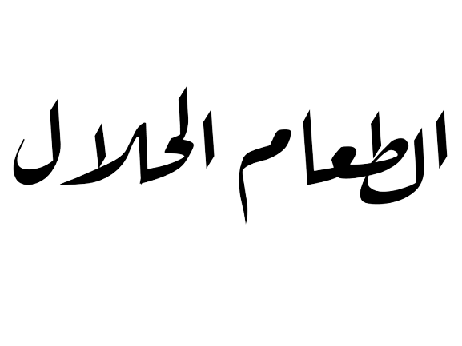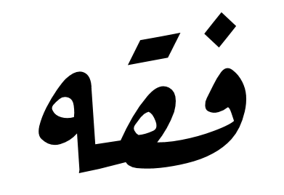

FIQH (JURISPRUDENCE) OF HALAL FOOD
WITH AN ADDENDUM OF FATAWA BY SHAYKH IBN UTHAYMEEN
(MAY ALLAH HAVE MERCY ON HIM)

Revised by the Sunnah College committee, under the scholarly supervision of:

Shaykh Dr. Haytham Sarhaan
(Teacher in the Masjid of the Prophet ﷺ)

Sarhaan.com - MahadSunnah.com

ﻣﺠﻴﻊ ﺣﻘﻮق اﻟﻄﺒﻊ ﺣﻤﻔﻮﻇﺔ © RESERVED RIGHTS ALL

THIS PUBLICATION IS A WAQF FOR ALLĀH AND FOR THE BENEFIT OF ALL MUSLIMS; IT IS NOT TO BE SOLD AND WHOEVER WISHES TO PRINT, COPY OR DISTRIBUTE COPIES FOR FREE MUST DO SO WITHOUT ANY ALTERATIONS TO THE ORIGINAL TEXT.

WWW.SARHAAN.COM WWW.MAHADSUNNAH.COM



According to the words of Allah (Quran 2:168),

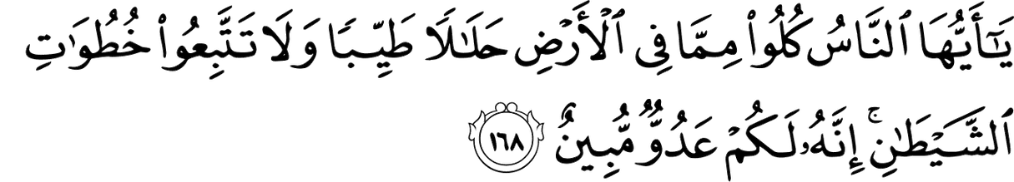

O mankind! Eat of that Which is laWful and good on the earth, and folloW not the footsteps of Shaitan (Satan). Verily, he is to you an open enemy.

The origin of foods and drinks is permissiveness (Halal), except for what came in Revelation, for prohibition such as carrion, blood, pork, alcohol, and so on. Islamic Law stipulates what is forbidden to consume.
First, all what has been proven as harmful to humans just

as the Almighty’s saying (Quran, 4:29):

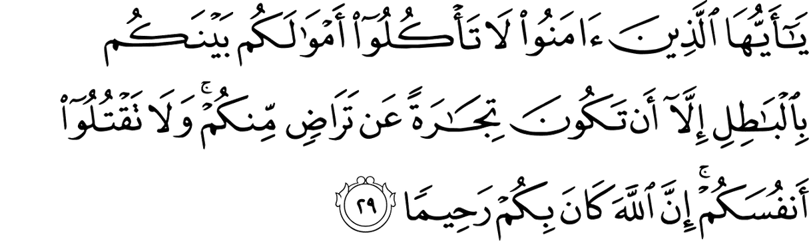

O you Who believe! Eat not up your property among yourselves unjustly except it be a trade amongst you, by mutual consent. And do not kill yourselves (nor kill one another). Surely, Allâh is Most Merciful to you.

Second, impure foods and drinks (Quran 7:157),
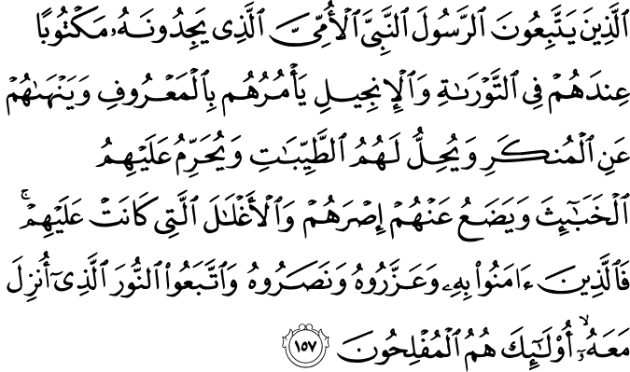

Those Who folloW the Messenger, the unlettered prophet, Whom they find Written [i.e., described] in What they have of the Torah and the Gospel, Who enjoins upon them What is right and prohibits them from What is Wrong and makes laWful for them What is good and forbids them from What is evil and relieves them of their burden and the shackles Which Were upon them. So they Who have believed in him, honored him, supported him and folloWed the light Which Was sent doWn With him - it is those Who Will be the successful.

As a summary, Allah Almighty has forbidden the dirty nutriments and the impure of them. Also, it is forbidden to take drugs of all kinds as reported by the saying of the Prophet (Peace be upon him): “Every intoxicant is alcohol, and every alcohol is forbidden” (Sahih (Muslim: 2003

Nowadays, smoking is among the forbidden things and impurities that have spread worldwide, which must be avoided and beware of due to the harm and fatal chronic diseases it causes to the body; thankfully, it has been all proven in modern medical research. It is also prohibited to take stimulant and sleeping pills since it is harmful to its abusers, however, if the need arises, it is mandatory to take them on the recommendation of a specialist doctor

Fatawa of Shaykh Ibn Uthaymeen (ﷲ رﺣﻤﻪ):
- It is not essential to ask about that which was slaughtered by a Muslim or a kitaabi, and how it was slaughtered, and whether the name of Allaah was mentioned over it or not. Rather that should not be done, because that is being obstinate in religious matters. The Prophet (peace and blessings of Allaah be upon him) ate meat slaughtered by the Jews and did not ask questions. In Saheeh al- Bukhaari and elsewhere it is narrated from ‘Aa’ishah (may Allaah be pleased with her) that some people said to the Prophet (peace and blessings of Allaah be upon him): Some people bring meat to us, and we do not know whether they mentioned the name of Allaah over it or not. The Messenger of Allaah (peace and blessings of Allaah be upon him) said: “Mention the name of Allaah over it and eat.” She said

They were new in Islam, and the Prophet (peace and blessings of Allaah be upon him) told them to eat without asking, even though those who brought the meat to them may not have been aware of the rulings of Islam because they were new in Islam. End quote from Risaalah fi Ahkaam al-Udhiyah wa’l-Dhakaah by Shaykh Ibn ‘Uthaymeen (may Allaah have mercy on him).

- It is proven in Saheeh al-Bukhaari (no. 5507) from ‘Aa’ishah (may Allaah be pleased with her) that some people came to the Prophet (peace and blessings of Allaah be upon him) and said: “Some people bring meat to us, and we do not know if they mentioned the name of Allaah or not.” He said: “Say it yourselves then eat.” I [Shaykh Ibn ‘Uthaymeen is speaking] say: They were new in Islam, and they did not know whether they had said the name of Allaah or not, so he said: “Say it yourselves, then eat.” So eating it is permissible even if we do not know whether the one who slaughtered the meat mentioned the name of Allaah or not. Similarly it is permissible to eat even if we do not know whether the meat was slaughtered in the proper manner or not, because if the action is carried out by the right people then the basic principle is that it is valid, unless there is evidence to the contrary. So if some meat comes to us from a Muslim, a Jew or a Christian, we should not ask about it or ask how it was slaughtered or whether the name of Allaah was mentioned over it. It is halaal so long as there is no clear proof that it is haraam. This is a way in which Allaah has made things easier for us. Liqaa’aat al-Baab il-Maftooh, 1/77
- With regard to meat that is imported from non-Muslim countries, if those who slaughter the meat are from among the People of the Book, namely Jews and Christians, then it is permissible to eat it, and it is not appropriate to ask how it was slaughtered, or whether they mentioned the name of Allah over it or not. That is because the Prophet (blessings and peace of Allah be upon him) ate the lamb that was given to him by the Jewish woman in Khaybar, and he ate the meal to which a Jewish man invited him, and it contained rendered fat, but the Prophet (blessings and peace of Allah be upon him) did

not ask how they had slaughtered it, or whether they had mentioned the name of Allah over it. In Saheeh al-Bukhaari it is narrated that some people said to the Prophet (blessings and peace of Allah be upon him): Some people bring us meat, and we do not know whether the name of Allah was mentioned over it or not. He said: “Say Bismillah over it yourselves and eat it.” ‘Aa’ishah (may Allah be pleased with her), who narrated the hadith, said: They had only recently become Muslim. These hadiths indicate that it is not appropriate to ask about how the slaughtering was done if the one who did it is qualified to do it. This highlights the wisdom of Islamic teachings and how Islam makes things easy for people, because if people were required to find out whether conditions are met even though the one who did the action is qualified, that would cause a great deal of difficulty and hardship, and that would make Islam a religion of hardship and difficulty. But if the meat came from a foreign country where those who do the slaughtering are people whose meat it is not permissible to eat, such as the Zoroastrians and idol worshippers, and those who do not follow any religion, then it is not permissible to eat it, because Allah, may He be exalted, has not permitted the meat of any non-Muslims except the meat of those who were given the Book, namely the Jews and Christians. If we are uncertain as to whether the slaughterman was one whose meat is permissible or one whose meat is not permissible, then that is not a problem [i.e., if most of the people in that country are those whose meat is permissible]. The fuqaha’ (may Allah have mercy on them) said: If there is meat that is found in a land where meat slaughtered by most of its people is permissible, then it is halaal. But in that case it is more appropriate to avoid it and choose that concerning which there is no doubt. For example, if the meat comes from those whose meat is permissible, but some of them slaughter it in the manner prescribed in Islam, in which the blood is allowed to flow out by means of slaughtering it with a blade, and it is not slaughtered using teeth or nails, and some of them slaughter it in a way other than the manner prescribed in Islam, but most of them do it in the first manner, then there is nothing wrong with eating meat that comes from there,

based on the actions of the majority. But it is better to avoid it, in order to be on the safe side. End quote. Shaykh Muhammad ibn ‘Uthaymeen (may Allah have mercy on him). Fataawa ‘Ulama’ al- Bilaad al-Haraam (p. 255, 256).

- If this meat comes from one whose slaughter is permissible, then it is halaal, and we do not have to ask how it was slaughtered or to ask whether the name of Allaah was mentioned over it or not. We do not have to do that and indeed we should not do that, because asking about this comes under the heading of exaggerating about religious matters. Hence when people came and asked the Prophet (peace and blessings of Allaah be upon him), “People bring us meat, and we do not know whether they mentioned the name of Allaah over it or not?” He said: “Say Bismillaah yourselves and eat.” He said not say: Ask them; he said: “Say Bismillaah yourselves and eat.” ‘Aa’ishah (may Allaah be pleased with her) said, narrating this hadeeth, They had recently become Muslim, and the one who has only recently become Muslim may be unaware of the necessity of saying Bismillaah when slaughtering. Whatever the case, if meat comes to you from people whose slaughter is permissible – and those whose slaughter is permissible are three types of people: Muslims, Jews and Christians – then do not ask. The Jews used to give gifts of meat to the Prophet (peace and blessings of Allaah be upon him) and he would eat it without asking about it. The Jews would invite him to eat barley bread and fat, and he did not ask about this fat and how the animal it came from was slaughtered. The best of guidance is the guidance of Muhammad (peace and blessings of Allaah be upon him). End quote. Liqa’ al-Baab il-Maftooh.

- So it is permissible to eat even if we do not know whether the slaughterer mentioned the name of Allah or not. Similarly, it is permissible to eat even if we do not know whether it was slaughtered in the proper manner or not, because if an action is done by the appropriate people, then in principle it is valid and sound unless there is evidence to the contrary.

If we receive some meat from a Muslim or a Jew or a Christian, we should not ask about it and we should not ask how it was slaughtered or whether the name of Allah was mentioned over it or not. It is halaal so long as there is no proof that it is haraam, and this is one of the ways in which Allah has made things easy for us. End quote. Liqaa’aat al-Baab al-Maftooh, 20805.
- One of the following three scenarios must apply to this meat:

- – We know that it has been slaughtered in the proper manner. This meat is halaal.
- – We know that it has not been slaughtered in the proper manner. This meat is haraam.
- – We are not sure; we do not know whether it has been slaughtered in the proper manner or not. The ruling in this case is that the meat is halaal, and we do not have to ask about how it was killed, or whether the name of Allaah was mentioned over it or not. Rather it seems from the Sunnah that it is better not to ask or try to find out. Hence when they said to the Prophet (peace and blessings of Allaah be upon him), “we do not know whether they mentioned the name of Allaah over it or not,” he did not say to them, Ask them whether they mentioned the name of Allaah over them or not, rather he said: “Say the name of Allaah over it yourselves, and eat it.” This tasmiyah or saying of the name of Allaah which the Prophet (peace and blessings of Allaah be upon him) told them to do is not the tasmiyah of slaughter, because the slaughter is over and done with. Rather it is the tasmiyah of eating, because what is prescribed is for the person who is eating to say the name of Allaah when he eats. The correct view regarding saying the name of Allaah when eating is that it is obligatory, because the Messenger of Allaah (peace and blessings of Allaah be upon him) enjoined it, and because if a person does not say the name of Allaah, the Shaytaan shares his food and drink. If a person wants to be cautious and forego eating this meat, there is nothing wrong with that, but there is also nothing wrong with eating it. From Fataawa Islamiyyah, 3/415

- The evidence for the prohibition of that which is harmful is to be found in the Qur’aan and the Sunnah. Qur’aan: [al-Baqarah 2:195],

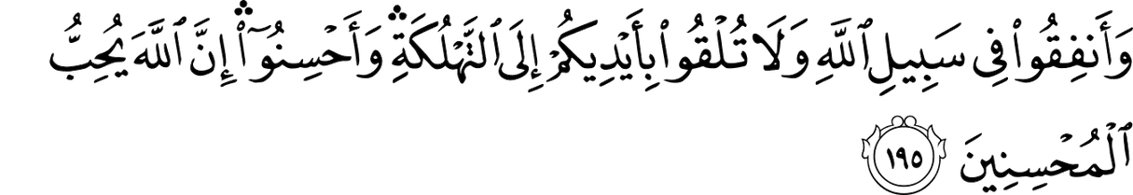

And spend in the Cause of Allâh and do not throW yourselves into destruction (by not spending your Wealth in the Cause of Allâh), and do good. Truly, Allâh loves Al-Muhsinûn (the good-doers).
and [an-Nisa’ 4:29],

O you Who believe! Eat not up your property among yourselves unjustly except it be a trade amongst you, by mutual consent. And do not kill yourselves (nor kill one another). Surely, Allâh is Most Merciful to you.
The prohibition on killing oneself is also a prohibition on the means of doing so. Whatever causes harm is haraam. The Prophet (blessings and peace of Allah be upon him) said: “There should be neither harming nor reciprocating harm.” We might also quote as evidence the verse in which Allah says (interpretation of the meaning) [al- Maa’idah 5:6],

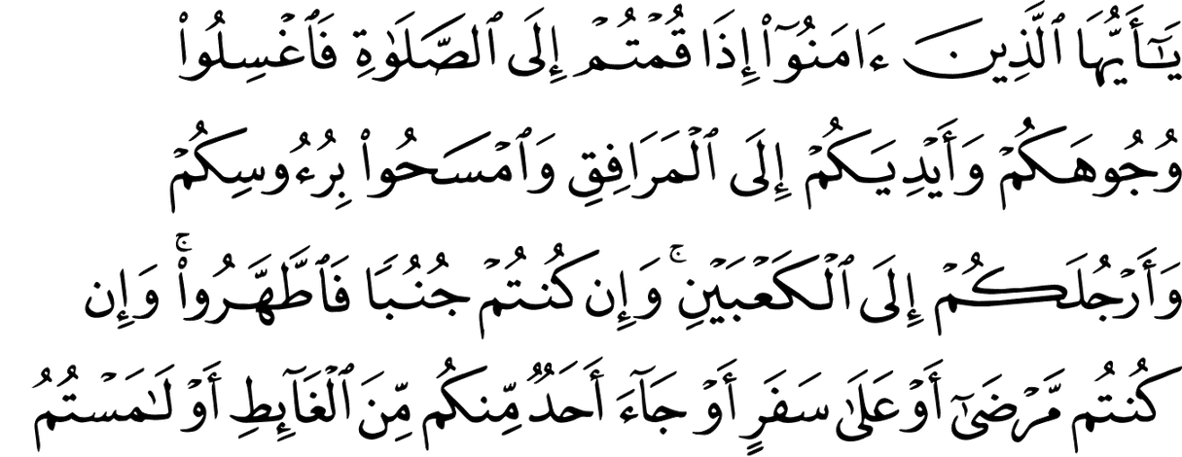

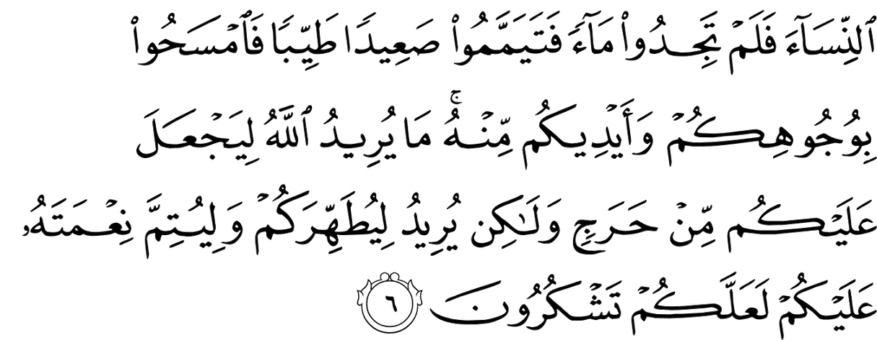

O you Who believe! When you intend to offer As-Salât (the prayer), Wash your faces and your hands (forearms) up to the elboWs, rub (by passing Wet hands over) your heads, and (Wash) your feet up to ankles. If you are in a state of Janâba (i.e. after a sexual discharge), purify yourselves (bathe your Whole body). But if you are ill or on a journey, or any of you comes after ansWering the call of nature, or you have been in contact With Women (i.e. sexual intercourse), and you find no Water, then perform Tayammum With clean earth and rub thereWith your faces and hands. Allâh does not Want to place you in difficulty, but He Wants to purify you, and to complete His Favour to you that you may be thankful.
The point here is that Allah enjoined tayammum for the one who is sick so as to protect him from harm and to offer him an alternative to water, which may harm him if he uses it when it is cold and he is sick and so on. End quote. Ash-Sharh al-Mumti‘, 15/12, 13

- The same applies to smoking, which is harmful in and of itself. The fact that it is harmful is a matter on which doctors are unanimously agreed nowadays, and there is no difference of opinion among them on that score, because tobacco contains toxic substances that damage the blood. End quote. Ash-Sharh al-Mumti‘, 15/10
- In the case of that which is harmful in conjunction with something else, such as if this food is not compatible with that food, in the sense that if you eat the two foods together it will result in harm, but if you eat them separately that will not result in harm, and the doctor has advised this dietary restriction for one who is sick and has told him, “If you eat it, it will harm you,” then it becomes haraam for him. Shaykh al-Islam (may Allah have mercy on him) said: If a person feels that some kind of food will cause him harm or give him indigestion, then it becomes haraam for him. If a person says: If I fill my belly with this food, I will need water, and if I add water to it I will hardly be able to

walk and it will bother me; and if I sit it will bother me, and if I bow it will bother me, and if I lie on my back it will bother me, and if I lie on my stomach it will bother me. In this case Shaykh al-Islam says:If he fears that it will harm him, then it becomes haraam for him to eat it. And what he said is correct, because it is not permissible for a person to eat that which will harm him or to wear that which will harm him or to sit on that which will harm him. Even the Sahaabah (may Allah be pleased with them), with regard to prostration, if the heat would harm them, they would spread out their garments and prostrate on them, lest they be harmed and so that they might be at ease in prayer. What Shaykh al-Islam mentioned comes under the heading of fear of harm and indigestion, meaning that it is not as a result of the food itself, rather it is the result of consuming too much of it, and even if there is someone who would not be harmed by that, but based on the medical advice that he will be harmed, because if the stomach is filled it will bother him and cause some discomfort…It was said that one of the harmful things is to eat food on top of other food. If that is correct then it is also haraam, because Allah says (interpretation of the meaning): [an-Nisa’ 4:29],

O you Who believe! Eat not up your property among yourselves unjustly except it be a trade amongst you, by mutual consent. And do not kill yourselves (nor kill one another). Surely, Allâh is Most Merciful to you.
It is not far fetched to say that this is correct. As it is something that it tried and tested. End quote. Ash-Sharh al-Mumti‘, 15/9-11
- Shaykh Ibn ‘Uthaymeen (may Allaah have mercy on him) was asked about cans of cat food that contain pork – is it permissible to buy them and feed them to cat? He replied: If that is by buying the

the cans then it is not permissible, because it is not permissible to pay for pork and buy it. But if he finds it thrown away and feeds it to his cat, there is nothing wrong with that. And Allaah knows best.

- With regard to saying Bismillah when slaughtering meat, that it is essential and cannot be waived under any circumstances, whether it is omitted by mistake or deliberately or out of ignorance. This is the view of the Zaahiris and was narrated from Maalik and Ahmad, and it was the view of some of the salaf; it was also the view favoured by Shaykh al-Islam Ibn Taymiyah. Shaykh Ibn ‘Uthaymeen (may Allaah have mercy on him) said: It is the correct view. He also said: They quoted as evidence the general meaning of the verse in which Allaah says (interpretation of the meaning): [al-An’aam 6:121]

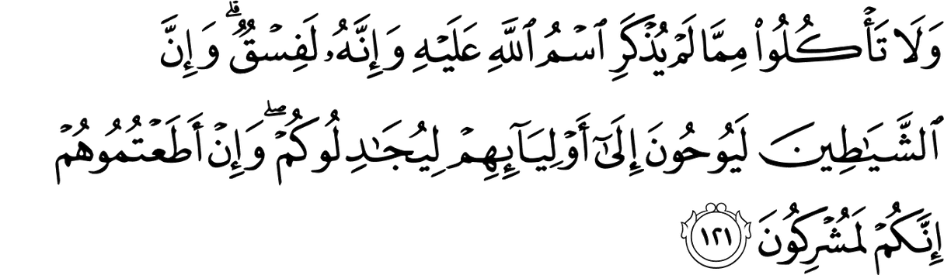

And do not eat of that upon Which the name of Allāh has not been mentioned, for indeed, it is grave disobedience. And indeed do the devils inspire their allies [among men] to dispute With you. And if you Were to obey them, indeed, you Would be associators [of others With Him].
And the Prophet (peace and blessings of Allaah be upon him) said: “If the blood flows and the name of Allaah is mentioned, then eat.” So in order for the meat to be halaal, it is essential that the name of Allaah be mentioned. It is well known that if the condition is not met, the thing is invalid, so if the name of Allaah is not mentioned, the meat is not halaal, as with any other condition. Hence if a person prays but he forgot to do wudoo’, he has to repeat the prayer. Similarly if he prays not realizing that he had broken his wudoo’ because he thought that breaking wind does not invalidate wudoo’, or that eating camel meat does not invalidate wudoo’, for example, then he must repeat it, because the thing is not valid without the conditions being met.

So if he slaughtered it but the blood did not flow, by mistake or out of ignorance, then it is not halaal, and the same applies if he does not mention the name of Allaah, because it is mentioned in the same hadeeth. End quote from al-Sharh al-Mumti’ (6/358).See also: al-‘Inaayah Sharh al-Hidaayah (9/489); al-Fawaakih al-Dawaani (1/382); and al-Majmoo’ (8/387).
- With regard to meat that is imported from the lands of the Jews and Christians, there are three scenarios: The first scenario: Where we know from seeing it ourselves or trustworthy reports that the meat was slaughtered in the Islamic manner, which is by cutting the two veins in the neck, whilst mentioning the name of Allah over it. In this case, the meat is undoubtedly halaal, because Allah, may He be exalted, says (interpretation of the meaning): {and the food of those who were given the Scripture is lawful for you} [al-Maa’idah 5:5], meaning meat slaughtered by them. The second scenario: Where we know that the way in which it is slaughtered is not the Islamic way, such as if it is done by strangling, or stunning, or a violent blow, or by striking the head, and the like, or that the name of Allah is not mentioned over it. In this case, the meat is haraam, because Allah, may He be exalted, says (interpretation of the meaning): [al-Maa’idah 5:3],

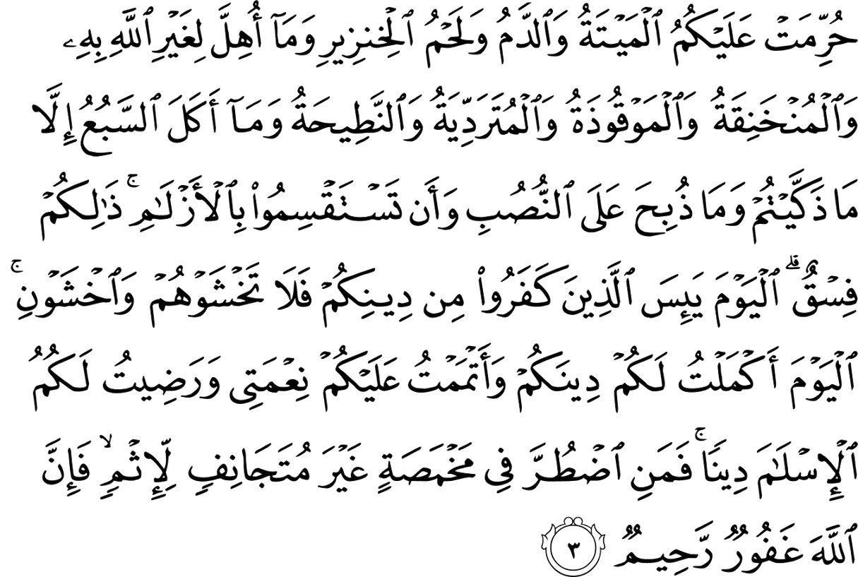

Forbidden to you (for food) are: Al-Maitah (the dead animals - cattle - beast not slaughtered), blood, the flesh of sWine, and that on Which Allâh’s Name has not been mentioned While slaughtering, (that Which has been slaughtered as a sacrifice for others than Allâh, or has been slaughtered for idols) and that Which has been killed by strangling, or by a violent bloW, or by a headlong fall, or by the goring of horns - and that Which has been (partly) eaten by a Wild animal - unless you are able to slaughter it (before its death) - and that Which is sacrificed (slaughtered) on An-Nusub (stone- altars). (Forbidden) also is to use arroWs seeking luck or decision; (all) that is Fisqun (disobedience of Allâh and sin). This day, those Who disbelieved have given up all hope of your religion; so fear them not, but fear Me. This day, I have perfected your religion for you, completed My Favour upon you, and have chosen for you Islâm as your religion. But as for him Who is forced by severe hunger, With no inclination to sin (such can eat these above mentioned meats), then surely, Allâh is Oft-Forgiving, Most Merciful.
And [al-An‘aam 6:121],

And do not eat of that upon Which the name of Allāh has not been mentioned, for indeed, it is grave disobedience. And indeed do the devils inspire their allies [among men] to dispute With you. And if you Were to obey them, indeed, you Would be associators [of others With Him].
The third scenario: When we do not know how it was slaughtered, and we do not know in which manner it was done. In this case, there is some doubt and hesitation concerning the meat. The texts which were narrated from the Prophet (blessings and peace of Allah be upon him) indicate that it is halaal and that we should not ask about the way in which it was slaughtered or try to find out about that, so as to make things easier for people, and because the basic principle concerning actions and dealings is that they are valid if they are done by those who are qualified to do them. [The above has been summarised from a lengthy fatwa that was issued by Shaykh Ibn ‘Uthaymeen. See: Abhaath Hay’at Kibaar al-‘Ulama’ (2/677)].

- If it is imported from a country where most of the population are those whose meat is permissible, then based on what appears to be the case, their meat may be deemed permissible, based on the majority, unless it is known that the one who did the slaughtering was someone whose meat is not permissible. In that case, it cannot be deemed to be permissible because there is an impediment to ruling on the basis of what appears to be the case. End quote from Abhaath Hay’at Kibaar al-‘Ulama’ (2/683).

- How will the kaafir be brought to account on the Day of Resurrection when he is not required to follow the obligations of Islam? He replied: This question is based on a misconception. The same is required of the kaafir as is required of the believer, but he is not to be compelled to follow it in this world. The fact that it is required of him is indicated by the passage in which Allaah says (interpretation of the meaning): [al-Muddaththir 74:39-46]

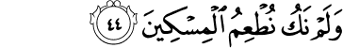

Except those on the Right, (i.e. the pious true believers of Islâmic Monotheism).In Gardens (Paradise) they Will ask one another, About Al-Mujrimûn (polytheists, criminals, disbelievers), (And they Will say to them): "What has caused you to enter Hell?" They Will say: "We Were not of those Who used to offer the Salât (prayers), "Nor We used to feed Al-Miskîn (the poor); "And We used to talk falsehood (all that Which Allâh hated) With vain talkers. And We used to belie the Day of Recompense
If they were not being punished for not praying and not feeding the poor, they would not have mentioned that, because there would be no point in mentioning it in this situation. This indicates that they are being punished for not doing the minor issues enjoined by Islam. As this is implied by the texts, it is also implied by reasoning.

If Allaah will punish His believing slave for what he failed to do of religious duties, how can He not punish the kaafir? Moreover, the kaafir will be punished for all the blessings that Allaah bestowed upon him of food and drink etc. Allaah says (interpretation of the meaning): [al-Maa’idah 5:93],

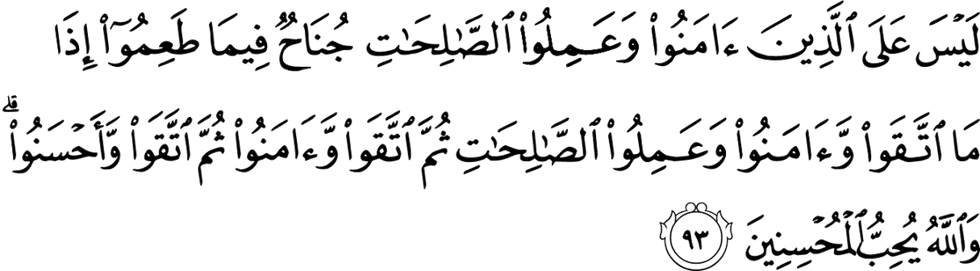
Those Who believe and do righteous good deeds, there is no sin on them for What they ate (in the past), if they fear Allâh (by keeping aWay from His forbidden things), and believe and do righteous good deeds, and again fear Allâh and believe, and once again fear Allâh and do good deeds With Ihsân (perfection). And Allâh loves the good-doers.
The apparent meaning of the verse is that there is no sin on the believers for what they have eaten. What this implies is that there is sin on the kuffaar for what they have eaten. End quote. Majmoo’ Fataawa al-Shaykh Ibn ‘Uthaymeen (2/question no. 164). Based on this, it is not permissible for a Muslim to offer food to a non-Muslim during the day in Ramadaan, because the minor issues of sharee’ah are addressed to the kuffaar too. In Nihaayat al-Muhtaaj (5/274) it says that the scholars regarded it as haraam to sell food to the kuffaar during the day in Ramadaan.

- Shaykh Ibn ‘Uthaymeen said in Sharh Riyadh al-Saaliheen (2/454): The wisdom behind that is that breathing into the vessel is off putting to the one who is going to drink from it after him. Some diseases from the stomach, lungs or mouth may be expelled with the breath and stick to the vessel, or he may choke if he breathes into the vessel. Hence the Prophet (peace and blessings of Allaah be upon him) forbade breathing into vessels; rather one should take three breaths, holding the vessel away from the mouth each time. End quote.

Shaykh Ibn ‘Uthaymeen (may Allaah have mercy on him) said in Sharh Riyadh al-Saaliheen (2/457): That is because if a person blows (into the vessel), some harmful things may come with the air that is exhaled, such as disease and the like. But some of the scholars made an exception in cases of necessity, such as if the drink is hot and he needs to drink it quickly. In that case some scholars granted a concession. But it is better not to blow on it, even if it is hot. If it is hot and he has another vessel, then he may pour some of it into that vessel then pour it back until it cools down.

- The animal that feeds on filth is one whose food is mostly impure (najaasah). There are two scholarly views concerning this: one view is that it is haraam because it has been nourished by impure matter that has an effect on its meat. The other view is that it is halaal. This is based on the idea that impure things become pure when they undergo a transformation. They said: The impurity that it ate has been transformed into blood, flesh and the like that grows in the body, so it is taahir. End quote. al-Sharh al-Mumti‘ (11/298)

- The scholars differed concerning the ruling on the skin of dead animals if it is tanned. Shaykh Ibn ‘Uthaymeen favoured the view that tanning purifies the skin of the dead animal if it is from an animal whose meat may be eaten, such as camels, cattle and sheep. But if it comes from an animal whose meat may not be eaten, such as pigs, then it cannot be purified by tanning. Al-Sharh al-Mumti’, 1/72
- The hadeeth of Jaabir was narrated by al-Bukhaari (2121) and Muslim (1581). The wording is as follows: It was narrated from Jaabir ibn ‘Abd-Allaah (may Allaah be pleased with him) that he heard the Messenger of Allaah (peace and blessings of Allaah be upon him) say on the day of the Conquest when he was in Makkah: “Allaah and His Messenger have forbidden the sale of alcohol, dead meat, pigs and idols.” It was said, “O Messenger of Allaah, what do you think of the fat taken from a dead animal which is used for caulking ships, greasing animal skins and which people use to light their lamps?” He said, “No, it is haraam.” Then the Messenger of Allaah (peace and

blessings of Allaah be upon him) said, “May Allaah curse the Jews, for Allaah forbade them the fat, but they melted it then they sold it and consumed its price.” With regard to the meaning: It is clear that the context is explaining the prohibition on selling alcohol (khamr – that which fogs (khaamara) the mind – which includes all kinds of alcohol), dead meat, pigs and idols – which are things made from wood, copper, gold, etc, in the form of people or animals. Then the Sahaabah wanted to make an exception from this prohibition in the case of selling the fat of dead animals, because of the benefits that there were in it, which that it was used as caulking for ships, to protect the wood from water, and to grease animal skins in order to keep them soft and supple, and as fuel for lamps. The Prophet (peace and blessings of Allaah be upon him) did not make these things exceptions from the prohibition, as he said, “No, it is forbidden.” Then he mentioned what the Jews did, which was that they melted down the fat that Allaah has forbidden to them, and turned it into another substance, such as wax, which they then sold and consumed its price. The scholars differed as to what the pronoun huwa (it) in the Prophet’s phrase Laa, huwa haraam (No, it is forbidden) referred. Some of them said that what is haraam is benefitting from the thing; others said that what is haraam is selling it. The latter view is the one which was regarded as correct by Shaykh Ibn ‘Uthaymeen (may Allaah have mercy on him), who said in al-Sharh al-Mumti’ (8/136): “This view is the one which is correct: that the pronoun in the phrase ‘it is forbidden’ refers to selling, even though the substance in question has these uses that the Sahaabah (may Allaah be pleased with them) mentioned. That is because the context of the hadeeth has to do with selling. And it was said that ‘it is forbidden’ refers to benefitting from it in these ways, so it is not permissible to caulk ships with it, or grease animal skins with it, or to use it in people’s lamps. But this view is da’eef (weak). The correct view is that it is permissible to caulk ships with it, and grease animal skins, and use it in people’s lamps.” al-Sharh al-Mumti’ (8/136)

- The last of the two commands from the Messenger of Allaah (peace and blessings of Allaah be upon him) was that there was no need to do wudoo after eating meat that had been touched by fire. But this hadeeth is general, whereas the hadeeth about doing wudoo after eating camel meat is specific, and a specific ruling takes precedence over a general one. (Sharh Muslim, 4/49). Among modern scholars Shaykh Ibn Uthaymeen also said this.

- Yes, if you shoot a rifle when hunting birds or rabbits or deer, and you say the name of Allah when pulling the trigger, then it will be halaal, even if you find it already dead, because the Prophet (peace and blessings of Allah be upon him) said: “Whatever causes the blood to flow and the name of Allah has been mentioned over it, then eat.” And he said: “If you release your (hunting) dog and mention the name of Allah over it, then eat.” But if it is still alive and able to move then you must slaughter it properly and mention the name of Allah over it when slaughtering it. If you do not do that and it dies, then it becomes haraam for you. But attention must be paid to mentioning the name of Allah when pulling the trigger, because if you do not mention the name of Allah then it is haraam to eat it, even if you forget, because the Prophet (peace and blessings of Allah be upon him) said: “Whatever causes the blood to flow and the name of Allah has been mentioned over it, then eat.” And he said: “Do not eat of that over which the name of Allah has not been mentioned.” End quote from Fataawa Noor ‘ala al-Darb.



