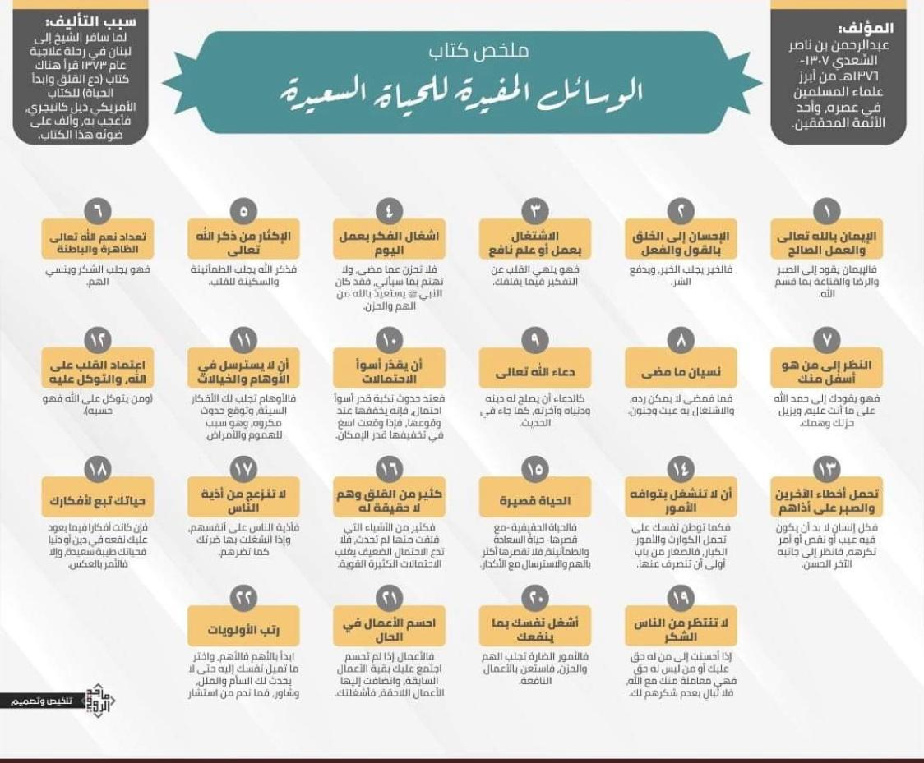
بسم الله الرحمن الرحيم

Book Summary:
"Happy Living Tips"

Author: Abdurrahman bin Nasir As-Si'di (1307 – 1376 H)-rahimahullah-; He was one of the Famous Islamic scholars of his time, and a reliable researcher (in the field of religion).

The reason for writing this book: When the Shaykh traveled to Lebanon for medical treatment (in 1373 H), he read a book entitled, "Leave Worries And Start a New Life" written by Dale Carnegie; where he was impressed by the book, then he wrote a book with a similar theme.

(1) Believe in Allah The Almighty and do good deeds : Because faith will lead you to patience, happiness and satisfaction with what Allah has destinated .

(2) Be kind to others in speech and action : Kindness will leads to good and removes evil .

(3) Busying (self) with [good] deeds or useful knowledge seeking : Because it can distract the heart from thinking about what worries you.

(4) Busying the Mind With Daily Tasks: Do not be sad for what has passed, and do not worry about what is to come, for the Prophet shallallahu alaihi wa sallam once asked Allah for protection from worry and sadness .

(5) Allah The Almighty a lot : Because remembering Allah brings peace and tranquility.

(6) Remembering the blessings of Allah that are visible and invisible: because it will makes us more grateful and forgets our worries.

(7) Looking at people who are lower than you : Because it can makes you to praise Allah for what you are going through, and it can also remove your sadness and worries .

(8) Forget the Past: For what has passed is impossible to return and make oneself busy with it is a waste of time and foolishness .

(9) Praying to Allah the Almighty : Like praying that Allah improves our religion, the life of the this world and the afterlife, as mentioned in the Hadith.

(10) Should Estimate the Worst Possibilitys ; When the disaster occurs , at least estimate the worst possibility, which because if it happens we can overcome it, and when it happens, then try to overcome it as much as possible.

(11) Do not Get Carried Away With Illusions And Delusions; Because illusions can lead you to bad thoughts, so you think something bad happened, besides that it is also the cause of worry and various diseases.

(12) Depending on Allah and Relying on Him; Because whoever is trusted in Allah will undoubtedly fulfill (his needs).

(13) Forgive the mistakes of others and be patient for their misbehavior; Every human being must have mistakes or something that is not liked, so look at him from the good side .

(14) Do not Concern Yourself with Trivial Matters; Just as you can get used to being patient in the face of big problems and things, then trivial things are certainly easier for you to turn away from them.

(15) Life Is Short: The real life (though short) is a life full of happiness and tranquility, so do not be shortened anymore by anxiety and many thoughts.

(16) Many worries are not real : Most of the things you worry about don't necessarily happen, so don't let this small possibility overcome the big and more possibilities .

(17) Don’t get annoyed by others mistakes against you: Because their bad deeds will actually harm themselves, but if you are busy with them, it will harm you as they have harmed themselves.

(18) Your Life Journey Depends on Your Thoughts; If your mind is centered on something that can bring benefits to your religion or world, then your life will be beautiful and happy, but if not then the opposite will happen.

(19) Do not expect people to thank you; If you do good to people who have rights over you or people who do not have rights over you, then this is a transaction between you and Allah, so don't mind their lack of thanks for you.

(20) Busy yourself with something useful; Becausr harmful things bring you worrian sadness , so busy yourself with useful things.

(21) Try to complete your work immediately ; Because the delayed work will stack up with the upcoming work, and will eventually make you busier.

(22) Organizing Tasks With Priority Scales; Start with the most important and what you like the most, so that you don't get tired and bored quickly, and ask others for advice, because the person who asks for advice won’t regret .

