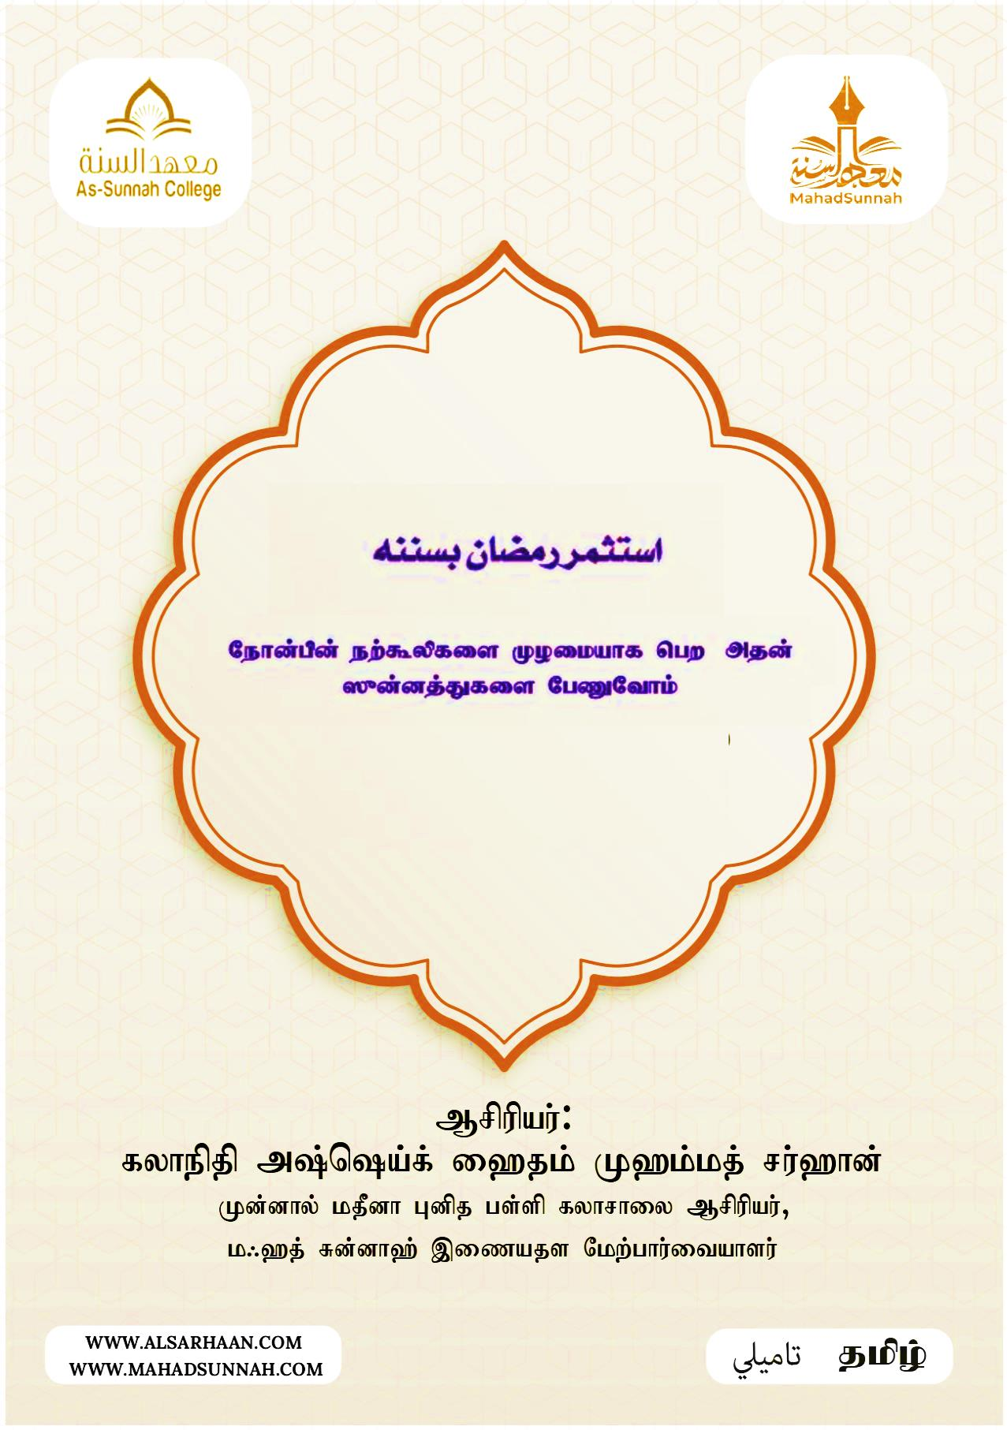

Nehd;gpd; ew;$ypfis Koikahf ngw mjd; ]{d;dj;Jfis NgZNthk;

Nehd;gpd; ew;$ypfis KOikahf mile;Jnfhs;sTk;> mjd; capNuhl;lj;ij czu;e;Jnfhs;sTk; Mirg;gLfpwPu;fsh? mt;thwhapd;> Nehd;gpd; ]{d;dj;jhd fhupaq;fis jtwhJ NgzpthUq;fs; :
1. ]`u; czT cl;nfhs;sy; : egpatu;fs; $wpdhu;fs; : ]`u; czT gwfj; epiwe;jjhFk;. mij jtpu;f;f Ntz;lhk;. xU kplu; ePiu mUe;jpNaDk; ]`u; nra;Aq;fs;. ]`u; czit cl;nfhs;Nthu; kPJ my;yh`; mUs;Gupfpwhd;> thdtu;fs; mUs; Ntz;bg; gpuhu;j;jpf;fpwhu;fs;. (m`;kj;:11003)
2. k/upg; Ntis te;jTld; jhkjpahJ Nehd;G Jwj;jy; : Nehd;G Jwg;gjw;F xUrpy NguPj;jk; goq;fs; NghJkhdit. mit fpilf;fhtpl;lhy; rpy kplu; jz;zPu; mUe;JtNj NghJkhdJ.

3. Nehd;G Jwf;Fk; Ntisapy; gpd;tUk; JMit XJjy;. “”j`go; okc tg;jy;yjpy; cW}F tjgjy; m[;U ,d; \h my;yh`;”.
4. gpw Nehd;ghspfis (jdJ nrytpy;) Nehd;G Jwf;fr; nra;jy; : “”ahu; xU Nehd;ghspia (jdJ nrytpy;) Nehd;G Jwf;fr; nra;fpwhNuh mtUf;F Nehd;ghspf;F fpilf;Fk; ew;$yp Nghd;W fpilf;Fk;. MapDk; Nehd;ghspf;F fpilf;Fk; ew;$ypapy; ve;jf; FiwTk; Vw;glhJ” vd egpatu;fs; Fwpg;gpl;lhu;fs;. (jph;kpjp:807)
5. wkohdpy; ck;whnra;jy; : “”wkohdpy; Xu; ck;wh nra;jhy; mjw;F `[;[{f;F rkkhd ew;$yp fpilf;Fk;” vd egpfshu; $wpdhu;fs;. (K];ypk;:1256)
Nkw;$wg;gl;l ew;fhupaq;fSld;>
wkohd; gfy; nghOJfis JMnra;jy;> my;Fu;Md; Xjy;> kw;Wk; gy tzf;fq;fspy; fopg;gjd; %ykhfTk; Nehd;gpd; KOikahd ew;$ypfisg; ngw;Wf;nfhs;s KbAk;.
wkohd; vd;gJ ekJ <khidg; gyg;gLj;Jtjw;Fk; euf tpLjiy ngw;W Rtdg; ghf;fpaj;ijg; ngw;Wf;nfhs;tjw;Fkhd mupanjhU re;ju;g;gkhFk;.
egpatu;fs; $wpdhu;fs; :
wkohid mile;Jk; (mij rupahfg; gad;gLj;jp) ghtkd;dpg;Gg; ngw;Wf;nfhs;shkNy wkohid topaDg;gpitj;j xUtu; ehrkile;Jtpl;lhu;. (jh;kpjp:3545)

