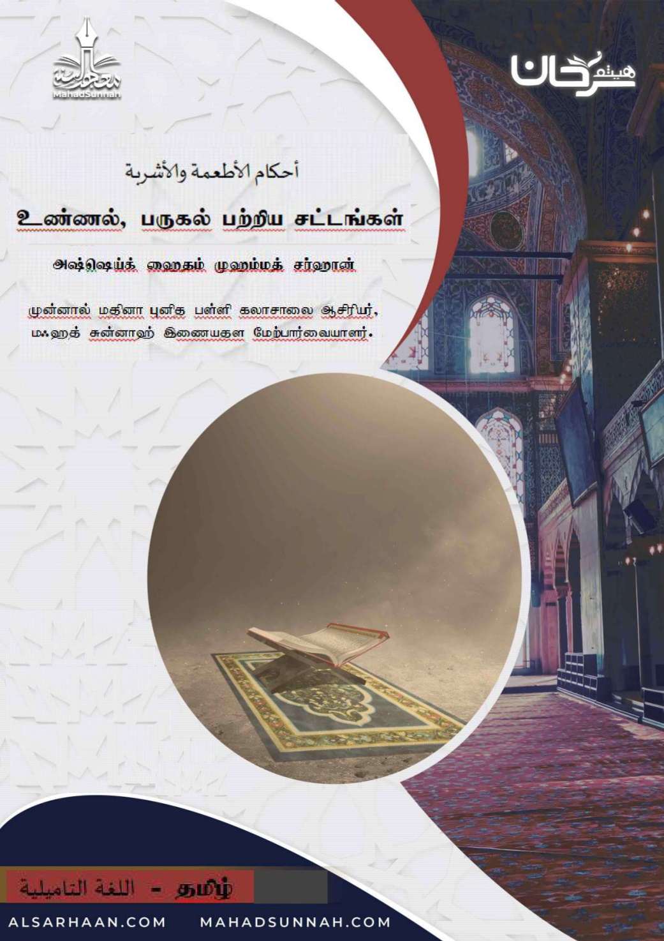

cz;zy;> gUfy; gw;wpa rl;lq;fs;.

jpUf;Fu;Md; trdj;jpw;F mikthf> czTfs;> Fbghdq;fs; Mfpatw;wpy; nghJtpjp ahnjdpy; `uhkhf;fg;gl;ltw;iwj; jtpu Vida midj;Jk; `yhy; MFk;.
cjhuzkhf: nrj;jgpuhzpfs;> ,uj;jk;> gd;wp ,iwr;rp> kJghdk; Mfpatw;iw Fwpg;gplyhk;. ,];yj;jpy; cl;nfhs;sj; jilnra;ag;gl;ltw;iwg; nghWj;jtiu:
- nghJthf kdpjDf;F jPq;F tpistpf;Fk; midj;Jk; `uhkhFk;.
jpUkiw $Wfpd;wJ :
“cq;fis ePq;fs; mopj;Jf; nfhs;s Ntz;lhk;”(4:29)
- mLj;jJ mRj;jkhd czTfs;> Fbghdq;fs;.
my;Fu;Mdpy; my;yh`; mUtUg;ghdit> mRj;jkhdit Mfpatw;iw `uhk; vd Fwpg;gpl;Ls;shd;.
- mNjNghy; midj;J tpjkhd Nghij t];Jf;fis cl;nfhs;tJk; `uhkhFk;.
egp (]y;)$wpdhu;fs;:
“”Nghij jUk; midj;Jk; kJghdkhFk;. kJghdk; midj;Jk; `uhkhFk;” (Gfhup:5575)
Fwpg;ghf ,f;fhyj;jpy; jhuhskhf gad;gLj;jg;gLfpd;w> xt;nthUtUk; vr;rupf;ifahf ,Uf;f Ntz;ba xd;Wjhd; Gifj;jy; gof;fk;. ,JTk; “my; /fghapj;” vd Fu;Md; $Wk; `uhkhdtw;wpy; xd;Wjhd;. Vnddpy;> ,jd; %yk; kdpjDf;F Mgj;Jf;fSk;> jPuhj Neha;fSk; Vw;gLfpd;wd.
mNj Nghd;W> J}f;f khj;jpiufs;> Cf;f khj;jpiufs; Mfpatw;iw cl;nfhs;tJk; `uhkhFk;. Vnddpy; ,itahTk; MNuhf;fpaj;jpw;F Mgj;jhdit. rpy ,f;fl;lhd re;ju;g;gq;fspy; khj;jpuk; ek;gpf;ifahd jukhd itj;jpaupd; MNyhridf;F mikthf ,ij gad;gLj;Jtjpy; jtwpy;iy vdyhk;.


