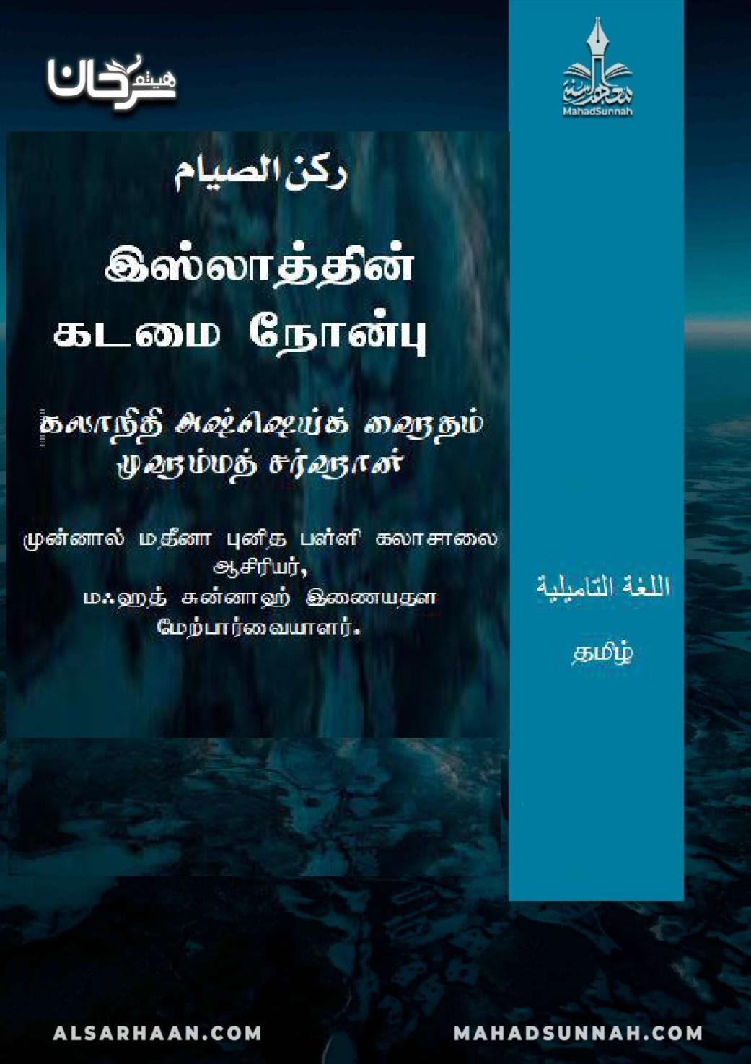

,];yhj;jpd; flik Nehd;G

,];yhj;jpd; Ik;ngUk; flikfSs; ehd;fhk; ,lj;ij wkohd; khj Nehd;G ngWfpwJ. ,];yhk; Ie;J J}z;fspy; epWtg;gl;Ls;sJ vd;Wk; mj;J}z;fspy; Nehd;Gk; xU J}z; vd;Wk; egpatu;fs; Fwpg;gpl;lhu;fs;.
gUt taij mile;j> Gj;jp RthjPdKs;s> cly; typikAs;s> nrhe;j Cupy; trpf;fpd;w xt;nthU K];ypKk; Nehd;G Nehw;gJ flikahFk;.
wkohd; khjj;jpd; Muk;gkhdJ ntw;Wf; fz;fshy; my;yJ etPd fUtpfshy; jiyg;gpiw ghu;g;gjd; %ykhf cWjpg;gLj;jg;gl Ntz;Lk;. gpiw njd;glhj NghJ \/ghd; khjj;ij Kg;gjhfg; G+u;j;jpnra;j gpd;du; wkohid Muk;gpf;f Ntz;Lk;. wkohd; khj Muk;gj;ij jPu;khdpf;f thdpay; fzpg;gPL fUj;jpy;nfhs;sg;glkhl;lhJ.
Nehd;G Nehw;gjhf ,uT Ntisapy; kdjpy; epidj;Jf;nfhs;tJ (epa;aj;) mtrpakhFk;.
wkohd; khj Muk;gj;jpy; xU jlit epa;aj; itj;Jf;nfhz;lhy; nkhj;j khjj;jpw;Fk; mJ NghJkhdjhFk;. MapDk;> ,ilapNy VNjDk; xUehs; my;yJ gy ehl;fs; Nehd;G Nehw;f KbahJ Nghdhy; kPz;Lk; Nehd;igj; njhlu epa;aj; mtrpakhFk;.
Nehd;G Nehw;wtu; mjpfhiy njhlf;fk; R+upad; kiwAk; tiu Nehd;ig Kwpf;Fk; fhupaq;fspy; <Lgl;L tplf;$lhJ.
Nehd;G Nehw;gjhf ,utpy; epa;aj; itj;j xUtu;> mjpfhiy cjakhd gpd;du; mjpfhiy cjakhftpy;iy vd epidj;J vijahtJ cz;lhy; my;yJ Fbj;jhy;; my;yJ Nehd;ghsp xUtu; khiyNtisapy; R+upad; kiwe;Jtpl;lnjd epidj;J cz;lhy; my;yJ Fbj;jhy;> gpd;du; mJ jtW vdj; njupa te;jhYk;> mtuJ Nehd;G nry;YgbahdjhfNt fUjg;gLk;. Vnddpy; egpfshu; $wpdhu;fs; :
“”vdJ r%fj;jtu; jtWjyhf my;yJ kwjpahf my;yJ epu;g;ge;j epiyapy; nra;Ak; fhupaq;fis my;yh`; kd;dpj;JtpLthd;”.
mUyhsd; my;yh`; ehk; Nehw;Fk; Nehd;Gfis mq;fPfupj;J mUs;Gupthdhdf.


